Sunday, August 16, 2026
12th Sunday of Pentecost

Our Savior’s Lutheran Church
Website: oursaviorswymore.com
8:00 AM Worship 9:00 AM Fellowship
Faith Formation 5:30 PM Wednesdays

Pastor Gary Grinvalds

Organist: Alice Meints or Sandy Eltiste

Introduction to the day
In Isaiah we hear that God’s house shall be a house of prayer for all people and that God will gather the outcasts of Israel. The Canaanite woman in today’s gospel is a Gentile, an outsider, who is unflinching in her request that Jesus heal her daughter. As Jesus commends her bold faith, how might our church extend its mission to those on the margins of society? In our gathering around word and meal we receive strength to be signs of comfort, healing, and justice for those in need.
*Please Stand
Congregational responses in bold print

WELCOME AND ANNOUNCEMENTS

*Brief order for CONFESSION AND FORGIVENESS

Blessed be the holy Trinity,☩ one God,
whose compassion endures forever.
Amen.
Let us confess our sin to God.
Silence is kept for reflection.
Compassionate God,
we confess to you all our sins.
Our burden is heavy, and we cannot free ourselves.
In your mercy, call us back to you.
Your yoke is easy and your burden is light.
Restore us to dwell in your peace.
In Christ’s name we pray,
Amen.
Jesus says, “Come to me,
all you who are weary
and are carrying heavy burdens,
and I will give you rest.”
In the name of God,
Father, ☩ Son, and Holy Spirit,
your sins are forgiven.
Rest in God’s love.
Amen.

*Entrance Hymn ELW 641

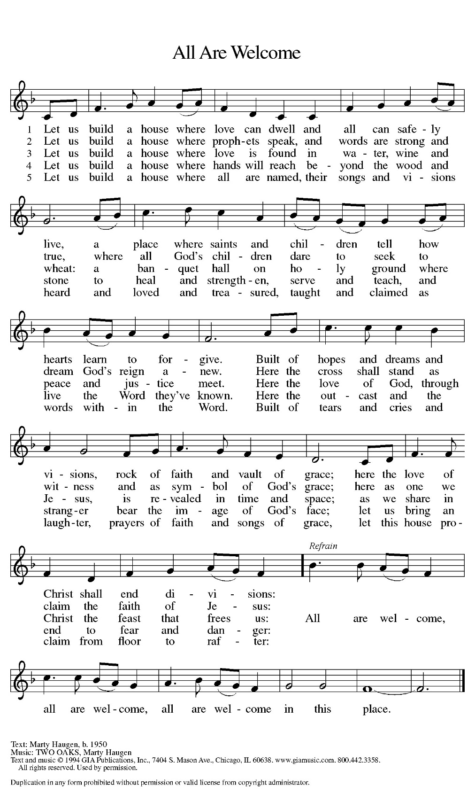
*Greeting

The grace of our Lord Jesus Christ, the love of God, and the communion of the Holy Spirit be with you all.
And also with you.

*Kyrie LBW pg 57
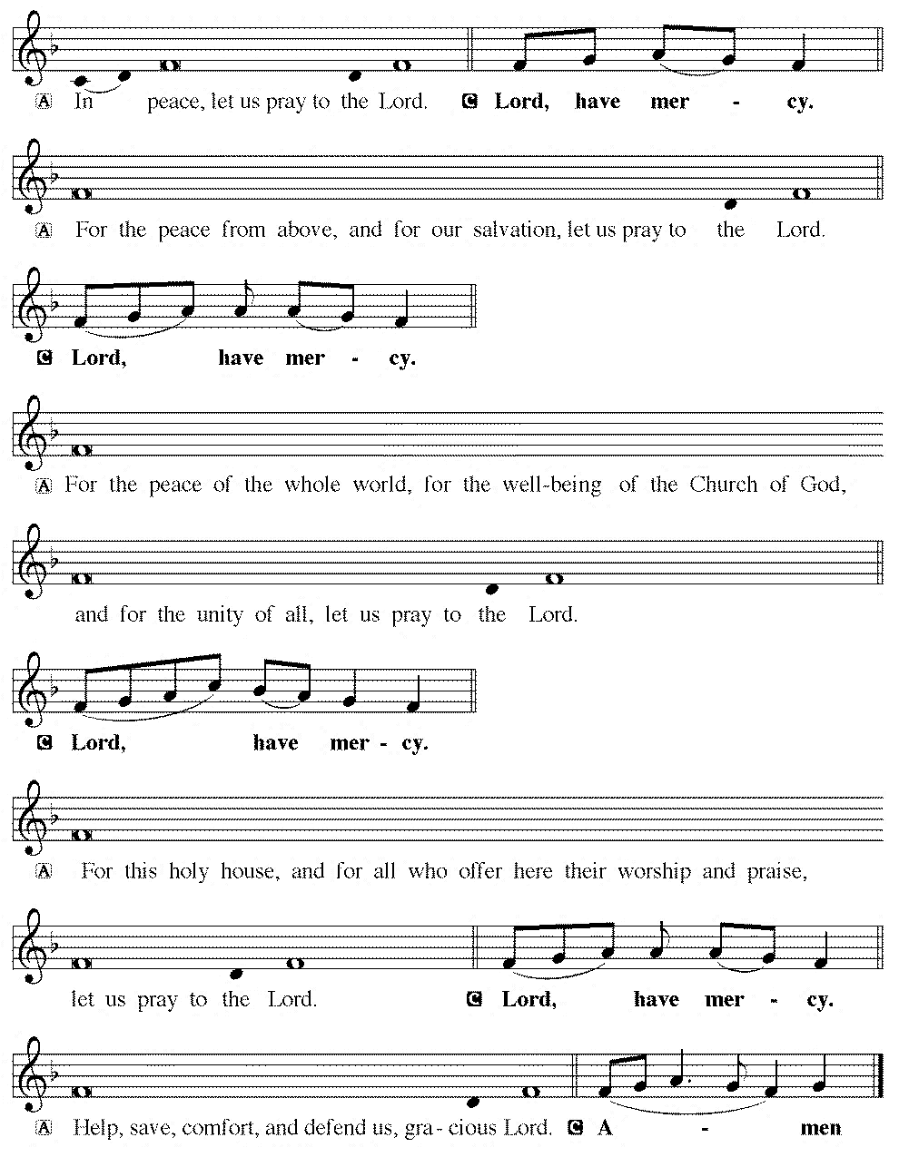

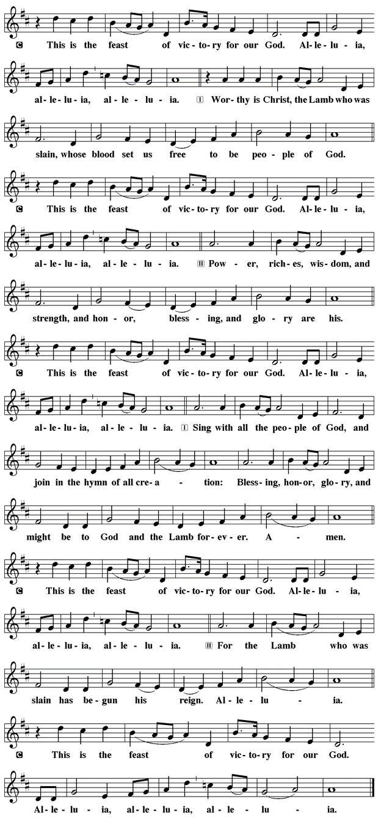
*Prayer of the Day

The Lord be with you.
And also with you.

Let us pray.

God of all peoples, your arms reach out to embrace all those who call upon you. Teach us as disciples of your Son to love the world with compassion and constancy, that your name may be known throughout the earth, through Jesus Christ, our Savior and Lord.
Amen.

First Lesson: Isaiah 56:1, 6-8
The prophet calls upon Israel to do justice in view of God’s imminent intervention to save. Righteousness and obedience define who belongs to the Israelite community—not race, nationality, or any other category.
¹ Thus says the Lord: Maintain justice, and do what is right, for soon my salvation will come and my deliverance be revealed.
⁶ And the foreigners who join themselves to the Lord, to minister to him, to love the name of the Lord, and to be his servants, all who keep the Sabbath and do not profane it and hold fast my covenant—⁷ these I will bring to my holy mountain and make them joyful in my house of prayer; their burnt offerings and their sacrifices will be accepted on my altar, for my house shall be called a house of prayer for all peoples. ⁸ Thus says the Lord God, who gathers the outcasts of Israel:
I will gather others to them besides those already gathered.
Word of God, Word of life.
Thanks be to God.

Psalm 67 Read Responsively

¹ May God be merciful to us and bless us; may the light of God’s face shine upon us.
² Let your way be known upon earth, your saving health among all nations.
³ Let the peoples praise you, O God; let all the peoples praise you.
⁴ Let the nations be glad and sing for joy, for you judge the peoples with equity and guide all the nations on earth.
⁵ Let the peoples praise you, O God; let all the peoples praise you.
⁶ The earth has brought forth its increase; God, our own God, has blessed us.
⁷ May God give us blessing, and may all the ends of the earth stand in awe.

Second Lesson: Romans 11:1-2a, 29-32
God has not rejected Israel. Rather, the call and gifts of God are irrevocable so that, while all have been disobedient, God has mercy upon all.
[Paul writes:] ¹ I ask, then, has God rejected his people? By no means! I myself am an Israelite, a descendant of Abraham, a member of the tribe of Benjamin. ^{2a} God has not rejected his people whom he foreknew.
²⁹ For the gifts and the calling of God are irrevocable. ³⁰ Just as you were once disobedient to God but have now received mercy because of their disobedience, ³¹ so also they have now been disobedient in order that, by the mercy shown to you, they also may now receive mercy. ³² For God has imprisoned all in disobedience so that he may be merciful to all.

Word of God, Word of life.
Thanks be to God.

childrens sermon

*Gospel: Matthew 6:25-34

Glory to you, O Lord.

²⁵ “Therefore I tell you, do not worry about your life, what you will eat or what you will drink, or about your body, what you will wear. Is not life more than food and the body more than clothing? ²⁶ Look at the birds of the air: they neither sow nor reap nor gather into barns, and yet your heavenly Father feeds them. Are you not of more value than they? ²⁷ And which of you by worrying can add a single hour to your span of life? ²⁸ And why do you worry about clothing? Consider the lilies of the field, how they grow; they neither toil nor spin, ²⁹ yet I tell you, even Solomon in all his glory was not clothed like one of these. ³⁰ But if God so clothes the grass of the field, which is alive today and tomorrow is thrown into the oven, will he not much more clothe you—you of little faith? ³¹ Therefore do not worry, saying, ‘What will we eat?’ or ‘What will we drink?’ or ‘What will we wear?’ ³² For it is the gentiles who seek all these things, and indeed your heavenly Father knows that you need all these things. ³³ But seek first the kingdom of God and his righteousness, and all these things will be given to you as well.
³⁴ “So do not worry about tomorrow, for tomorrow will bring worries of its own. Today’s trouble is enough for today.
The Gospel of our Lord

Praise to you, O Christ.

Sermon pastor GARY GRINVALDS

HYMN OF THE DAY ELW 733
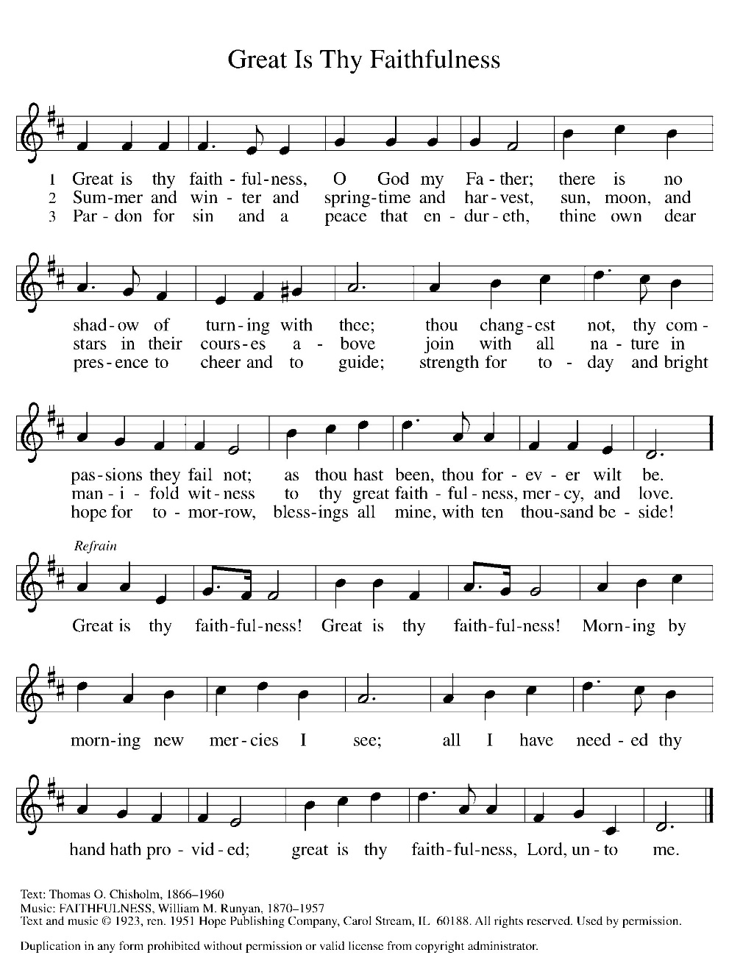

*NICENE CREED
We believe in one God,
the Father, the Almighty,
maker of heaven and earth,
of all that is, seen and unseen.
We believe in one Lord, Jesus Christ,
the only Son of God,
eternally begotten of the Father,
God from God, Light from Light,
true God from true God,
begotten, not made,
of one Being with the Father;
through him all things were made.
For us and for our salvation
he came down from heaven,
was incarnate of the Holy Spirit and the virgin Mary,
and became truly man.
For our sake he was crucified under Pontius Pilate;
he suffered death and was buried.
On the third day he rose again
in accordance with the scriptures;
he ascended into heaven
and is seated at the right hand of the Father.
He will come again in glory to judge the living and the dead, and his kingdom will have no end.
We believe in the Holy Spirit, the Lord, the giver of life,
who proceeds from the Father and the Son,
who with the Father and the Son is worshiped and glorified, who has spoken through the prophets.
We believe in one holy catholic and apostolic church.
We acknowledge one baptism for the forgiveness of sins.
We look for the resurrection of the dead,
and the life of the world to come. Amen.

*The Prayers
With bold trust in God’s unfailing provision, we pray for the church, those in need, and all of God’s creation.
A brief silence.
For believers around the world who stream to your holy mountain, that all be united in faith and harmony in the body of Christ. Let your church on earth be a witness to the beloved community of your heavenly kingdom. Merciful God,
receive our prayer.
For your wondrous creation, that it thrives and flourishes as you intend. Raise up wise stewards to defend the natural world against carelessness and destruction. Safeguard endangered species and their habitats. Merciful God,
receive our prayer.
For the nations of the world and all in authority, that they heed the cry of the outcast and ensure care for the most vulnerable. Give wisdom to leaders of countries, congregations, and communities, that they lead and serve justly. Merciful God,
receive our prayer.
For all who are lonely, grieving, or struggling with chronic pain, that they find comfort, community, and hope. Send relief to all who struggle with illness of any kind. Merciful God,
receive our prayer.
For this congregation, for visitors and those new to this faith community, that all may recognize the presence of Christ in each new face. Draw this community together in love and strengthen it in unwavering faith. Merciful God,
receive our prayer.
For the saints before us whose work is done, that their faithful example continues to direct your church. May their witness remind us that your gifts and calling are irrevocable, whether in life or death. Merciful God,
receive our prayer.
Receive our prayers and answer, O God, as you have promised. All this we ask in the name of your Son, Jesus Christ our Lord.
Amen.

*Peace
The peace of the Lord be with you always.
And also with you.

OFFERING

*Offertory

*Offertory Prayer

Loving God,
we offer at your table the gifts of our hearts.
Help us take heart in you and share freely of your love,
so that all creation can taste your abundance.
We ask this in the name of Jesus,
through the Spirit abiding with us now and forever.
Amen.
*Dialogue

The Lord be with you.
And also with you.

Lift up your hearts.
We lift them to the Lord.

Let us give thanks to the Lord our God.
It is right to give our thanks and praise

*Preface

It is indeed right, our duty and our joy,
that we should at all times and in all places
give thanks and praise to you, almighty and merciful God,
through our Savior Jesus Christ;
who on this day overcame death and the grave,
and by his glorious resurrection opened to us the way of everlasting life.
And so, with all the choirs of angels,
with the church on earth and the hosts of heaven,
we praise your name and join their unending hymn:

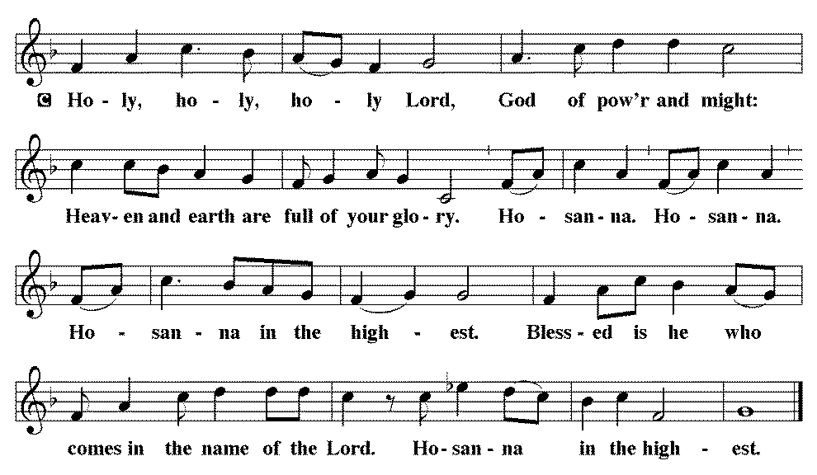

*THE GREAT Thanksgiving
You are indeed holy, almighty and merciful God.
You are most holy, and great is the majesty of your glory.

You so loved the world that you gave your only Son,
so that everyone who believes in him may not perish
but have eternal life.

We give you thanks for his coming into the world to fulfill for us your holy will and to accomplish all things for our salvation.

In the night in which he was betrayed,
our Lord Jesus took bread, and gave thanks;
broke it, and gave it to his disciples, saying:
Take and eat; this is my body, given for you.
Do this for the remembrance of me.

Again, after supper, he took the cup, gave thanks,
and gave it for all to drink, saying:
This cup is the new covenant in my blood,
shed for you and for all people for the forgiveness of sin.
Do this for the remembrance of me.

For as often as we eat of this bread and drink from this cup,
we proclaim the Lord’s death until he comes.
Christ has died. Christ is risen. Christ will come again.

Remembering, therefore, his salutary command, his life-giving passion and death, his glorious resurrection and ascension, and the promise of his coming again, we give thanks to you, O Lord God Almighty, not as we ought but as we are able;
we ask you mercifully to accept our praise and thanksgiving
and with your Word and Holy Spirit to bless us, your servants,
and these your own gifts of bread and wine,
so that we and all who share in the body and blood of Christ
may be filled with heavenly blessing and grace,
and, receiving the forgiveness of sin,
may be formed to live as your holy people
and be given our inheritance with all your saints.
To you, O God, Father, Son, and Holy Spirit,
be all honor and glory in your holy church, now and forever.
Amen.

*Lord's Prayer

Our Father, who art in heaven, hallowed be thy name,
thy kingdom come,
thy will be done,
on earth as it is in heaven.
Give us this day our daily bread;
and forgive us our trespasses,
as we forgive those
who trespass against us;
and lead us not into temptation,
but deliver us from evil.
For thine is the kingdom,
and the power, and the glory,
forever and ever. Amen.

*INVITATION TO HOLY COMMUNION

Heaven has come near.
Come, share in the feast!

AGNUS DEI (Lamb of God) ~ HOLY Communion 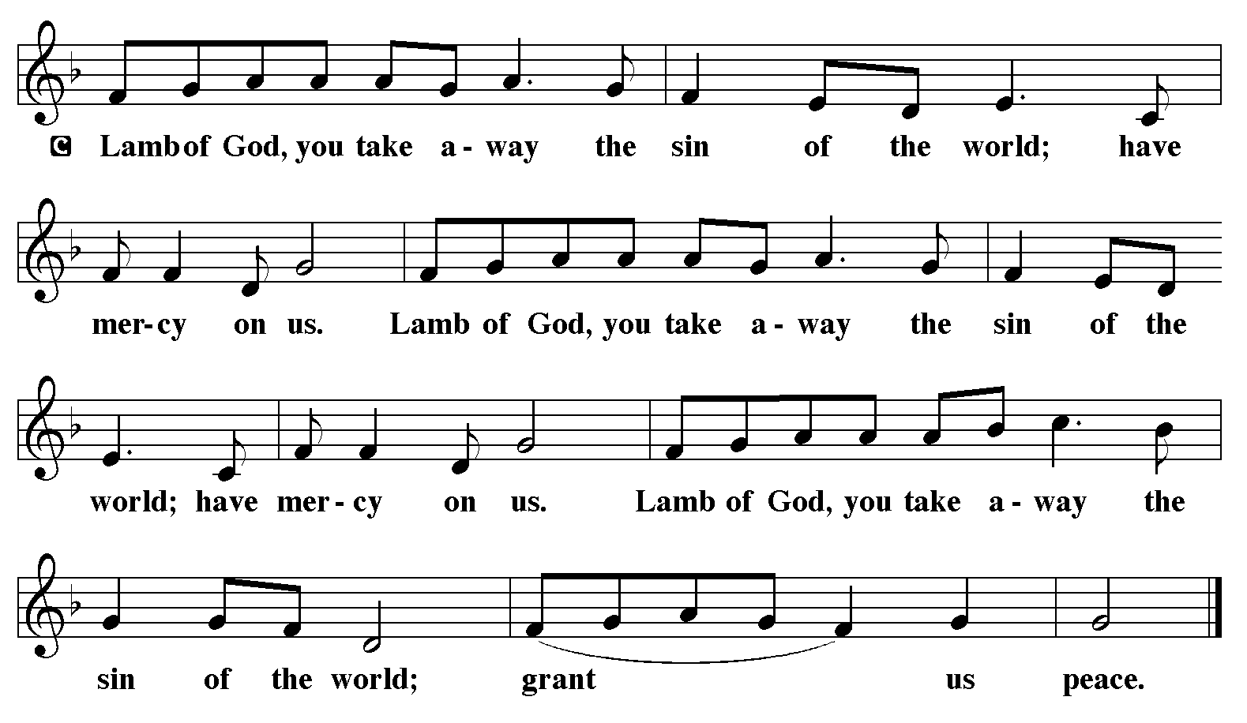
COMMUNION HYMN ELW 742
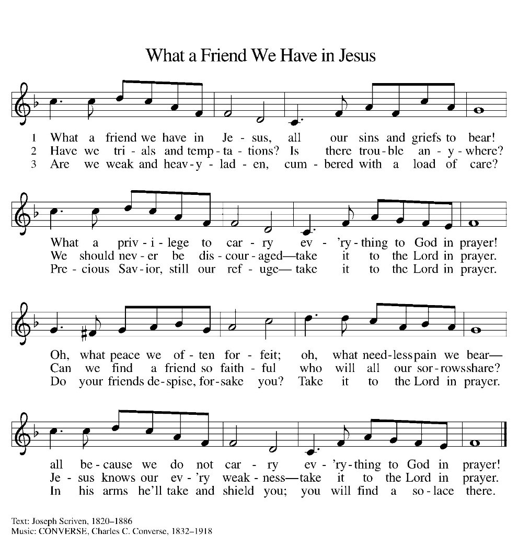
*BLESSING
May the body and blood of our Lord Jesus Christ strengthen you and keep you in his grace.
Amen

*Canticle
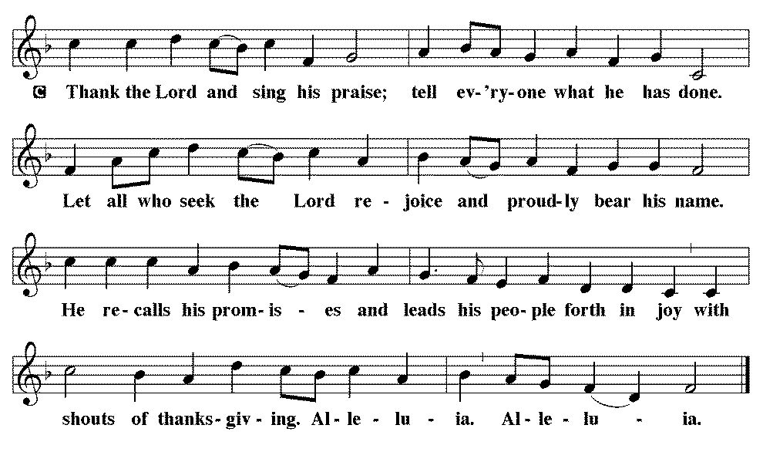

*Prayer after communion

Compassionate God,
through the gifts of bread and wine
our hearts are filled with the abundance of your love.
Strengthen us that we, through this holy meal,
may share your love freely, as you have shared with us.
We ask this in the name of Jesus,
through the Spirit nourishing us now and forever.
Amen.
*Blessing

Father, Son and Holy Spirit,
☩ one God,
bless, heal, and hold you today and always.
Amen.

SENDING HYMN WOV 778
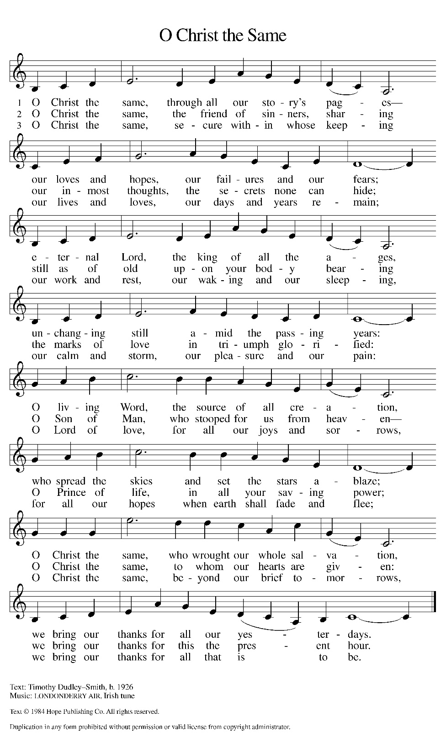
*Dismissal

Heaven has come near. Go, share the good news!
Thanks be to God.

From sundaysandseasons.com. Copyright © 2017 Augsburg Fortress. All rights reserved. Reprinted with permission OneLicenses.net #A-722514.

ANNOUNCEMENTS

Reminder of church coffee at 10 a.m. this Tuesday, August 18

Bible Study at 6:00 this Thursday, August 20

Today, August 16th – Sundae Fun Day from 3-5 sponsored by LYF. Free will donation.

Chad Barnhill will be in the area on Wednesday, August 19 and Thursday, August 20. We have a list of several people interested in having their pianos tuned. If you are interested but have not contacted a council member, please do so as soon as possible. The cost is approximately $150.

If you have a favorite hymn you would like to sing during a future church service, please complete one of the cards on the table in the fellowship hall and place it in the basket provided.

There are sign up sheets on the table in the entryway for the classes that Pastor is offering to the congregation. If you are interested in any of these, please sign up. There are also descriptions of each class beneath the sign up sheet.

Upcoming Community coffees are as follows:
August 21—Wymore Food Pantry at Park Lodge
August 28—KWBE at Park Lodge
September 4—Wymore Library

Remembered in Our Prayers:
Blake Barg Jennifer Cohorst Kent Hohensee
Kathleen Remmers Eric Riley Kai Spann

Pastor Gary: Phone: (402) 658-2253
Email: garygrinvalds@gmail.com
If you wish to have Pastor visit you, please contact him to set up a time. Sunday afternoon & Thursday are his open days.

Your Council leaders are:
President: Josh Schmidt (402) 520-0950
Vice President: Chavonn Mailahn (308) 214-0039
Secretary: Rachel Frerichs (402) 239-0466
At Large: Roger Henrichs (402) 239-7740
Erin Saathoff (402) 239-9117
Jodi Wegner (402) 223-8263
Council meetings are now held on the 3rd Thursday of each month after Bible Study.

Church Account Balance: 07/31/2026: $53,458.94
Church Offerings: 08/02/2026: $ 915.00
08/09/2026: $ 1,272.00

Attendance: 08/09/2026: 32

August Birthdays Anniversaries
17-Lennon Frerichs 15-Darin&Betsy Frerichs
22-Dyan Allinton
27-Darla Acton
28-Larry Frerichs 28-Dustin&Jodi Wegner
28-Shelby Saathoff 29-Caleb&Lindsey McKeever

Please have any announcements for the bulletin to Pam by Wednesday noon each week. You may text or call her at
(402) 239-2715 or send an email to the church at oursaviorslutheranwymore@gmail.com. Thank you.

