Sunday, September 20, 2026
17th Sunday of Pentecost

Our Savior’s Lutheran Church
Website: oursaviorswymore.com
8:00 AM Worship 9:00 AM Fellowship
Faith Formation 5:30 PM Wednesdays

Pastor Gary Grinvalds

Organist: Alice Meints or Sandy Eltiste

Introduction to the day
Matthew narrates one of Jesus’ controversial parables in which Jesus says that the reign of God is like that of a landowner who pays his workers the same wage no matter what time of day they began to work. When God changes God’s mind about punishing Nineveh for their evil ways, Jonah is angry. Yet God is gracious and merciful, abounding in steadfast love. In baptism we receive the grace of God that is freely given to all. As Martin Luther wrote, in the presence of God’s mercy we are all beggars.

*Please Stand
Congregational responses in bold print

WELCOME AND ANNOUNCEMENTS

*Brief order for CONFESSION AND FORGIVENESS

Blessed be the holy Trinity, ☩ one God,
who pours love into our hearts
and healing upon the earth.
Amen.
Confident that God justifies us by grace through faith,
let us confess our sin.
Silence is kept for reflection.
Compassionate God,
we confess that we struggle to embody your goodness
in the world and in our own hearts.
Creation groans from overuse.
Jealousy and bitterness strain our relationships.
Indifference keeps us from seeking justice.
Divisions disrupt your call to show genuine love
to others.
Turn our hearts back to you.
Restore our world and reconcile us to one another.
Renew us to live as your holy people,
following the way of Jesus Christ.
Amen.
Hear this good news:
We have peace with God through ☩ Jesus Christ,
in whom there is no condemnation,
but only forgiveness and the promise of eternal life.
Receive freely this healing gift of grace.
Amen.

*Entrance Hymn ELW 456
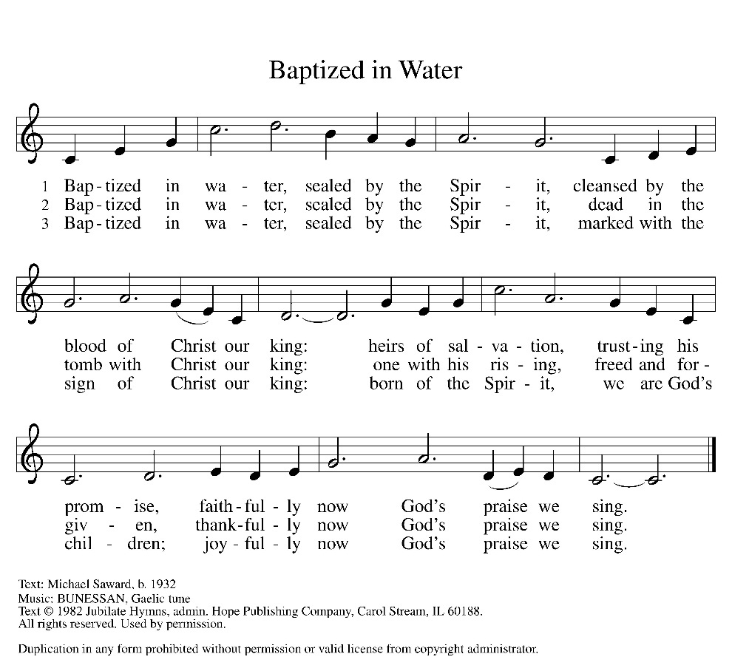

HOLY BAPTISM OF KOLLYNS KAY JOHNSON
PRESENTATION
(Candidates for baptism, sponsors, and parents gather with the minister at the font. The assembly is seated.)
God, who is rich in mercy and love, gives us a new birth into a living hope through the sacrament of baptism. By water and the Word God delivers us from sin and death and raises us to new life in Jesus Christ. We are united with all the baptized in the one body of Christ, anointed with the gift of the Holy Spirit, and joined in God's mission for the life of the world.

Sponsors present the candidate:
I present Kollyns Kay Johnson for baptism.

The presiding minister addresses parents:
Called by the Holy Spirit, trusting in the grace and love of God, do you desire to have Kollyns Kay baptized into Christ?
Response: I do.

As you bring Kollyns Kay to receive the gift of baptism, you are entrusted with responsibilities:
to live with her among God's faithful people,
bring her to the word of God and the holy supper,
teach her the Lord's Prayer, the Creed, and the Ten Commandments,
place in her hands the holy scriptures,
and nurture her in faith and prayer,
so that she may learn to trust God,
proclaim Christ through word and deed,
care for others and the world God made,
and work for justice and peace.
Do you promise to help Kollyns Kay grow in the Christian faith and life?
Response: I do.

The presiding minister addresses sponsors:
Sponsors, do you promise to nurture Kollyns Kay in the Christian faith as you are empowered by God's Spirit, and to help her live in the covenant of baptism and in communion with the church?
Response: I do.

The presiding minister addresses the assembly:
People of God, do you promise to support Kollyns Kay and pray for her in her new life in Christ?
We do.

*Profession of Faith
I ask you to profess your faith in Christ Jesus, reject sin, and confess the faith of the church.
Do you renounce the devil and all the forces that defy God?
Response: I renounce them.

Do you renounce the powers of this world that rebel against God?
Response: I renounce them.

Do you renounce the ways of sin that draw you from God?
Response: I renounce them.

Do you believe in God the Father?
I believe in God, the Father almighty,
creator of heaven and earth.
Do you believe in Jesus Christ, the Son of God?
I believe in Jesus Christ, God’s only Son, our Lord,
who was conceived by the Holy Spirit,
born of the virgin Mary,
suffered under Pontius Pilate,
was crucified, died, and was buried;
he descended to the dead.
On the third day he rose again;
he ascended into heaven,
he is seated at the right hand of the Father,
and he will come to judge the living and the dead.

Do you believe in God the Holy Spirit?
I believe in the Holy Spirit,
the holy catholic church,
the communion of saints,
the forgiveness of sins,
the resurrection of the body,
and the life everlasting.

*Thanksgiving at the Font

The Lord be with you.
And also with you.

Let us give thanks to the Lord our God.
It is right to give our thanks and praise.

We give you thanks, O God, for in the beginning your Spirit moved over the waters and by your Word you created the world, calling forth life in which you took delight. Through the waters of the flood you delivered Noah and his family, and through the sea you led your people Israel from slavery into freedom. At the river your Son was baptized by John and anointed with the Holy Spirit. By the baptism of Jesus' death and resurrection you set us free from the power of sin and death and raise us up to live in you.
Pour out your Holy Spirit, the power of your living Word, that those who are washed in the waters of baptism may be given new life. To you be given honor and praise through Jesus Christ our Lord, in the unity of the Holy Spirit, now and forever.
Amen.

Baptism

Kollyns Kay Johnson, I baptize you in the name of the Father,
and of the Son,
and of the Holy Spirit.
Amen.

Let us pray.
We give you thanks, O God, that through water and the Holy Spirit you give your daughters and sons new birth, cleanse them from sin, and raise them to eternal life.

Laying both hands on the head of the newly baptized, the minister prays:
Sustain Kollyns Kay with the gift of your Holy Spirit: the spirit of wisdom and understanding, the spirit of counsel and might, the spirit of knowledge and the fear of the Lord, the spirit of joy in your presence, both now and forever.
Amen.

The presiding minister marks the sign of the cross on the forehead of the baptized. As the sign of the cross is made, the minister says:
Kollyns Kay , child of God, you have been sealed by the Holy Spirit and marked with the cross of Christ forever.
Amen.

Welcome
A lighted candle may be given to a sponsor of a young child as a representative of the congregation says:
Jesus said, I am the light of the world.
Whoever follows me
will have the light of life.

The ministers and the baptismal group face the assembly. A representative of the congregation leads the assembly in the welcome.
Let us welcome the newly baptized.
We welcome you into the body of Christ and into the mission we share:
join us in giving thanks and praise to God and bearing God's creative and redeeming word to all the world.

First Lesson: Jonah 3:10---4:11
¹⁰ When God saw what [the people of Ninevah] did, how they turned from their evil ways, God changed his mind about the calamity that he had said he would bring upon them, and he did not do it.
^{4:1} But this was very displeasing to Jonah, and he became angry. ² He prayed to the Lord and said, “O Lord! Is not this what I said while I was still in my own country? That is why I fled to Tarshish at the beginning, for I knew that you are a gracious and merciful God, slow to anger, abounding in steadfast love, and relenting from punishment. ³ And now, O Lord, please take my life from me, for it is better for me to die than to live.” ⁴ And the Lord said, “Is it right for you to be angry?” ⁵ Then Jonah went out of the city and sat down east of the city and made a booth for himself there. He sat under it in the shade, waiting to see what would become of the city.
⁶ The Lord God appointed a bush and made it come up over Jonah, to give shade over his head, to save him from his discomfort, so Jonah was very happy about the bush. ⁷ But when dawn came up the next day, God appointed a worm that attacked the bush, so that it withered. ⁸ When the sun rose, God prepared a sultry east wind, and the sun beat down on the head of Jonah so that he was faint and asked that he might die. He said, “It is better for me to die than to live.”
⁹ But God said to Jonah, “Is it right for you to be angry about the bush?” And he said, “Yes, angry enough to die.” ¹⁰ Then the Lord said, “You are concerned about the bush, for which you did not labor and which you did not grow; it came into being in a night and perished in a night. ¹¹ And should I not be concerned about Nineveh, that great city, in which there are more than a hundred and twenty thousand persons who do not know their right hand from their left and also many animals?”
Word of God, Word of life.
Thanks be to God.

Psalm 145:1-8 Read Responsively

¹ I will exalt you, my God and king, and bless your name forever and ever.
² Every day will I bless you and praise your name forever and ever.
³ Great is the Lord and greatly to be praised! There is no end to your greatness.
⁴ One generation shall praise your works to another and shall declare your power.
⁵ I will speak of the glorious splendor of your majesty and all your marvelous works.
⁶ They shall tell of the might of your wondrous acts, and I will recount your greatness.
⁷ They shall publish the remembrance of your great goodness; they shall sing joyfully of your righteousness.
⁸ The Lord is gracious and full of compassion, slow to anger and abounding in steadfast love.

Second Lesson: Philippians 1:21-30
²¹ For to me, living is Christ and dying is gain. ²² If I am to live in the flesh, that means fruitful labor for me, yet I cannot say which I will choose. ²³ I am hard pressed between the two: my desire is to depart and be with Christ, for that is far better, ²⁴ but to remain in the flesh is more necessary for you. ²⁵ Since I am convinced of this, I know that I will remain and continue with all of you for your progress and joy in faith, ²⁶ so that, by my presence again with you, your boast might abound in Christ Jesus because of me.
²⁷ Only, live your life in a manner worthy of the gospel of Christ, so that, whether I come and see you or am absent and hear about you, I will know that you are standing firm in one spirit, striving side by side with one mind for the faith of the gospel ²⁸ and in no way frightened by those opposing you. For them, this is evidence of their destruction but of your salvation. And this is God’s doing. ²⁹ For he has graciously granted you the privilege not only of believing in Christ but of suffering for him as well, ³⁰ since you are having the same struggle that you saw I had and now hear that I still have.

Word of God, Word of life.
Thanks be to God.

childrens sermon

*Sermon Text: 1 Corinthians 11:17-34
¹⁷ Now in the following instructions I do not commend you, because when you come together it is not for the better but for the worse. ¹⁸ For, to begin with, when you come together as a church, I hear that there are divisions among you, and to some extent I believe it. ¹⁹ Indeed, there have to be factions among you, for only so will it become clear who among you are genuine. ²⁰ When you come together, it is not really to eat the Lord’s supper. ²¹ For when the time comes to eat, each of you proceeds to eat your own supper, and one goes hungry and another becomes drunk. ²² What! Do you not have households to eat and drink in? Or do you show contempt for the church of God and humiliate those who have nothing? What should I say to you? Should I commend you? In this matter I do not commend you!
²³ For I received from the Lord what I also handed on to you, that the Lord Jesus on the night when he was betrayed took a loaf of bread, ²⁴ and when he had given thanks, he broke it and said, “This is my body that is for you. Do this in remembrance of me.” ²⁵ In the same way he took the cup also, after supper, saying, “This cup is the new covenant in my blood. Do this, as often as you drink it, in remembrance of me.” ²⁶ For as often as you eat this bread and drink the cup, you proclaim the Lord’s death until he comes.
²⁷ Whoever, therefore, eats the bread or drinks the cup of the Lord in an unworthy manner will be answerable for the body and blood of the Lord. ²⁸ Examine yourselves, and only then eat of the bread and drink of the cup. ²⁹ For all who eat and drink without discerning the body eat and drink judgment against themselves. ³⁰ For this reason many of you are weak and ill, and some have died. ³¹ But if we judged ourselves, we would not be judged. ³² But when we are judged by the Lord, we are disciplined so that we may not be condemned along with the world.
³³ So then, my brothers and sisters, when you come together to eat, wait for one another. ³⁴ If you are hungry, eat at home, so that when you come together, it will not be for your condemnation. About the other things I will give instructions when I come.
Word of God, Word of life.
Thanks be to God.

Sermon pastor GARY GRINVALDS

HYMN OF THE DAY ELW 471
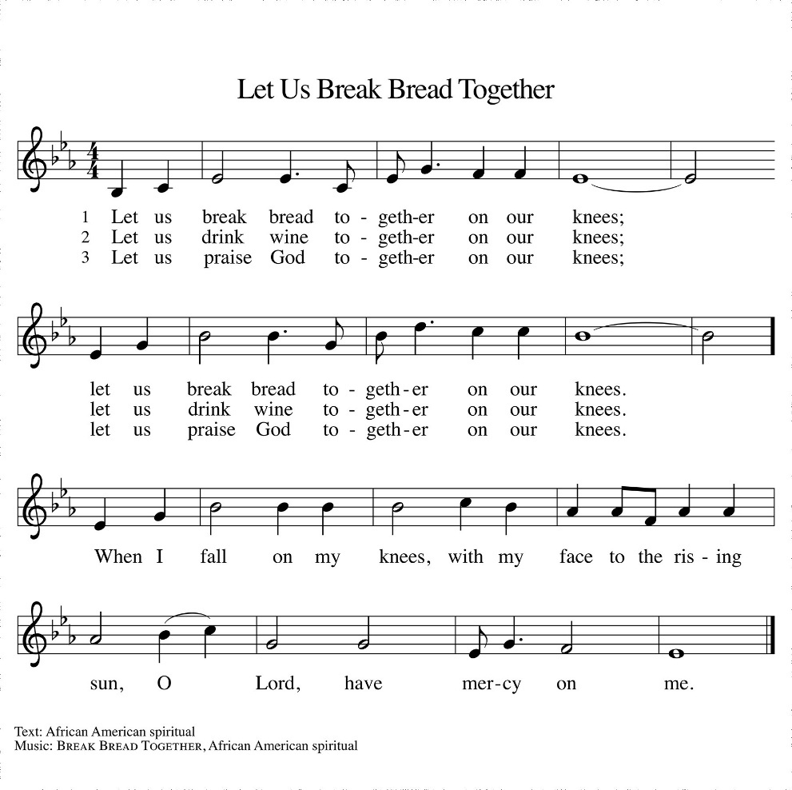

*The Prayers
Reminded of God’s gracious and abundant love, we offer our prayers, confident that God hears us.
A brief silence.
Hold your church accountable for our unwillingness to share your good news and our anger at your generosity to others. Nourish us by your grace to be witnesses to your love. Hear us, O God.
Your mercy is great.
Guide scientists and researchers studying responses to the climate crisis so that all your creation may inspire us to give thanks for your great goodness. Hear us, O God.
Your mercy is great.
Show employers the benefits of equal pay standards for all their employees. Reconcile conflicts between employees. Fill places of employment with camaraderie, and bring an end to employment disparity. Hear us, O God.
Your mercy is great.
Encourage any who cannot work or who cannot work a full day with the truth that their value comes from your everlasting love for them. Provide for those who are injured, ill, and for all in any need. Hear us, O God.
Your mercy is great.
Strengthen all those in this congregation whose labor serves the needs of others in the community. Inspire all in this congregation to support community endeavors with our time and talents.
Hear us, O God.
Your mercy is great.
Comfort us with the promise of the resurrection as we remember all our loved ones whose desire to be with Jesus is fulfilled. Hear us, O God.
Your mercy is great.
Grant the prayers we have offered, what we have forgotten to ask, and whatever else you see that we need. We ask this in Jesus’ name.
Amen.

*Peace
The peace of the Lord be with you always.
And also with you.

OFFERING

*Offertory Sing Verses 2&3

*Offertory Prayer

God of creation,
you send rain and the earth springs forth abundantly.
All blessings are from you;
make us generous with what we have.
Use our gifts, our abilities, and our hearts
in service to you and in love to our neighbors,
today and always.
Amen.
*Dialogue

The Lord be with you.
And also with you.

Lift up your hearts.
We lift them to the Lord.

Let us give thanks to the Lord our God.
It is right to give our thanks and praise

*Preface

It is indeed right, our duty and our joy,
that we should at all times and in all places
give thanks and praise to you, almighty and merciful God,
through our Savior Jesus Christ;
who on this day overcame death and the grave,
and by his glorious resurrection opened to us the way of everlasting life.
And so, with all the choirs of angels,
with the church on earth and the hosts of heaven,
we praise your name and join their unending hymn:

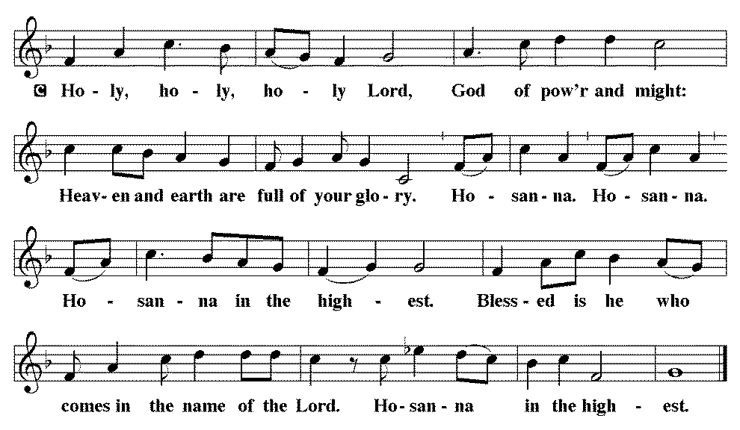

*THE GREAT Thanksgiving
You are indeed holy, almighty and merciful God.
You are most holy, and great is the majesty of your glory.

You so loved the world that you gave your only Son,
so that everyone who believes in him may not perish
but have eternal life.

We give you thanks for his coming into the world to fulfill for us your holy will and to accomplish all things for our salvation.

In the night in which he was betrayed,
our Lord Jesus took bread, and gave thanks;
broke it, and gave it to his disciples, saying:
Take and eat; this is my body, given for you.
Do this for the remembrance of me.

Again, after supper, he took the cup, gave thanks,
and gave it for all to drink, saying:
This cup is the new covenant in my blood,
shed for you and for all people for the forgiveness of sin.
Do this for the remembrance of me.

For as often as we eat of this bread and drink from this cup,
we proclaim the Lord’s death until he comes.
Christ has died. Christ is risen. Christ will come again.

Remembering, therefore, his salutary command, his life-giving passion and death, his glorious resurrection and ascension, and the promise of his coming again, we give thanks to you, O Lord God Almighty, not as we ought but as we are able;
we ask you mercifully to accept our praise and thanksgiving
and with your Word and Holy Spirit to bless us, your servants,
and these your own gifts of bread and wine,
so that we and all who share in the body and blood of Christ
may be filled with heavenly blessing and grace,
and, receiving the forgiveness of sin,
may be formed to live as your holy people
and be given our inheritance with all your saints.
To you, O God, Father, Son, and Holy Spirit,
be all honor and glory in your holy church, now and forever.
Amen.

*Lord's Prayer

Our Father, who art in heaven, hallowed be thy name,
thy kingdom come,
thy will be done,
on earth as it is in heaven.
Give us this day our daily bread;
and forgive us our trespasses,
as we forgive those
who trespass against us;
and lead us not into temptation,
but deliver us from evil.
For thine is the kingdom,
and the power, and the glory,
forever and ever. Amen.

*INVITATION TO HOLY COMMUNION

Christ invites you to this table.
All who are thirsty, all who are hungry, come!

Communion will be done differently today. Instead of being served, we will serve each other. Pastor will give instructions before we start. Council members will go first to demonstrate.
Parents, please serve your children.

AGNUS DEI (Lamb of God) ~ HOLY Communion 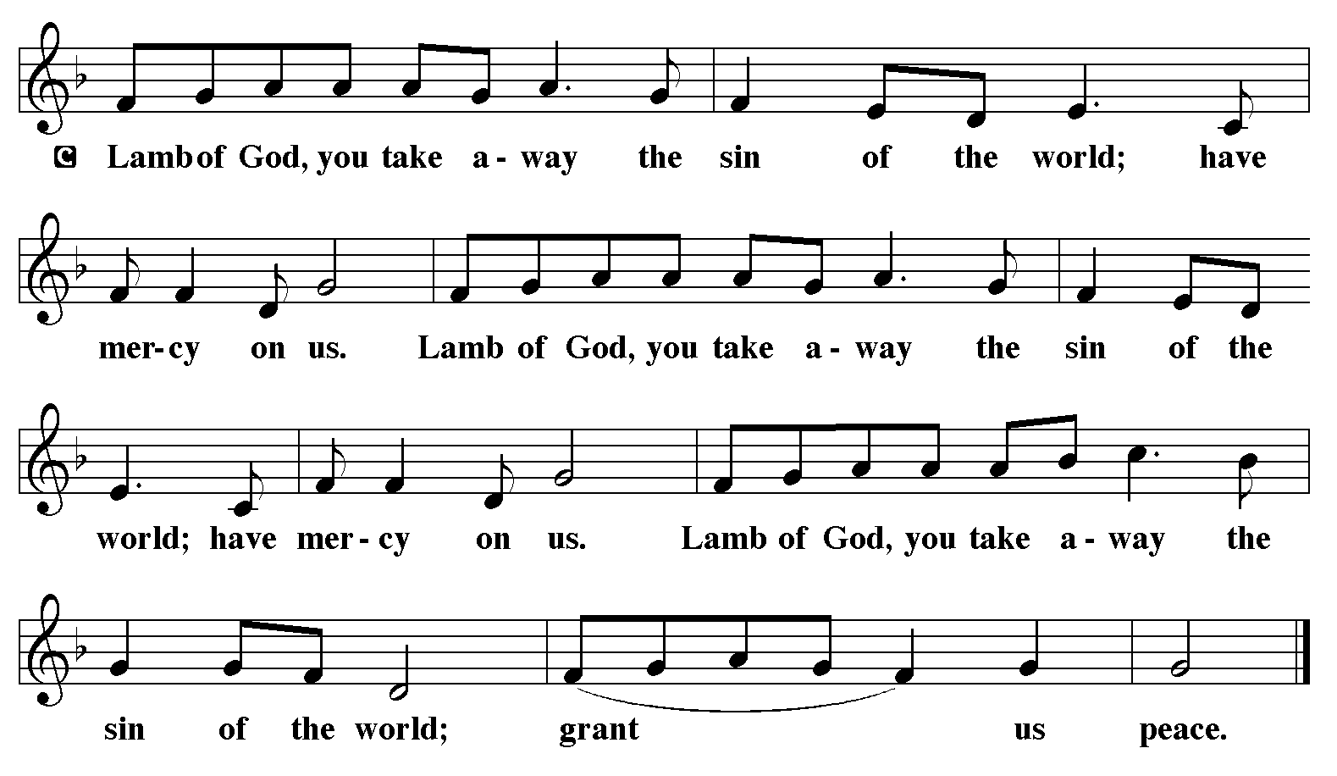

COMMUNION HYMN ELW 482
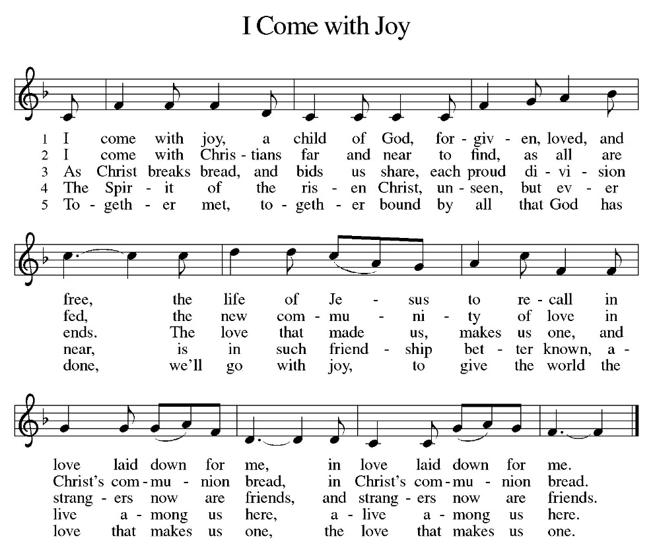
*BLESSING
May the body and blood of our Lord Jesus Christ strengthen you and keep you in his grace.
Amen

*Canticle
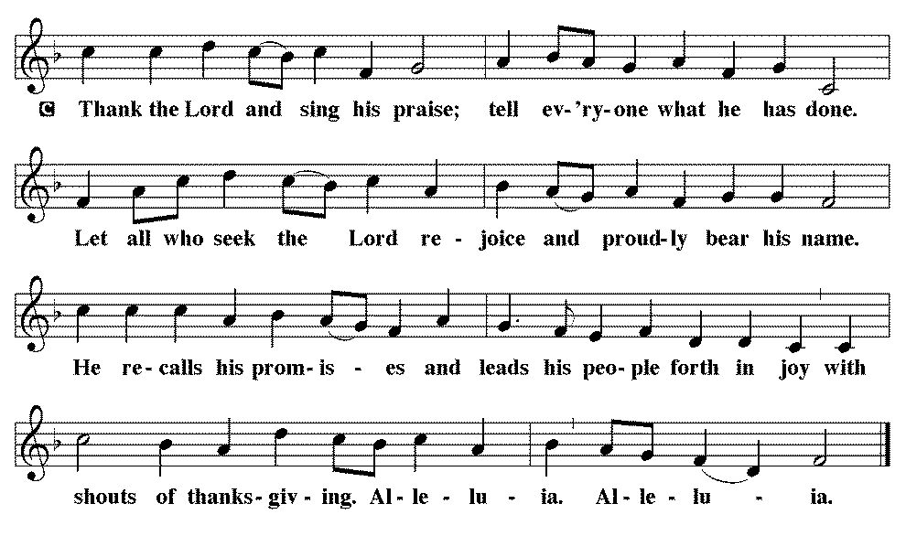

*Prayer after communion

Sustaining God,
with this bread and cup,
you nourish us with mercy and abundant life.
By your Spirit, send us from this table to serve a needy world.
Make us living signs of your liberation, healing, and love,
following the way of Jesus, in whose name we pray.
Amen.

*Blessing

The God of love
draw you into full accord and one mind,
in the body of Christ Jesus. Amen.
The God of hope
grant you strength and joy in all circumstances
through the interceding of the Spirit. Amen.
The God of grace
☩ bless you now and forever. Amen.

SENDING HYMN ELW 543
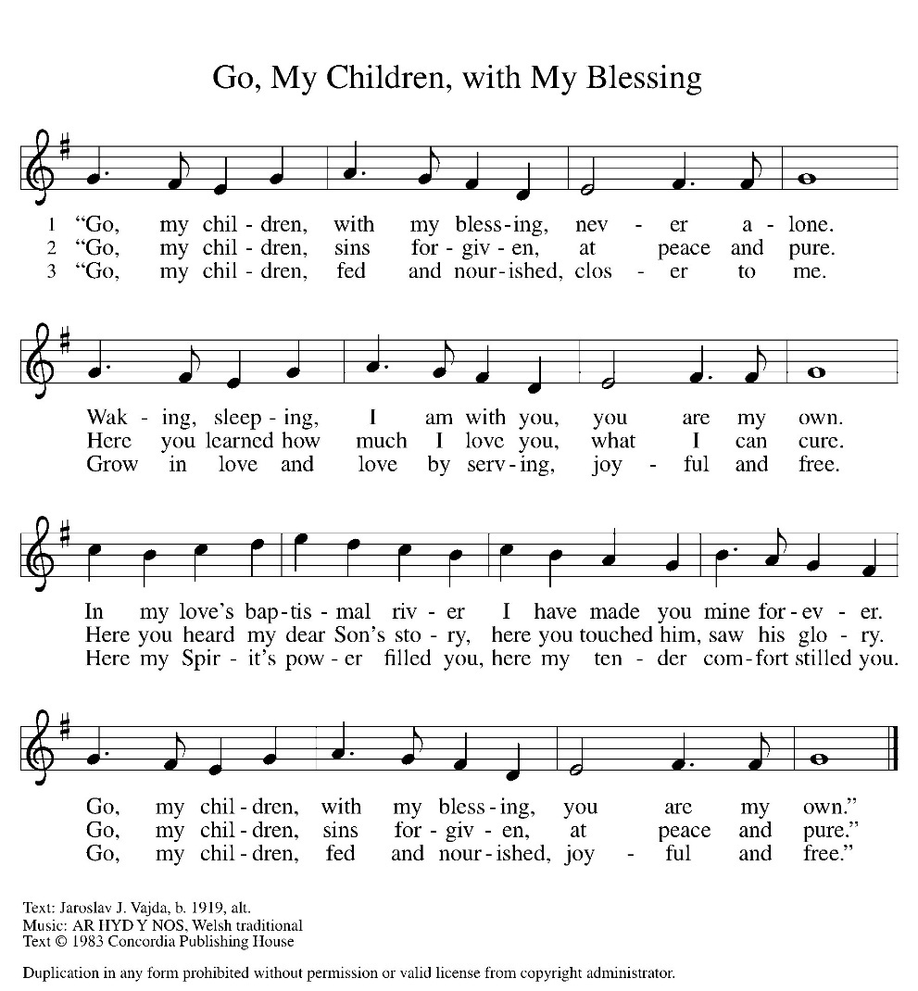
*Dismissal

Go out in joy. Be led forth in peace.
Thanks be to God.

From sundaysandseasons.com. Copyright © 2017 Augsburg Fortress. All rights reserved. Reprinted with permission OneLicenses.net #A-722514.

ANNOUNCEMENTS

September 27, 2026—Trinity Lutheran Church, Hanover 42nd annual “all you can eat” Church Supper from 4-8 p.m. The menu includes grilled ham, BBQ beef, pan fried chicken, scalloped potatoes, corn, green beans, homemade pies, homemade breads and salad bar. Price: Adults -$15, Children 10 and under-$8. Tickets are purchased at the door. Raffle tickets for prizes are being sold in advance by Trinity members and may also be purchased at the door.

October 4, 2026—Fields of Faith will hold their annual event from 6-8 p.m. at the House of Orange Complex, 800 Orange Blvd, Beatrice. It includes a free dinner for all students, live worship band, Student-led prayer & testimonies. The LYF group plans to attend the event. More info to follow.

A suggestion box has been placed on the table in the entry way. Please feel free to put any suggestions or comments for the council in it.

The new sound system has hearing aid assisted listening devices available for use. If you would like to use one, please speak with a council member before the church service.

If you have a favorite hymn you would like to sing during a future church service, please complete one of the cards on the table in the fellowship hall and place it in the basket provided.

There are sign up sheets on the table in the entryway for the classes that Pastor is offering to the congregation. If you are interested in any of these, please sign up. There are also descriptions of each class beneath the sign up sheet.

Upcoming Community coffees are as follows:
September 25—Senior Benefits (Ray Manske) at Park Lodge
October 2—Wymore Library

Remembered in Our Prayers:
Jennifer Cohorst Kent Hohensee Dave Mick
Kathleen Remmers Eric Riley Kai Spann

Pastor Gary: Phone: (402) 658-2253
Email: garygrinvalds@gmail.com
If you wish to have Pastor visit you, please contact him to set up a time. Sunday afternoon & Thursday are his open days.

Your Council leaders are:
President: Josh Schmidt (402) 520-0950
Vice President: Chavonn Mailahn (308) 214-0039
Secretary: Rachel Frerichs (402) 239-0466
At Large: Roger Henrichs (402) 239-7740
Erin Saathoff (402) 239-9117
Jodi Wegner (402) 223-8263
Church Account Balance: 08/31/2026: $51,818.49
Church Offerings: 09/06/2026: $ 456.00
09/13/2026: $

Attendance: 09/13/2026: 38

September Birthdays Anniversaries
19 Seth Saathoff
20 Jacques Smit 20 Jacques & Jamie Smit
21 Mosely Weyer 24 Jason & Dyan Allington
22 Ron Schroeder 26 Gary & Larissa Grinvalds
27 Jaidyn Allington 28 Steve & Shelley Whitwer
30 Jared Epp
30 Rachel Frerichs

Please have any announcements for the bulletin to Pam by Wednesday noon each week. You may text or call her at
(402) 239-2715 or send an email to the church at oursaviorslutheranwymore@gmail.com. Thank you.

