Sunday, October 11, 2026
20th Sunday of Pentecost

Our Savior’s Lutheran Church
Website: oursaviorswymore.com
8:00 AM Worship 9:00 AM Fellowship
Faith Formation 5:30 PM Wednesdays

Pastor Gary Grinvalds

Organist: Alice Meints or Sandy Eltiste

Introduction to the day
In Isaiah we are given a vision of the great feast to come, when God will wipe away death forever. In Jesus’ parable about a great banquet, those invited do not come, so the invitation is extended to others. In our liturgy God spreads a table before us. Even amid anxiety and hardship we rejoice in the peace of God which surpasses all understanding. With great joy we feast at the table of the Lord, and we go forth to share the wonderful invitation with others hungering and thirsting for the abundant life of God.

*Please Stand
Congregational responses in bold print

WELCOME AND ANNOUNCEMENTS

*Brief order for CONFESSION AND FORGIVENESS

Blessed be the holy Trinity, ☩ one God,
who pours love into our hearts
and healing upon the earth.
Amen.
Confident that God justifies us by grace through faith,
let us confess our sin.
Silence is kept for reflection.
Compassionate God,
we confess that we struggle to embody your goodness
in the world and in our own hearts.
Creation groans from overuse.
Jealousy and bitterness strain our relationships.
Indifference keeps us from seeking justice.
Divisions disrupt your call to show genuine love
to others.
Turn our hearts back to you.
Restore our world and reconcile us to one another.
Renew us to live as your holy people,
following the way of Jesus Christ.
Amen.
Hear this good news:
We have peace with God through ☩ Jesus Christ,
in whom there is no condemnation,
but only forgiveness and the promise of eternal life.
Receive freely this healing gift of grace.
Amen.

Entrance Hymn ELW 523
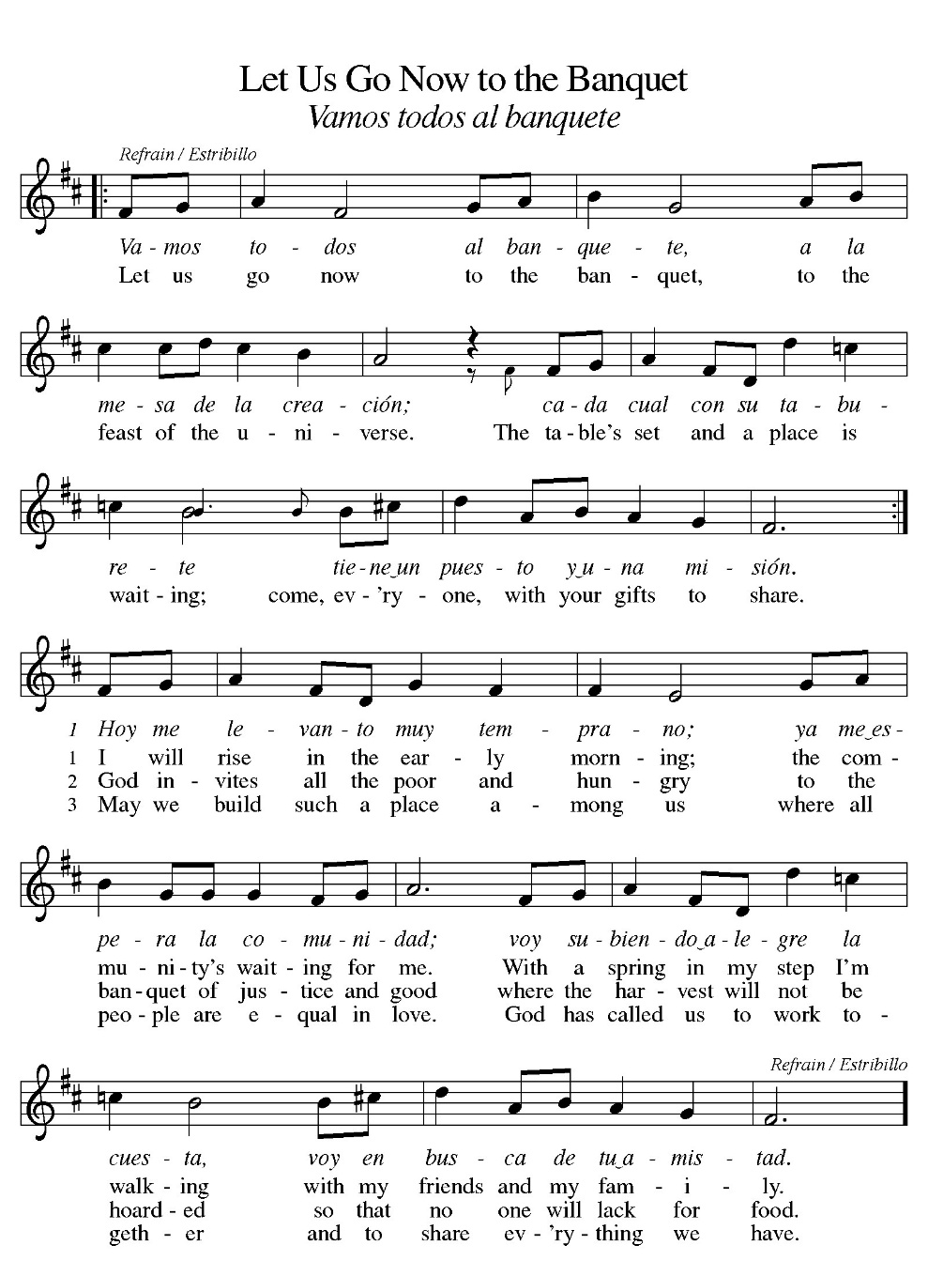

*Blessed are you, O Lord our God, king of the universe,
For in your wisdom you have formed us.
You feed the hungry and clothe the naked,
We bless you and praise your name forever.
You set free those who are bound.
We bless you and praise your name forever.
You raise up those whose courage falters.
We bless you and praise your name forever.
You provide for our every need.
Accept our grateful praises.
You have called us from all peoples.
We rejoice and bless your name forever.
You bless your people with peace.
We bless you and praise your loving grace.
Blessed are you, O Lord our God, king of the universe,
For in your wisdom you have formed us.

*Prayer of the Day

The Lord be with you.
And also with you.

Let us pray.

Lord of the feast, you have prepared a table before all peoples and poured out your life with abundance. Call us again to your banquet. Strengthen us by what is honorable, just, and pure, and transform us into a people of righteousness and peace, through Jesus Christ, our Savior and Lord.
Amen.

HYMN ELW 592
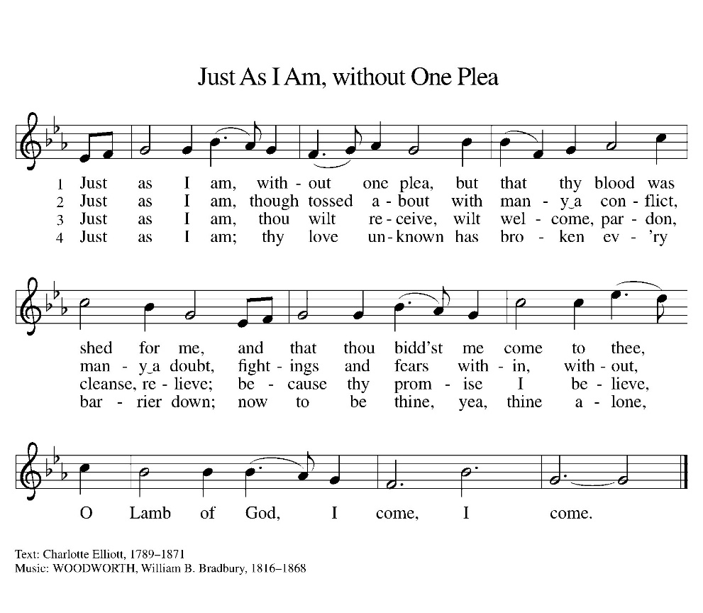

First Lesson: Isaiah 25:1-9
After a hymn of praise acknowledging God as a shelter for the poor, the prophet portrays a wonderful victory banquet at which death—which in ancient Canaan was depicted as a monster swallowing up everyone—will be swallowed up forever. The prophet urges celebration of this victory of salvation.
¹ O Lord, you are my God; I will exalt you; I will praise your name, for you have done wonderful things, plans formed of old, faithful and sure. ² For you have made the city a heap, the fortified city a ruin; the palace of foreigners is a city no more; it will never be rebuilt. ³ Therefore strong peoples will glorify you; cities of ruthless nations will fear you. ⁴ For you have been a refuge to the poor, a refuge to the needy in their distress, a shelter from the rainstorm and a shade from the heat. When the blast of the ruthless was like a winter rainstorm, ⁵ the noise of foreigners like heat in a dry place, you subdued the heat with the shade of clouds; the song of the ruthless was stilled. ⁶ On this mountain the Lord of hosts will make for all peoples a feast of rich food, a feast of well-aged wines, of rich food filled with marrow, of well-aged wines strained clear. ⁷ And he will destroy on this mountain the shroud that is cast over all peoples, the covering that is spread over all nations; ⁸ he will swallow up death forever. Then the Lord God will wipe away the tears from all faces, and the disgrace of his people he will take away from all the earth, for the Lord has spoken. ⁹ It will be said on that day, “See, this is our God; we have waited for him, so that he might save us. This is the Lord for whom we have waited; let us be glad and rejoice in his salvation.”
Word of God, Word of life.
Thanks be to God.

Psalm 23 Read Responsively

¹ The Lord is my shepherd; I shall not be in want.
² The Lord makes me lie down in green pastures and leads me beside still waters.
³ You restore my soul, O Lord, and guide me along right pathways for your name’s sake.
⁴ Though I walk through the valley of the shadow of death, I shall fear no evil; for you are with me; your rod and your staff, they comfort me.
⁵ You prepare a table before me in the presence of my enemies; you anoint my head with oil, and my cup is running over.
⁶ Surely goodness and mercy shall follow me all the days of my life, and I will dwell in the house of the Lord forever.

Second Lesson: Philippians 4:1-9
Though writing from prison and facing an uncertain future, Paul calls on the Philippians to rejoice and give thanks to God no matter what the circumstance. God’s peace is with us and binds together our hearts and minds in Jesus Christ, especially when things around us do not seem peaceful.
¹ My brothers and sisters, whom I love and long for, my joy and crown, stand firm in the Lord in this way, my beloved. ² I urge Euodia and I urge Syntyche to be of the same mind in the Lord. ³ Yes, and I ask you also, my loyal companion, help these women, for they have struggled beside me in the work of the gospel, together with Clement and the rest of my coworkers, whose names are in the book of life. ⁴ Rejoice in the Lord always; again I will say, Rejoice. ⁵ Let your gentleness be known to everyone. The Lord is near. ⁶ Do not be anxious about anything, but in everything by prayer and supplication with thanksgiving let your requests be made known to God. ⁷ And the peace of God, which surpasses all understanding, will guard your hearts and your minds in Christ Jesus. ⁸ Finally, brothers and sisters, whatever is true, whatever is honorable, whatever is just, whatever is pure, whatever is pleasing, whatever is commendable, if there is any excellence and if there is anything worthy of praise, think about these things. ⁹ As for the things that you have learned and received and heard and noticed in me, do them, and the God of peace will be with you.
Word of God, Word of life.
Thanks be to God.

childrens sermon

*Gospel: Matthew 22:1-14

Glory to you, O Lord.

Jesus tells a parable indicating that the blessings of God’s kingdom are available to all, but the invitation is not to be taken lightly.
¹ Once more Jesus spoke to them in parables, saying: ² “The kingdom of heaven may be compared to a king who gave a wedding banquet for his son. ³ He sent his slaves to call those who had been invited to the wedding banquet, but they would not come. ⁴ Again he sent other slaves, saying, ‘Tell those who have been invited: Look, I have prepared my dinner, my oxen and my fat calves have been slaughtered, and everything is ready; come to the wedding banquet.’ ⁵ But they made light of it and went away, one to his farm, another to his business, ⁶ while the rest seized his slaves, mistreated them, and killed them. ⁷ The king was enraged. He sent his troops, destroyed those murderers, and burned their city. ⁸ Then he said to his slaves, ‘The wedding is ready, but those invited were not worthy. ⁹ Go therefore into the main streets, and invite everyone you find to the wedding banquet.’ ¹⁰ Those slaves went out into the streets and gathered all whom they found, both good and bad, so the wedding hall was filled with guests.
¹¹ “But when the king came in to see the guests, he noticed a man there who was not wearing a wedding robe, ¹² and he said to him, ‘Friend, how did you get in here without a wedding robe?’ And he was speechless. ¹³ Then the king said to the attendants, ‘Bind him hand and foot, and throw him into the outer darkness, where there will be weeping and gnashing of teeth.’ ¹⁴ For many are called, but few are chosen.”
The Gospel of our Lord
Praise to you, O Christ.

Sermon pastor GARY GRINVALDS

HYMN OF THE DAY ELW 848
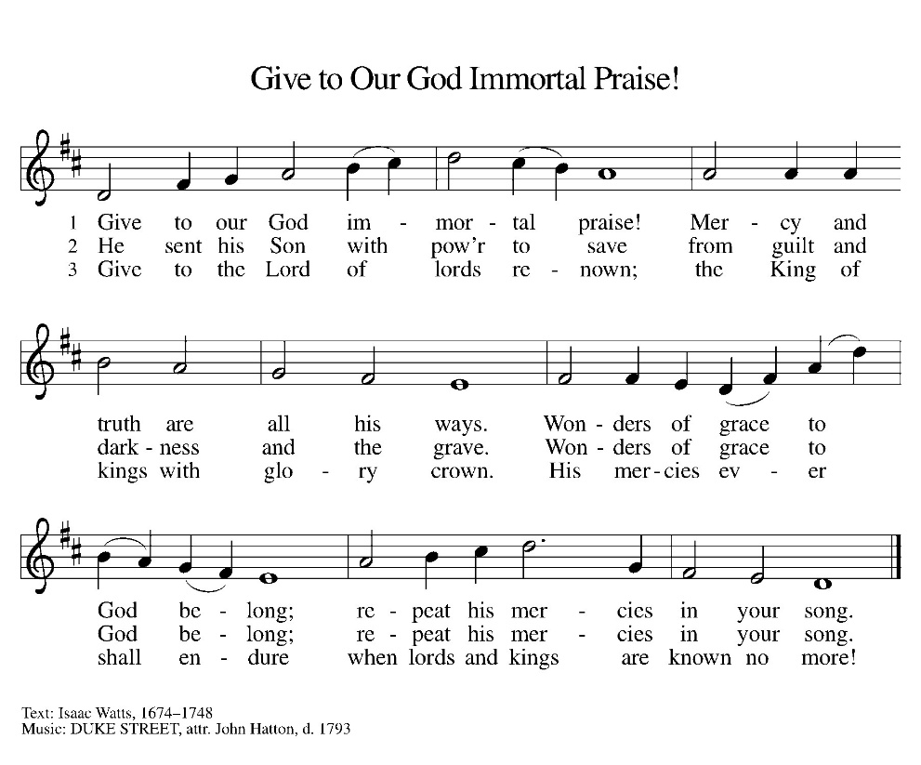

*APOSTLES Creed

I believe in God, the Father almighty,
creator of heaven and earth.
I believe in Jesus Christ, his only Son, our Lord.
He was conceived by the power of the Holy Spirit
and born of the virgin Mary.
He suffered under Pontius Pilate,
was crucified, died, and was buried.
He descended into hell.
On the third day he rose again.
He ascended into heaven,
and is seated at the right hand of the Father.
He will come again to judge the living and the dead.
I believe in the Holy Spirit,
the holy catholic Church,
the communion of saints,
the forgiveness of sins,
the resurrection of the body,
and the life everlasting. Amen

OFFERING

*OFFERTORY Sing verses 1 and 2

*The Prayers
Seeking the Spirit of God who makes all things new, we pray for the church and the world.
A brief silence.
Holy God, we remember your promise of unity on your holy mountain. Empower the World Council of Churches and all those working across religious difference, that the world may know your undivided love. Hear us, O God.
Your mercy is great.
We remember your promise of green pastures and quiet waters. Preserve all places of natural beauty and restore our relationship with the land. Hear us, O God.
Your mercy is great.
We remember your promise to not abandon us amid storm and disaster. Renew all communities facing disasters and give your courage to those leading relief efforts. Hear us, O God.
Your mercy is great.
We remember your promise to wipe away every tear. Heal and console all who are sick or suffering. Hear us, O God.
Your mercy is great.
We remember your promise of a banquet open to all people. Challenge this congregation to open wide our doors and welcome everyone to the table. Hear us, O God.
Your mercy is great.
We remember your promise to swallow up death forever. We give thanks for those who have gone before us. Hear us, O God.
Your mercy is great.
Trusting in your boundless grace, O God, we lift up these spoken prayers and those in our hearts; through Jesus Christ our Lord.
Amen.

*Lord's Prayer

Our Father, who art in heaven, hallowed be thy name,
thy kingdom come,
thy will be done,
on earth as it is in heaven.
Give us this day our daily bread;
and forgive us our trespasses,
as we forgive those
who trespass against us;
and lead us not into temptation,
but deliver us from evil.
For thine is the kingdom,
and the power, and the glory,
forever and ever. Amen.

*Blessing

The Lord bless us and keep us.
The Lord make his face shine on us and be gracious to us.
The Lord look upon us with favor and give us peace.
Amen.
SENDING HYMN ELW 547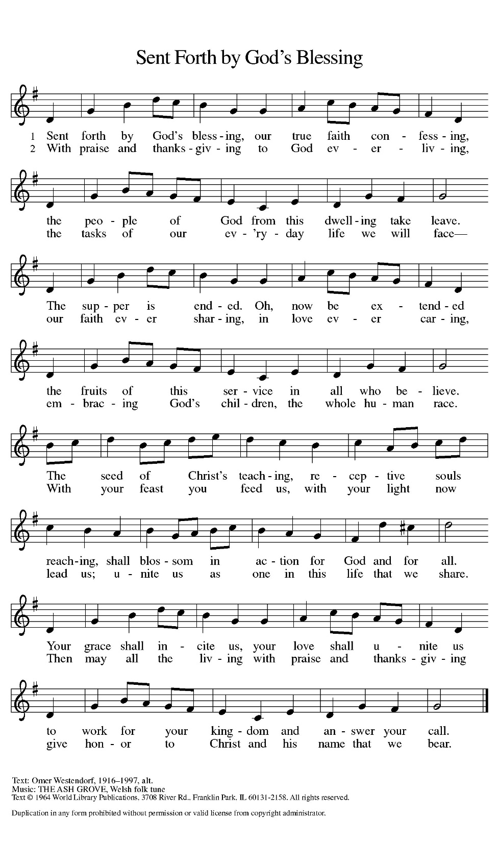

Dismissal
Go out in joy. Be led forth in peace.
Thanks be to God.

From sundaysandseasons.com. Copyright © 2017 Augsburg Fortress. All rights reserved. Reprinted with permission OneLicenses.net #A-722514.

ANNOUNCEMENTS

Bible Study at 6:00 this Thursday, October 15

November 1st-- Fall Dinner
11:30 a.m. – 1:00 p.m.
Dine In or Drive Thru
Sign up sheets in the fellowship hall
Church service will be moved to 10:00 that morning.

A suggestion box has been placed on the table in the entry way. Please feel free to put any suggestions or comments for the council in it.

The new sound system has hearing aid assisted listening devices available for use. If you would like to use one, please speak with a council member before the church service.

If you have a favorite hymn you would like to sing during a future church service, please complete one of the cards on the table in the fellowship hall and place it in the basket provided.

There are sign up sheets on the table in the entryway for the classes that Pastor is offering to the congregation. If you are interested in any of these, please sign up. There are also descriptions of each class beneath the sign up sheet.

Upcoming Community coffees are as follows:
October 16—Coffee Shop at Heritage Inn
October 23—Wymore City Office
October 30—St. Peter Lutheran Church
November 6—Wymore Library

Remembered in Our Prayers:
Jennifer Cohorst Kent Hohensee Dave Mick
Kathleen Remmers Eric Riley Kai Spann

Pastor Gary: Phone: (402) 658-2253
Email: garygrinvalds@gmail.com
If you wish to have Pastor visit you, please contact him to set up a time. Sunday afternoon & Thursday are his open days.

Your Council leaders are:
President: Josh Schmidt (402) 520-0950
Vice President: Chavonn Mailahn (308) 214-0039
Secretary: Rachel Frerichs (402) 239-0466
At Large: Roger Henrichs (402) 239-7740
Erin Saathoff (402) 239-9117
Jodi Wegner (402) 223-8263

Church Account Balance: 09/30/2026: $40,993.12
Church Offerings: 10/04/2026: $ 1,096.00

Attendance: 10/04/2026: 47

October Birthdays Anniversaries
13 Roger Theye
14 Joel Fossler
16 Landen McKeever 17 Caleb & Jesse Harms
17 Amelia Myer 18 Travis & Jonna Arnold
26 Jason Allington 23 Dave & Linda Creevan
27 Steve Epp
28 Jared Johnson
29 Natalie Trauernicht
31 Scott Trauernicht

Please have any announcements for the bulletin to Pam by Wednesday noon each week. You may text or call her at
(402) 239-2715 or send an email to the church at oursaviorslutheranwymore@gmail.com. Thank you.

