Maundy Thursday
April 2, 2026

Our Savior’s Lutheran Church
Website: oursaviorswymore.com
8:00 AM Worship 9:00 AM Fellowship
Faith Formation 5:30 PM Wednesdays

Pastor Gary Grinvalds

Organist: Alice Meints or Sandy Eltiste

Introduction to the day
This evening our Lenten observance comes to an end, and we gather with Christians around the world to celebrate the Three Days of Jesus’ death and resurrection. Tonight we remember Christ’s last meal with his disciples, but the central focus is his commandment that we live out the promise embodied in this meal. As Jesus washed his disciples’ feet, so we are called to give and receive love in humble service to one another. Formed into a new body in Christ through this holy meal, we are transformed by the mercy we have received and carry it into the world. Departing worship in solemn silence, we anticipate the coming days.

*Please Stand
Congregational responses in bold print

WELCOME AND ANNOUNCEMENTS

*BRIEF ORDER for confession and forgiveness
Friends in Christ, in this Lenten season we have heard our Lord’s call to struggle against sin, death, and the devil—all that keeps us from loving God and each other. This is the struggle to which we were called at baptism. Within the community of the church, God never wearies of forgiving sin and giving the peace of reconciliation. On this night let us confess our sin against God and our neighbor, and enter the celebration of the great Three Days reconciled with God and with one another.
Silence is kept for reflection and self-examination.
Most merciful God,
we confess that we are captive to sin
and cannot free ourselves.
We have sinned against you in thought, word, and deed,
by what we have done and by what we have left undone.
We have not loved you with our whole heart;
we have not loved our neighbors as ourselves.
For the sake of your Son, Jesus Christ,
have mercy on us.
Forgive us, renew us, and lead us,
so that we may delight in your will
and walk in your ways,
to the glory of your holy name. Amen.
God, who is rich in mercy, loved us
even when we were dead in sin,
and made us alive together with Christ.
By grace you have been saved.
In the name of ☩ Jesus Christ, your sins are forgiven.
Almighty God strengthen you with power
through the Holy Spirit,
that Christ may live in your hearts through faith. Amen.

ENTRANCE HYMN
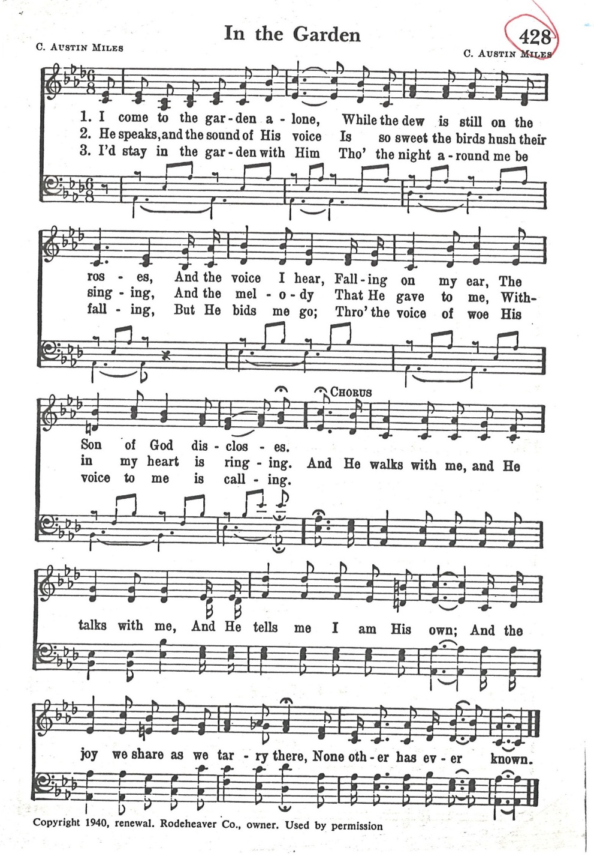

*Greeting
The grace of our Lord Jesus Christ, the love of God, and the communion of the Holy Spirit be with you all.

And also with you.

*Prayer of the Day

Holy God, source of all love, on the night of his betrayal, Jesus gave us a new commandment, to love one another as he loves us. Write this commandment in our hearts, and give us the will to serve others as he was the servant of all, your Son, Jesus Christ, our Savior and Lord, who lives and reigns with you and the Holy Spirit, one God, now and forever.
Amen.

First Lesson: Exodus 12:1-14
Israel remembered its deliverance from slavery in Egypt by celebrating the festival of Passover. This festival featured the Passover lamb, whose blood was used as a sign to protect God’s people from the threat of death. The early church described the Lord’s supper using imagery from the Passover, especially in portraying Jesus as the lamb who delivers God’s people from sin and death.
¹The Lord said to Moses and Aaron in the land of Egypt: ²This month shall mark for you the beginning of months; it shall be the first month of the year for you. ³Tell the whole congregation of Israel that on the tenth of this month they are to take a lamb for each family, a lamb for each household. ⁴If a household is too small for a whole lamb, it shall join its closest neighbor in obtaining one; the lamb shall be divided in proportion to the number of people who eat of it. ⁵Your lamb shall be without blemish, a year-old male; you may take it from the sheep or from the goats. ⁶You shall keep it until the fourteenth day of this month; then the whole assembled congregation of Israel shall slaughter it at twilight. ⁷They shall take some of the blood and put it on the two doorposts and the lintel of the houses in which they eat it. ⁸They shall eat the lamb that same night; they shall eat it roasted over the fire with unleavened bread and bitter herbs. ⁹Do not eat any of it raw or boiled in water, but roasted over the fire, with its head, legs, and inner organs. ¹⁰You shall let none of it remain until the morning; anything that remains until the morning you shall burn. ¹¹This is how you shall eat it: your loins girded, your sandals on your feet, and your staff in your hand; and you shall eat it hurriedly. It is the passover of the Lord. ¹²For I will pass through the land of Egypt that night, and I will strike down every firstborn in the land of Egypt, both human beings and animals; on all the gods of Egypt I will execute judgments: I am the Lord. ¹³The blood shall be a sign for you on the houses where you live: when I see the blood, I will pass over you, and no plague shall destroy you when I strike the land of Egypt.
¹⁴This day shall be a day of remembrance for you. You shall celebrate it as a festival to the Lord; throughout your generations you shall observe it as a perpetual ordinance.

Word of God, Word of life.
Thanks be to God.

pSALM 116:1-2, 12-19

¹I love the Lord, who has heard my voice, and listened to my supplication,
²for the Lord has given ear to me whenever I called.
¹²How shall I repay the Lord for all the good things God has done for me?
¹³I will lift the cup of salvation and call on the name of the Lord.
¹⁴I will fulfill my vows to the Lord in the presence of all God’s people.
¹⁵Precious in your sight, O Lord, is the death of your servants.
¹⁶O Lord, truly I am your servant; I am your servant, the child of your handmaid; you have freed me from my bonds.
¹⁷I will offer you the sacrifice of thanksgiving and call upon the name of the Lord.
¹⁸I will fulfill my vows to the Lord in the presence of all God’s people,
¹⁹in the courts of the Lord’s house, in the midst of you, O Jerusalem.

SECOND READING: 1 CORINTHIANS 11: 23-26
In the bread and cup of the Lord’s supper, we experience intimate fellowship with Christ and with one another because it involves his body given for us and the new covenant in his blood. Faithful participation in this meal is a living proclamation of Christ’s death until he comes in the future.
²³For I received from the Lord what I also handed on to you, that the Lord Jesus on the night when he was betrayed took a loaf of bread, ²⁴and when he had given thanks, he broke it and said, “This is my body that is for you. Do this in remembrance of me.” ²⁵In the same way he took the cup also, after supper, saying, “This cup is the new covenant in my blood. Do this, as often as you drink it, in remembrance of me.” ²⁶For as often as you eat this bread and drink the cup, you proclaim the Lord’s death until he comes.

Word of God, Word of life.
Thanks be to God

*Gospel: John 13:1-17, 31b-35

Glory to you, O Lord.

The story of the last supper in John’s gospel recalls a remarkable event not mentioned elsewhere: Jesus performs the duty of a slave, washing the feet of his disciples and urging them to do the same for one another.
¹Now before the festival of the Passover, Jesus knew that his hour had come to depart from this world and go to the Father. Having loved his own who were in the world, he loved them to the end. ²The devil had already put it into the heart of Judas son of Simon Iscariot to betray him. And during supper ³Jesus, knowing that the Father had given all things into his hands, and that he had come from God and was going to God, ⁴got up from the table, took off his outer robe, and tied a towel around himself. ⁵Then he poured water into a basin and began to wash the disciples’ feet and to wipe them with the towel that was tied around him. ⁶He came to Simon Peter, who said to him, “Lord, are you going to wash my feet?” ⁷Jesus answered, “You do not know now what I am doing, but later you will understand.” ⁸Peter said to him, “You will never wash my feet.” Jesus answered, “Unless I wash you, you have no share with me.” ⁹Simon Peter said to him, “Lord, not my feet only but also my hands and my head!” ¹⁰Jesus said to him, “One who has bathed does not need to wash, except for the feet, but is entirely clean. And you are clean, though not all of you.” ¹¹For he knew who was to betray him; for this reason he said, “Not all of you are clean.”
¹²After he had washed their feet, had put on his robe, and had returned to the table, he said to them, “Do you know what I have done to you? ¹³You call me Teacher and Lord—and you are right, for that is what I am. ¹⁴So if I, your Lord and Teacher, have washed your feet, you also ought to wash one another’s feet. ¹⁵For I have set you an example, that you also should do as I have done to you. ¹⁶Very truly, I tell you, servants are not greater than their master, nor are messengers greater than the one who sent them. ¹⁷If you know these things, you are blessed if you do them.”
^{31b}“Now the Son of Man has been glorified, and God has been glorified in him. ³²If God has been glorified in him, God will also glorify him in himself and will glorify him at once. ³³Little children, I am with you only a little longer. You will look for me; and as I said to the Jews so now I say to you, ‘Where I am going, you cannot come.’ ³⁴I give you a new commandment, that you love one another. Just as I have loved you, you also should love one another. ³⁵By this everyone will know that you are my disciples, if you have love for one another.”

The Gospel of our Lord

Praise to you, O Christ.

Sermon PASTOR GARY GRINVALDS

HYMN OF THE DAY ACS 930

*The Prayers
On this night when Jesus gave us a new commandment to love one another, let us bring our prayers before the One whose love knows no bounds.
A brief silence.
Gracious host, you knelt to wash your disciples’ feet. Cleanse us from pride and self-centeredness, and teach us to love one another as you have loved us. Hear us, O God.
Your mercy is great.
Creator God, the earth is yours and everything in it. Awaken us to care for all you have made and conserve the rich diversity of your good creation. Hear us, O God.
Your mercy is great.
God of the nations, guide the world’s leaders in the ways of justice and peace. Where they wield power unjustly, confront them. Where they are indifferent to suffering, awaken their conscience. Hear us, O God.
Your mercy is great.
Compassionate One, embrace all who are lonely or in captivity, comfort the grieving, and relieve those in pain. Draw near to all who suffer (especially). Hear us, O God.
Your mercy is great.
Blessed redeemer, we give you thanks for this community of faith, and for all who gather around your table of grace. Unite us in love for you and for one another. Hear us, O God.
Your mercy is great.
Here other intercessions may be offered.
Eternal God, we praise you for the great cloud of witnesses who now rest from their labors. At the last, gather us with them at your heavenly banquet. Hear us, O God.
Your mercy is great.
We entrust these prayers to you, O God, confident that you will strengthen us by your Spirit to love one another as Christ has loved us. We ask this in Jesus’ name.
Amen.

*Peace
The peace of the Lord be with you always.
And also with you.

OFFERING

*OFFERTORY

*Offertory Prayer

Gracious Provider,
you set your immense treasures among us,
opening your heart to the world.
As we prepare to feast on your bountiful love,
deepen our commitment to sharing those
treasures with others,
through our Savior, Jesus Christ.
Amen.

*Dialogue LBW pg 68

The Lord be with you.
And also with you.

Lift up your hearts.
We lift them to the Lord.

Let us give thanks to the Lord our God.
It is right to give our thanks and praise

*Preface
It is indeed right, our duty, and our joy that we should at all times and in all places give thanks and praise to you, almighty and merciful God, through our Savior Jesus Christ. You call your people to cleanse their hearts and prepare with joy for the paschal feast, that renewed in the gift of baptism, we may come to the fullness of your grace. And so, with all the choirs of angels, with the Church on earth and the hosts of heaven, we praise your name and join their unending hymn:
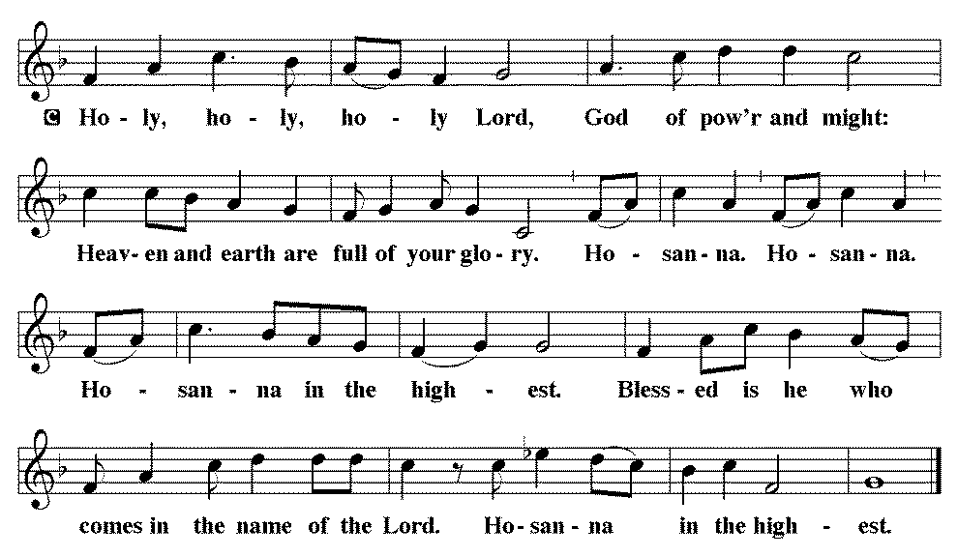

*THE GREAT Thanksgiving
Blessed are you, O God of the universe. Your mercy is everlasting and your faithfulness endures from age to age.

Praise to you for creating the heavens and the earth.
Praise to you for saving the earth from the waters of the flood.
Praise to you for bringing the Israelites safely through the sea.
Praise to you for leading your people through the wilderness to the land of milk and honey.
Praise to you for the words and deeds of Jesus, your anointed one.
Praise to you for the death and resurrection of Christ.
Praise to you for your Spirit poured out on all nations.

In the night in which he was betrayed,
our Lord Jesus took bread, and gave thanks;
broke it, and gave it to his disciples, saying:
Take and eat; this is my body, given for you.
Do this for the remembrance of me.

Again, after supper, he took the cup, gave thanks,
and gave it for all to drink, saying:
This cup is the new covenant in my blood,
shed for you and for all people for the forgiveness of sin.
Do this for the remembrance of me.
With this bread and cup, we remember our Lord’s Passover from death to life as we proclaim the mystery of faith:
Christ has died. Christ has risen. Christ will come again.

O God of resurrection and new life:
Pour out your Holy Spirit on us and on these gifts of bread and wine.
Bless this feast. Grace our table with your presence.
Come, Holy Spirit.

Reveal yourself to us in the breaking of the bread. Raise us up as the body of Christ for the world. Breathe new life into us. Send us forth, burning with justice, peace and love.
Come, Holy Spirit.

With your holy ones of all times and places, with the earth and all its creatures, with sun and moon and stars, we praise you, O God, blessed and holy Trinity, now and forever.
Amen.

*Lord's Prayer
Lord, remember us in your kingdom and teach us to pray.

Our Father, who art in heaven, hallowed be thy name,
thy kingdom come,
thy will be done,
on earth as it is in heaven.
Give us this day our daily bread;
and forgive us our trespasses,
as we forgive those
who trespass against us;
and lead us not into temptation,
but deliver us from evil.
For thine is the kingdom,
and the power, and the glory, forever and ever. Amen.

*INVITATION TO HOLY COMMUNION
Come to the table.
Feast on God’s goodness and mercy

AGNUS DEI (Lamb of God) ~ HOLY Communion
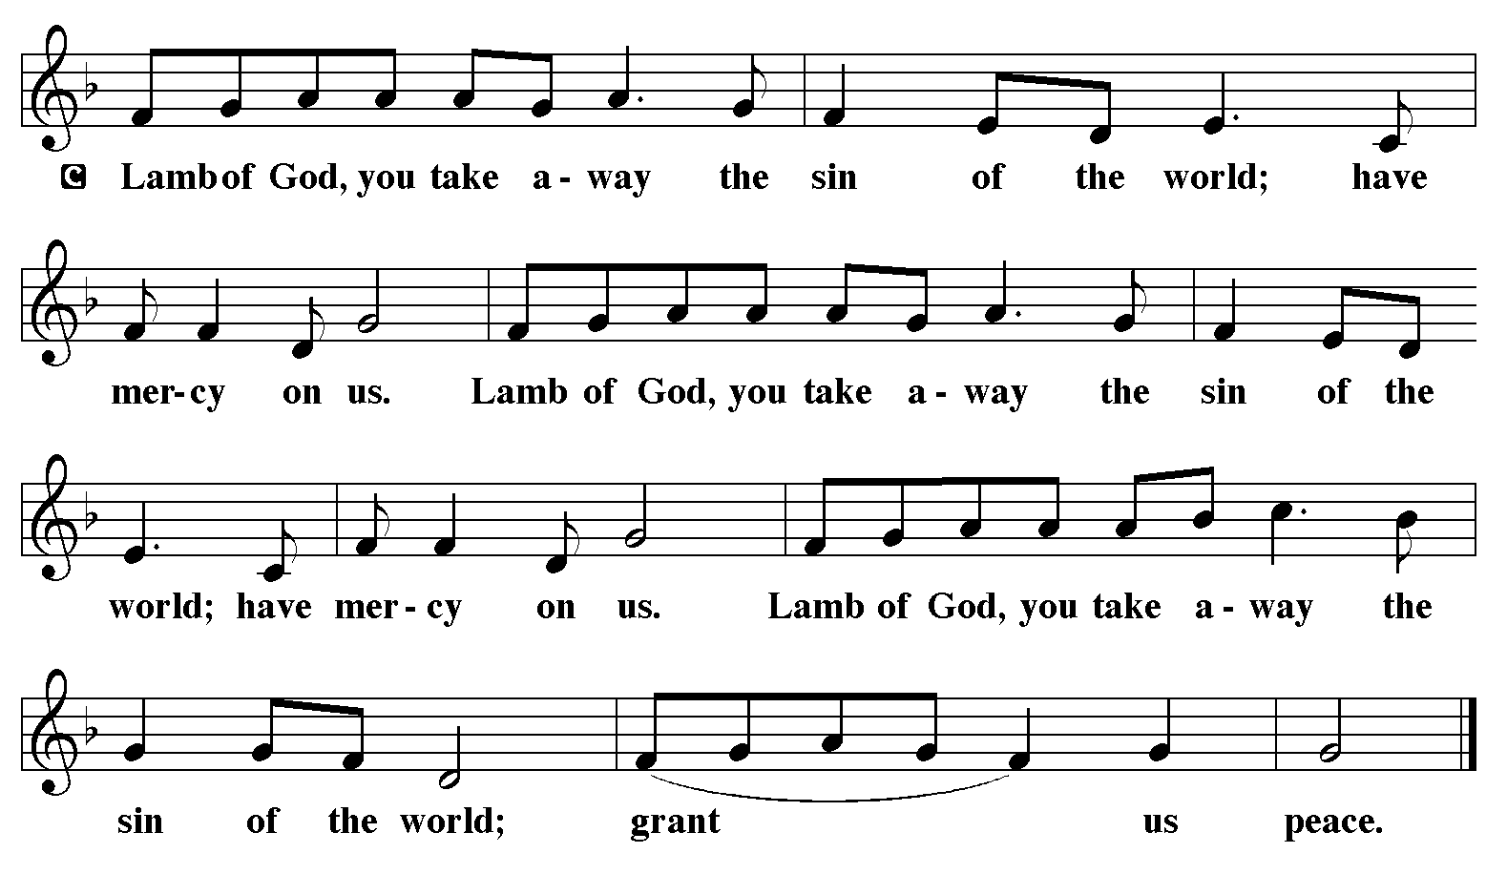
Communion HYMN eLW 803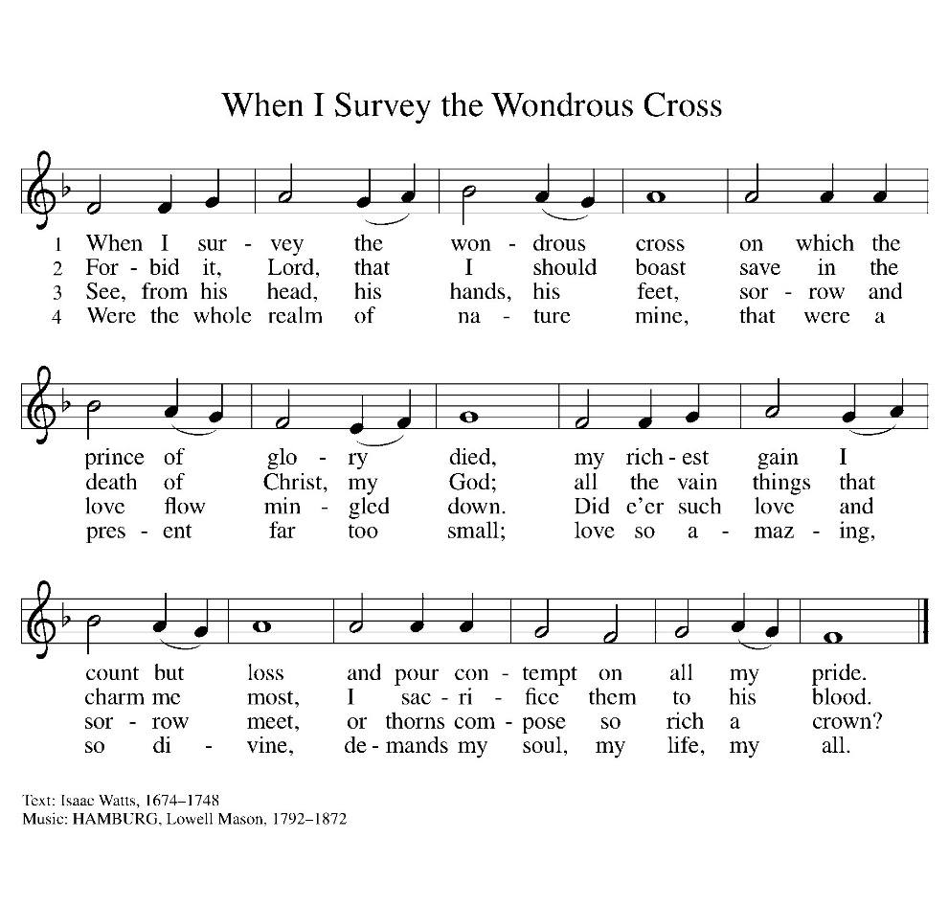
*BLESSING
May the body and blood of our Lord Jesus Christ strengthen you and keep you in his grace.
Amen

*Prayer after communion

Lord Jesus, in a wonderful sacrament
you strengthen us with the saving power
of your suffering, death, and resurrection.
May this sacrament of your body and blood
so work in us that the fruits of your redemption
will show forth in the way we live,
for you live and reign with the Father and the Holy Spirit,
one God, now and forever. Amen.
The congregation is invited to be seated.

STRIPPING THE ALTAR
After all have communed, the altar is stripped while Psalm 88 is read.
Symbolically, Christ, stripped of all power and authority is now in the hands of his captors. There is no benediction in this service as this service begins the Three Days including Good Friday and Holy Saturday.

PSALM 88

We depart in silence.

We would like to welcome the following young people as they partake in their first communion:
Kynley Allington Kasen Allington Karlee Dieter
Brigslee Dieter Trevin Dorn Huntley Fossler
Kasen Fossler Judson Frerichs Addi Kostal
Jaxson Mailahn Leighton McKeever

Holy Week Services: Good Friday, April 3 at 7:30 p.m.
Easter, April 5, at 8:00 a.m.

An Easter egg hunt will be held after church on Easter Sunday.

