Sunday, August 23, 2026
13th Sunday of Pentecost

Our Savior’s Lutheran Church
Website: oursaviorswymore.com
8:00 AM Worship 9:00 AM Fellowship
Faith Formation 5:30 PM Wednesdays

Pastor Gary Grinvalds

Organist: Alice Meints or Sandy Eltiste

Introduction to the day
In Isaiah the people are advised to look to their spiritual ancestors as the rock from which they were hewn. Jesus declares that the church will be built on the rock of Peter’s bold confession of faith. God’s word of reconciliation and God’s mercy are keys to the church’s mission. Paul urges us to not be conformed to this world but to offer our bodies as a living sacrifice, using our individual gifts to build up the body of Christ. From the table we go forth to offer our spiritual worship through word and deed.
*Please Stand
Congregational responses in bold print

WELCOME AND ANNOUNCEMENTS

*Brief order for CONFESSION AND FORGIVENESS

Blessed be the holy Trinity,☩ one God,
whose compassion endures forever.
Amen.
Let us confess our sin to God.
Silence is kept for reflection.
Compassionate God,
we confess to you all our sins.
Our burden is heavy, and we cannot free ourselves.
In your mercy, call us back to you.
Your yoke is easy and your burden is light.
Restore us to dwell in your peace.
In Christ’s name we pray,
Amen.
Jesus says, “Come to me,
all you who are weary
and are carrying heavy burdens,
and I will give you rest.”
In the name of God,
Father, ☩ Son, and Holy Spirit,
your sins are forgiven.
Rest in God’s love.
Amen.

Entrance Hymn ELW 820
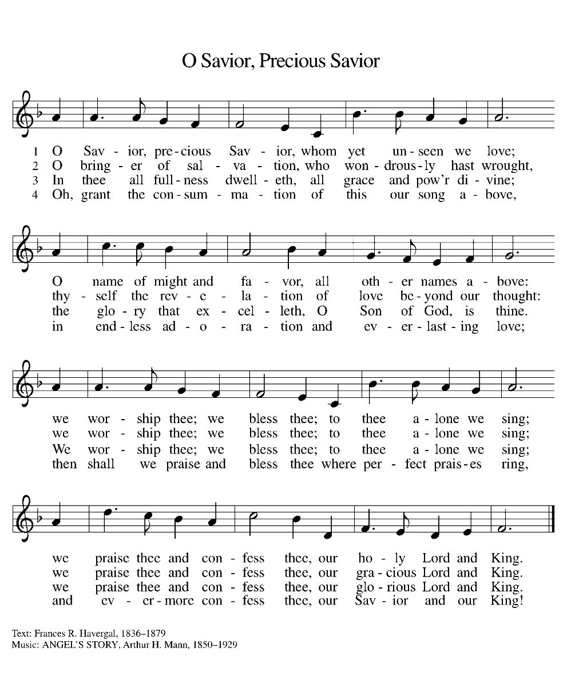

*Blessed are you, O Lord our God, king of the universe,
For in your wisdom you have formed us.
You feed the hungry and clothe the naked,
We bless you and praise your name forever.
You set free those who are bound.
We bless you and praise your name forever.
You raise up those whose courage falters.
We bless you and praise your name forever.
You provide for our every need.
Accept our grateful praises.
You have called us from all peoples.
We rejoice and bless your name forever.
You bless your people with peace.
We bless you and praise your loving grace.
Blessed are you, O Lord our God, king of the universe,
For in your wisdom you have formed us.

*Prayer of the Day

The Lord be with you.
And also with you.

Let us pray.

O God, with all your faithful followers of every age, we praise you, the rock of our life. Be our strong foundation and form us into the body of your Son, that we may gladly minister to all the world, through Jesus Christ, our Savior and Lord.
Amen.

HYMN ELW 876
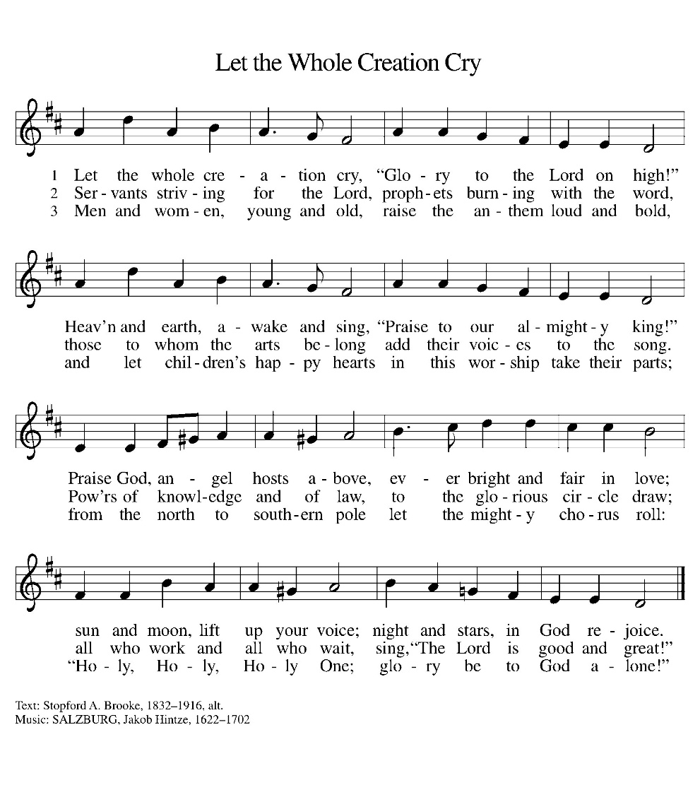

First Lesson: Isaiah 51:1-6
Just as God had called Abraham and Sarah and given them many descendants, so now God offers comfort to Zion. God’s deliverance will come soon and will never end.
¹ Listen to me, you who pursue righteousness, you who seek the Lord. Look to the rock from which you were hewn and to the quarry from which you were dug. ² Look to Abraham your father and to Sarah, who bore you, for he was but one when I called him, but I blessed him and made him many. ³ For the Lord will comfort Zion; he will comfort all her waste places and will make her wilderness like Eden, her desert like the garden of the Lord; joy and gladness will be found in her, thanksgiving and the voice of song. ⁴ Listen to me, my people, and give heed to me, my nation, for a teaching will go out from me and my justice for a light to the peoples. ⁵ I will bring near my deliverance swiftly; my salvation has gone out, and my arms will rule the peoples; the coastlands wait for me, and for my arm they hope. ⁶ Lift up your eyes to the heavens and look at the earth beneath, for the heavens will vanish like smoke, the earth will wear out like a garment, and those who live on it will die like gnats, but my salvation will be forever, and my deliverance will never be ended.
Word of God, Word of life.
Thanks be to God.

Psalm 138 Read Responsively

¹ I will give thanks to you, O Lord, with my whole heart; before the gods I will sing your praise.
² I will bow down toward your holy temple and praise your name, because of your steadfast love and faithfulness; for you have glorified your name and your word above all things.
³ When I called, you answered me; you increased my strength within me.
⁴ All the rulers of the earth will praise you, O Lord, when they have heard the words of your mouth.
⁵ They will sing of the ways of the Lord, that great is the glory of the Lord.
⁶ The Lord is high, yet cares for the lowly, perceiving the haughty from afar.
⁷ Though I walk in the midst of trouble, you keep me safe; you stretch forth your hand against the fury of my enemies; your right hand shall save me.
⁸ You will make good your purpose for me; O Lord, your steadfast love endures forever; do not abandon the works of your hands.

Second Lesson: Romans 12:1-8
In response to God’s merciful activity, we are to worship by living holistic, God-pleasing lives. Our values and viewpoints are not molded by the time in which we live but are transformed by the Spirit’s renewing work. God’s grace empowers different forms of service among Christians, but all forms of ministry function to build up the body of Christ.
¹ I appeal to you therefore, brothers and sisters, on the basis of God’s mercy, to present your bodies as a living sacrifice, holy and acceptable to God, which is your reasonable act of worship. ² Do not be conformed to this age, but be transformed by the renewing of the mind, so that you may discern what is the will of God—what is good and acceptable and perfect.
³ For by the grace given to me I say to everyone among you not to think of yourself more highly than you ought to think but to think with sober judgment, each according to the measure of faith that God has assigned. ⁴ For as in one body we have many members and not all the members have the same function, ⁵ so we, who are many, are one body in Christ, and individually we are members one of another. ⁶ We have gifts that differ according to the grace given to us: prophecy, in proportion to faith; ⁷ ministry, in ministering; the teacher, in teaching; ⁸ the encourager, in encouragement; the giver, in sincerity; the leader, in diligence; the compassionate, in cheerfulness.
Word of God, Word of life.
Thanks be to God.

childrens sermon

*Gospel: 2 Samuel 6:12-19

Glory to you, O Lord.

¹² It was told King David, “The Lord has blessed the household of Obed-edom and all that belongs to him because of the ark of God.” So David went and brought up the ark of God from the house of Obed-edom to the city of David with rejoicing, ¹³ and when those who bore the ark of the Lord had gone six paces, he sacrificed an ox and a fatted calf. ¹⁴ David danced before the Lord with all his might; David was girded with a linen ephod. ¹⁵ So David and all the house of Israel brought up the ark of the Lord with shouting and with the sound of the trumpet.
¹⁶ As the ark of the Lord came into the city of David, Michal daughter of Saul looked out of the window and saw King David leaping and dancing before the Lord, and she despised him in her heart.
¹⁷ They brought in the ark of the Lord and set it in its place, inside the tent that David had pitched for it, and David offered burnt offerings and offerings of well-being before the Lord. ¹⁸ When David had finished offering the burnt offerings and the offerings of well-being, he blessed the people in the name of the Lord of hosts ¹⁹ and distributed food among all the people, the whole multitude of Israel, both men and women, to each a cake of bread, a portion of meat, and a cake of raisins. Then all the people went back to their homes.
The Gospel of our Lord
Praise to you, O Christ.

Sermon pastor GARY GRINVALDS

HYMN OF THE DAY ELW 836
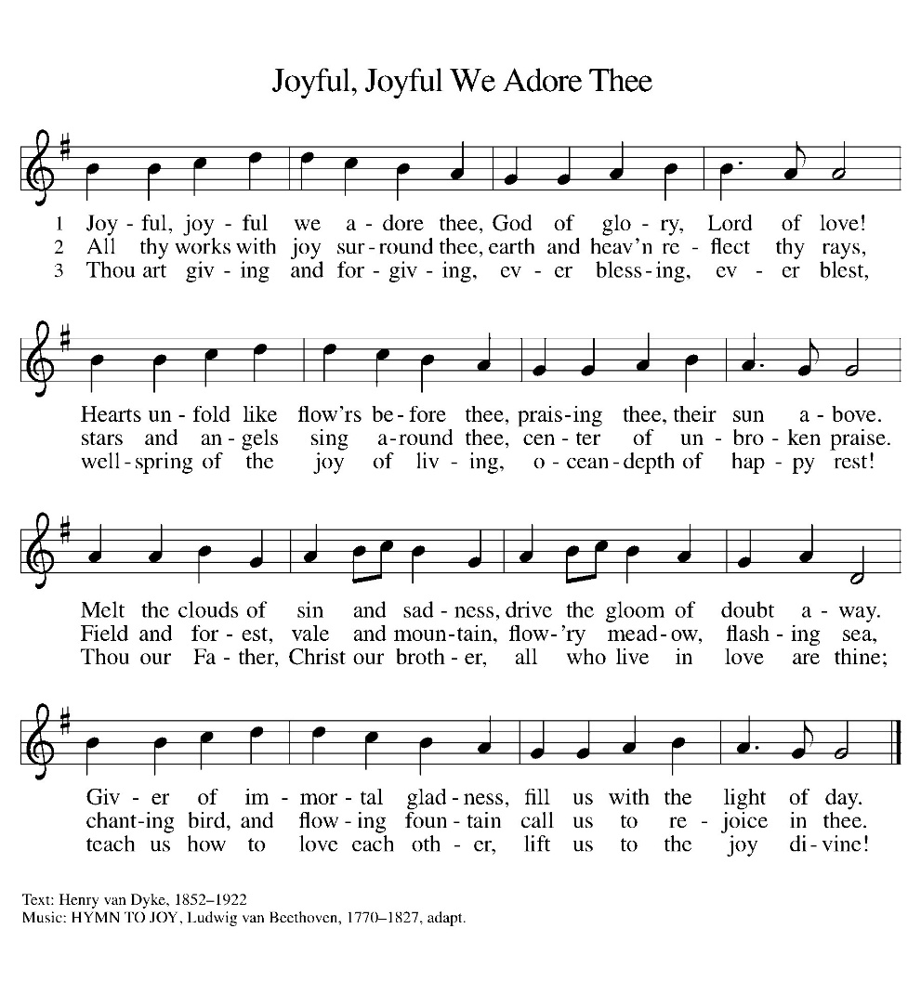

*APOSTLES Creed

I believe in God, the Father almighty,
creator of heaven and earth.
I believe in Jesus Christ, his only Son, our Lord.
He was conceived by the power of the Holy Spirit
and born of the virgin Mary.
He suffered under Pontius Pilate,
was crucified, died, and was buried.
He descended into hell.
On the third day he rose again.
He ascended into heaven,
and is seated at the right hand of the Father.
He will come again to judge the living and the dead.
I believe in the Holy Spirit,
the holy catholic Church,
the communion of saints,
the forgiveness of sins,
the resurrection of the body,
and the life everlasting. Amen

OFFERING
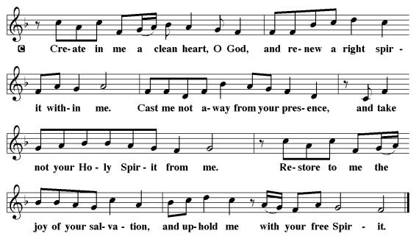
*OFFERTORY
*The Prayers
With bold trust in God’s unfailing provision, we pray for the church, those in need, and all of God’s creation.
A brief silence.
God, our rock, you are the foundation on which the church is built. Strengthen and encourage your faithful people everywhere they gather, that they boldly proclaim your word of life to all the world. Merciful God,
receive our prayer.
You spoke and all creation came into being. Field and forest, wetland and wilderness—all reveal your glory. Sustain and nourish your creation. Teach us to be wise stewards of all you have made. Merciful God,
receive our prayer.
You bring deliverance to nations and peoples. Come to the aid of nations experiencing war, conflict, disease, famine, and disaster. Guide the work of relief agencies and peacemaking organizations. Merciful God,
receive our prayer.
You regard the lowly and hear us when we cry out to you. Be present among all who struggle with addiction, housing insecurity, incarceration, and mental illness, that they know they are not alone. Hear our prayers for all in need this day (especially). Merciful God,
receive our prayer.
You draw together people with differing gifts. Lift up the many and varied gifts and talents of this congregation and strengthen the bonds of fellowship that all may be united as the body of Christ. Merciful God,
receive our prayer.
Your steadfast love endures forever. We give thanks for the faithful who died in the hope of this promise. Strengthen us in faith until the day we join them at your eternal banquet. Merciful God,
receive our prayer.
Receive our prayers and answer, O God, as you have promised. All this we ask in the name of your Son, Jesus Christ our Lord.
Amen.

*Lord's Prayer

Our Father, who art in heaven, hallowed be thy name,
thy kingdom come,
thy will be done,
on earth as it is in heaven.
Give us this day our daily bread;
and forgive us our trespasses,
as we forgive those
who trespass against us;
and lead us not into temptation,
but deliver us from evil.
For thine is the kingdom,
and the power, and the glory,
forever and ever. Amen.

*Blessing

The Lord bless us and keep us.
The Lord make his face shine on us and be gracious to us.
The Lord look upon us with favor and give us peace.
Amen.

SENDING HYMN ELW 818
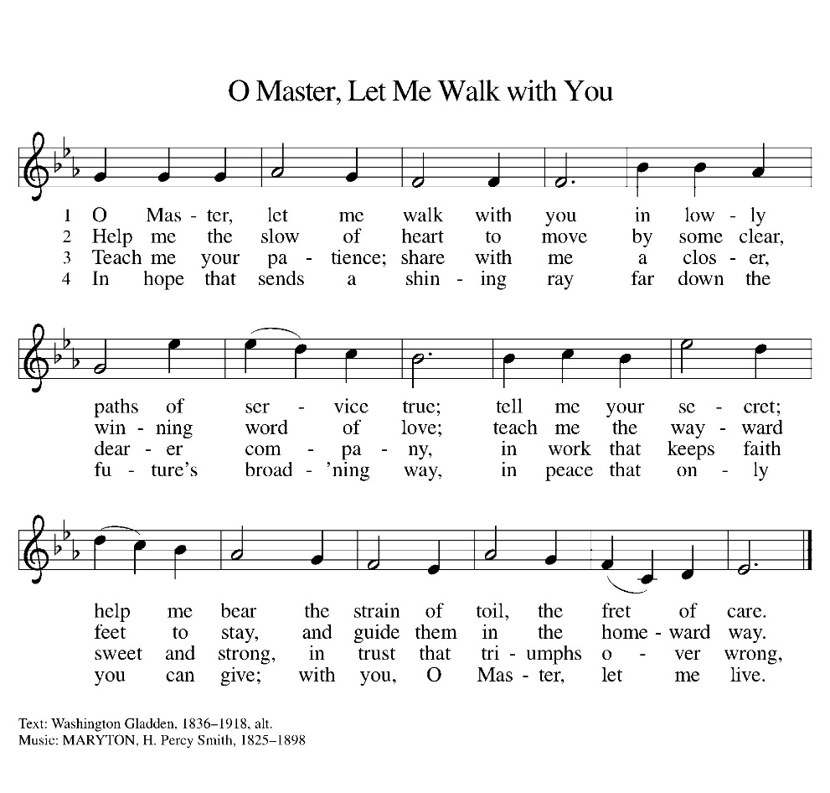

Dismissal
Heaven has come near. Go, share the good news!
Thanks be to God.

From sundaysandseasons.com. Copyright © 2017 Augsburg Fortress. All rights reserved. Reprinted with permission OneLicenses.net #A-722514.

ANNOUNCEMENTS

If you have a favorite hymn you would like to sing during a future church service, please complete one of the cards on the table in the fellowship hall and place it in the basket provided.

There are sign up sheets on the table in the entryway for the classes that Pastor is offering to the congregation. If you are interested in any of these, please sign up. There are also descriptions of each class beneath the sign up sheet.

Upcoming Community coffees are as follows:
August 28—KWBE at Park Lodge
September 4—Wymore Library

Remembered in Our Prayers:
Jennifer Cohorst Kent Hohensee
Kathleen Remmers Eric Riley Kai Spann

Pastor Gary: Phone: (402) 658-2253
Email: garygrinvalds@gmail.com
If you wish to have Pastor visit you, please contact him to set up a time. Sunday afternoon & Thursday are his open days.

Your Council leaders are:
President: Josh Schmidt (402) 520-0950
Vice President: Chavonn Mailahn (308) 214-0039
Secretary: Rachel Frerichs (402) 239-0466
At Large: Roger Henrichs (402) 239-7740
Erin Saathoff (402) 239-9117
Jodi Wegner (402) 223-8263
Council meetings are now held on the 3rd Thursday of each month after Bible Study.

Church Account Balance: 07/31/2026: $53,458.94
Church Offerings: 08/02/2026: $ 915.00
08/09/2026: $ 1,272.00
08/16/2026: $ 817.00

Attendance: 08/16/2026: 51

August Birthdays Anniversaries
22-Dyan Allinton
27-Darla Acton
28-Larry Frerichs 28-Dustin&Jodi Wegner
28-Shelby Saathoff 29-Caleb&Lindsey McKeever

Please have any announcements for the bulletin to Pam by Wednesday noon each week. You may text or call her at
(402) 239-2715 or send an email to the church at oursaviorslutheranwymore@gmail.com. Thank you.

