Sunday, October 18, 2026
21st Sunday of Pentecost

Our Savior’s Lutheran Church
Website: oursaviorswymore.com
8:00 AM Worship 9:00 AM Fellowship
Faith Formation 5:30 PM Wednesdays

Pastor Gary Grinvalds

Organist: Alice Meints or Sandy Eltiste

Introduction to the day
In today’s first reading God uses the Gentile ruler Cyrus to accomplish divine purposes. When the Pharisees try to trap Jesus, he tells them to give the emperor what belongs to him and to God what belongs to God. To gather for worship reminds us that our ultimate allegiance is to God rather than to any earthly authority. Created in the image of God, we offer our entire selves in the service of God and for the sake of the world.

*Please Stand
Congregational responses in bold print

WELCOME AND ANNOUNCEMENTS

*Brief order for CONFESSION AND FORGIVENESS

Blessed be the holy Trinity, ☩ one God,
who pours love into our hearts
and healing upon the earth.
Amen.
Confident that God justifies us by grace through faith,
let us confess our sin.
Silence is kept for reflection.
Compassionate God,
we confess that we struggle to embody your goodness
in the world and in our own hearts.
Creation groans from overuse.
Jealousy and bitterness strain our relationships.
Indifference keeps us from seeking justice.
Divisions disrupt your call to show genuine love
to others.
Turn our hearts back to you.
Restore our world and reconcile us to one another.
Renew us to live as your holy people,
following the way of Jesus Christ.
Amen.
Hear this good news:
We have peace with God through ☩ Jesus Christ,
in whom there is no condemnation,
but only forgiveness and the promise of eternal life.
Receive freely this healing gift of grace.
Amen.

*Entrance Hymn ELW 526
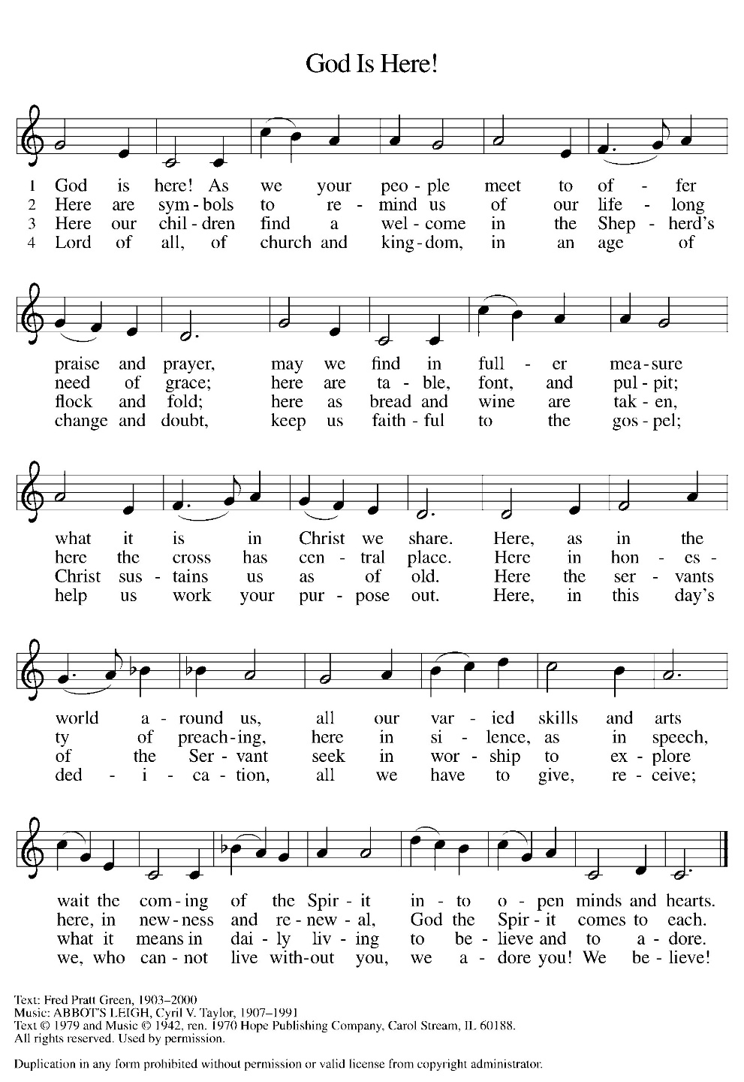

*Greeting

The grace of our Lord Jesus Christ, the love of God, and the communion of the Holy Spirit be with you all.
And also with you.

*Kyrie LBW pg 57
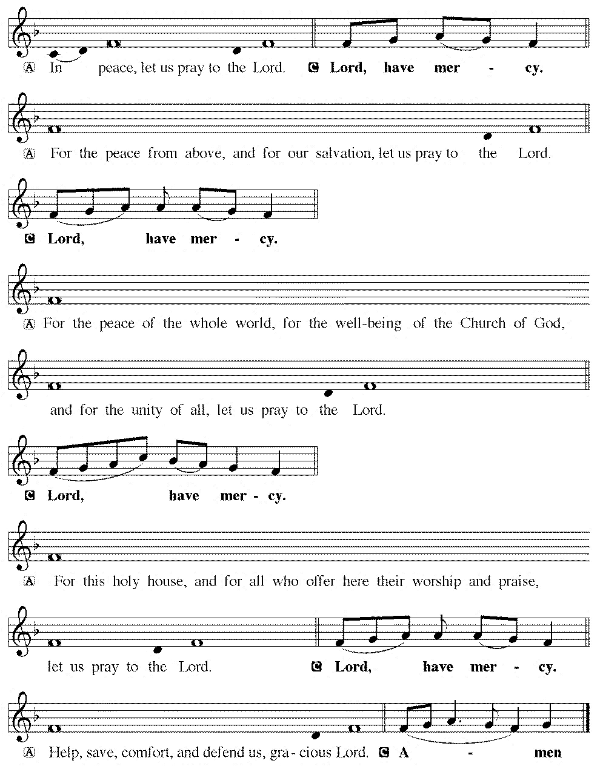

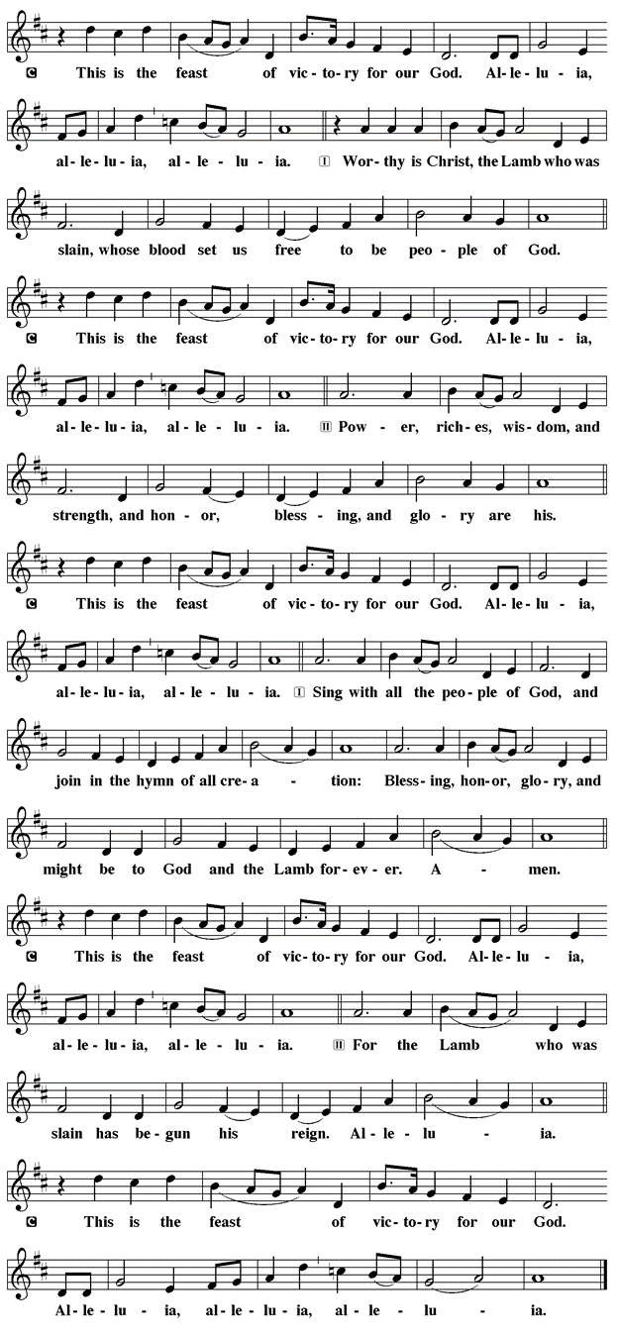
*Prayer of the Day

The Lord be with you.
And also with you.

Let us pray.

Sovereign God, raise your throne in our hearts. Created by you, let us live in your image; created for you, let us act for your glory; redeemed by you, let us give you what is yours, through Jesus Christ, our Savior and Lord.
Amen.

First Lesson: Isaiah 45:1-7
The prophet announces that Cyrus the Persian emperor is the one the Lord has anointed to end Israel’s exile. The Lord makes this choice so that the whole world will recognize this Lord as the only God. Persia had a god of light and a god of darkness; the Lord claims sovereignty over both light and darkness.
¹ Thus says the Lord to his anointed, to Cyrus, whose right hand I have grasped to subdue nations before him and to strip kings of their robes, to open doors before him—and the gates shall not be closed: ² I will go before you and level the mountains; I will break in pieces the doors of bronze and cut through the bars of iron; ³ I will give you the treasures of darkness and riches hidden in secret places, so that you may know that it is I, the Lord, the God of Israel, who call you by your name. ⁴ For the sake of my servant Jacob and Israel my chosen, I call you by your name; I give you a title, though you do not know me. ⁵ I am the Lord, and there is no other; besides me there is no god. I arm you, though you do not know me, ⁶ so that they may know, from the rising of the sun and from the west, that there is no one besides me; I am the Lord, and there is no other. ⁷ I form light and create darkness, I make weal and create woe; I the Lord do all these things.
Word of God, Word of life.
Thanks be to God.

Psalm 96:1-13 Read Responsively

¹ Sing to the Lord a new song; sing to the Lord, all the earth.
² Sing to the Lord, bless the name of the Lord; proclaim God’s salvation from day to day.
³ Declare God’s glory among the nations and God’s wonders among all peoples.
⁴ For great is the Lord and greatly to be praised, more to be feared than all gods.
⁵ As for all the gods of the nations, they are but idols; but you, O Lord, have made the heavens.
⁶ Majesty and magnificence are in your presence; power and splendor are in your sanctuary.
⁷ Ascribe to the Lord, you families of the peoples, ascribe to the Lord honor and power.
⁸ Ascribe to the Lord the honor due the holy name; bring offerings and enter the courts of the Lord.
⁹ Worship the Lord in the beauty of holiness; tremble before the Lord, all the earth.
¹⁰ Tell it out among the nations: “The Lord is king! The one who made the world so firm that it cannot be moved will judge the peoples with equity.”
¹¹ Let the heavens rejoice, and let the earth be glad; let the sea thunder and all that is in it; let the field be joyful and all that is therein.
¹² Then shall all the trees of the wood shout for joy at your coming, O Lord, for you come to judge the earth.
¹³ You will judge the world with righteousness and the peoples with your truth.
Second Lesson: 1 Thessalonians 1:1-10
Most likely this letter is the first written by Paul. Paul gives pastoral encouragement and reassurances to new Christians living in an antagonistic environment. Their commitment of faith, love, and hope makes them a model for other new Christian communities.
¹ Paul, Silvanus, and Timothy,
To the church of the Thessalonians in God the Father and the Lord Jesus Christ: Grace to you and peace.
² We always give thanks to God for all of you and mention you in our prayers, constantly ³ remembering before our God and Father your work of faith and labor of love and steadfastness of hope in our Lord Jesus Christ. ⁴ For we know, brothers and sisters beloved by God, that he has chosen you, ⁵ because our message of the gospel came to you not in word only but also in power and in the Holy Spirit and with full conviction; just as you know what kind of persons we proved to be among you for your sake. ⁶ And you became imitators of us and of the Lord, for in spite of persecution you received the word with joy from the Holy Spirit, ⁷ so that you became an example to all the believers in Macedonia and in Achaia. ⁸ For the word of the Lord has sounded forth from you not only in Macedonia and Achaia but in every place your faith in God has become known, so that we have no need to speak about it. ⁹ For they report about us what kind of welcome we had among you and how you turned to God from idols to serve a living and true God ¹⁰ and to wait for his Son from heaven, whom he raised from the dead—Jesus, who rescues us from the coming wrath.

Word of God, Word of life.
Thanks be to God.

childrens sermon

*Gospel: Matthew 22:15-22

Glory to you, O Lord.

After Jesus begins teaching in the temple, religious leaders try to trap him with questions. First they ask if God’s people should pay taxes to an earthly tyrant like Caesar.
¹⁵ The Pharisees went and plotted to entrap [Jesus] in what he said. ¹⁶ So they sent their disciples to him, along with the Herodians, saying, “Teacher, we know that you are sincere, and teach the way of God in accordance with truth, and show deference to no one, for you do not regard people with partiality. ¹⁷ Tell us, then, what you think. Is it lawful to pay taxes to Caesar or not?” ¹⁸ But Jesus, aware of their malice, said, “Why are you putting me to the test, you hypocrites? ¹⁹ Show me the coin used for the tax.” And they brought him a denarius. ²⁰ Then he said to them, “Whose head is this and whose title?” ²¹ They answered, “Caesar’s.” Then he said to them, “Give therefore to Caesar the things that are Caesar’s and to God the things that are God’s.” ²² When they heard this, they were amazed, and they left him and went away.
The Gospel of our Lord

Praise to you, O Christ.

Sermon pastor GARY GRINVALDS

HYMN OF THE DAY ELW 685
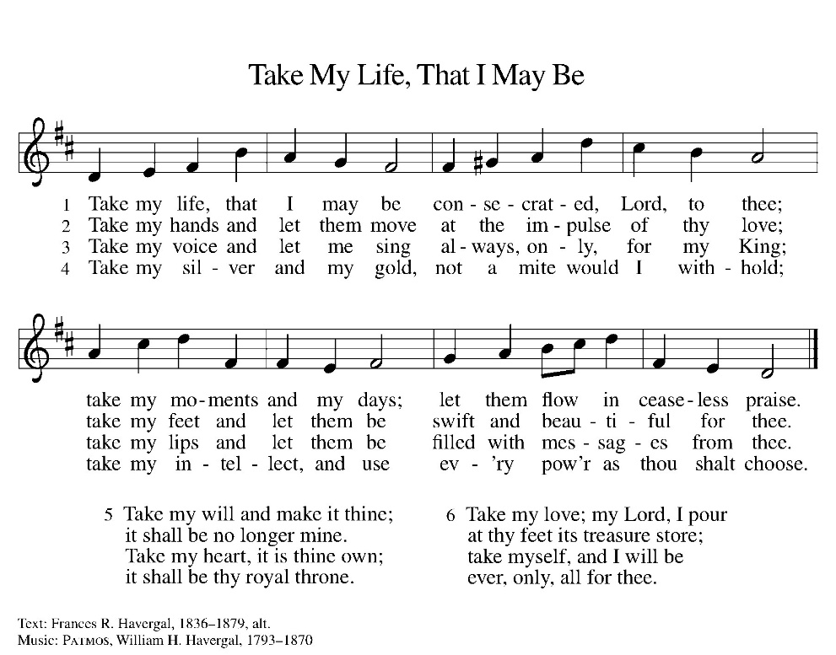

*NICENE CREED
We believe in one God,
the Father, the Almighty,
maker of heaven and earth,
of all that is, seen and unseen.
We believe in one Lord, Jesus Christ,
the only Son of God,
eternally begotten of the Father,
God from God, Light from Light,
true God from true God,
begotten, not made,
of one Being with the Father;
through him all things were made.
For us and for our salvation
he came down from heaven,
was incarnate of the Holy Spirit and the virgin Mary,
and became truly man.
For our sake he was crucified under Pontius Pilate;
he suffered death and was buried.
On the third day he rose again
in accordance with the scriptures;
he ascended into heaven
and is seated at the right hand of the Father.
He will come again in glory to judge the living and the dead, and his kingdom will have no end.
We believe in the Holy Spirit, the Lord, the giver of life,
who proceeds from the Father and the Son,
who with the Father and the Son is worshiped and glorified, who has spoken through the prophets.
We believe in one holy catholic and apostolic church.
We acknowledge one baptism for the forgiveness of sins.
We look for the resurrection of the dead,
and the life of the world to come. Amen.

*The Prayers
Seeking the Spirit of God who makes all things new, we pray for the church and the world.
A brief silence.
Living and true God, you inspire us to share the message of the gospel. Give your spirit of love to seminarians and those beginning their lives in ordained ministry. Hear us, O God.
Your mercy is great.
We give you thanks for the majesty of our oceans. Protect the abundant life within them and sustain all those who work to preserve them. Hear us, O God.
Your mercy is great.
We seek your wisdom in all things. Direct all who hold positions of authority around the world, that they act with compassion, seeking the good of all. Hear us, O God.
Your mercy is great.
We pray for all people who work in dangerous or degrading environments. Grant them safety and courage, and heal all those who are injured, sick, or suffering. Hear us, O God.
Your mercy is great.
We ask your blessing on those who do the quiet, unseen work of the church. Encourage them in their work of faith and labor of love. Hear us, O God.
Your mercy is great.
We thank you for our ancestors who have been called home to you. Hear us, O God.
Your mercy is great.
Trusting in your boundless grace, O God, we lift up these spoken prayers and those in our hearts; through Jesus Christ our Lord.
Amen.

*Peace
The peace of the Lord be with you always.
And also with you.

OFFERING

*Offertory Sing Verses 2&3

*Offertory Prayer

God of creation,
you send rain and the earth springs forth abundantly.
All blessings are from you;
make us generous with what we have.
Use our gifts, our abilities, and our hearts
in service to you and in love to our neighbors,
today and always.
Amen.

*Dialogue

The Lord be with you.
And also with you.

Lift up your hearts.
We lift them to the Lord.

Let us give thanks to the Lord our God.
It is right to give our thanks and praise

*Preface

It is indeed right, our duty and our joy,
that we should at all times and in all places
give thanks and praise to you, almighty and merciful God,
through our Savior Jesus Christ;
who on this day overcame death and the grave,
and by his glorious resurrection opened to us the way of everlasting life.
And so, with all the choirs of angels,
with the church on earth and the hosts of heaven,
we praise your name and join their unending hymn:

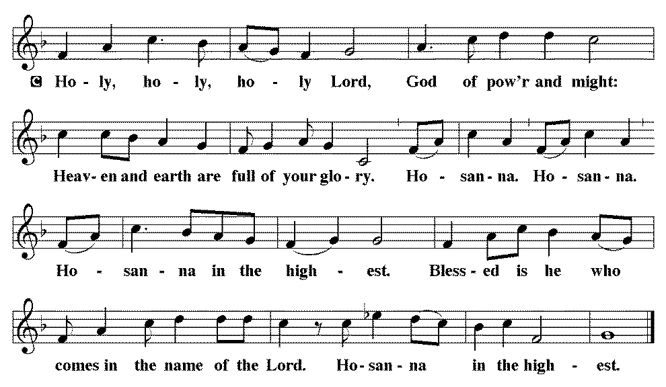

*THE GREAT Thanksgiving
You are indeed holy, almighty and merciful God.
You are most holy, and great is the majesty of your glory.

You so loved the world that you gave your only Son,
so that everyone who believes in him may not perish
but have eternal life.

We give you thanks for his coming into the world to fulfill for us your holy will and to accomplish all things for our salvation.

In the night in which he was betrayed,
our Lord Jesus took bread, and gave thanks;
broke it, and gave it to his disciples, saying:
Take and eat; this is my body, given for you.
Do this for the remembrance of me.

Again, after supper, he took the cup, gave thanks,
and gave it for all to drink, saying:
This cup is the new covenant in my blood,
shed for you and for all people for the forgiveness of sin.
Do this for the remembrance of me.

For as often as we eat of this bread and drink from this cup,
we proclaim the Lord’s death until he comes.
Christ has died. Christ is risen. Christ will come again.

Remembering, therefore, his salutary command, his life-giving passion and death, his glorious resurrection and ascension, and the promise of his coming again, we give thanks to you, O Lord God Almighty, not as we ought but as we are able;
we ask you mercifully to accept our praise and thanksgiving
and with your Word and Holy Spirit to bless us, your servants,
and these your own gifts of bread and wine,
so that we and all who share in the body and blood of Christ
may be filled with heavenly blessing and grace,
and, receiving the forgiveness of sin,
may be formed to live as your holy people
and be given our inheritance with all your saints.
To you, O God, Father, Son, and Holy Spirit,
be all honor and glory in your holy church, now and forever.
Amen.

*Lord's Prayer

Our Father, who art in heaven, hallowed be thy name,
thy kingdom come,
thy will be done,
on earth as it is in heaven.
Give us this day our daily bread;
and forgive us our trespasses,
as we forgive those
who trespass against us;
and lead us not into temptation,
but deliver us from evil.
For thine is the kingdom,
and the power, and the glory,
forever and ever. Amen.

*INVITATION TO HOLY COMMUNION

Christ invites you to this table.
All who are thirsty, all who are hungry, come!

AGNUS DEI (Lamb of God) ~ HOLY Communion 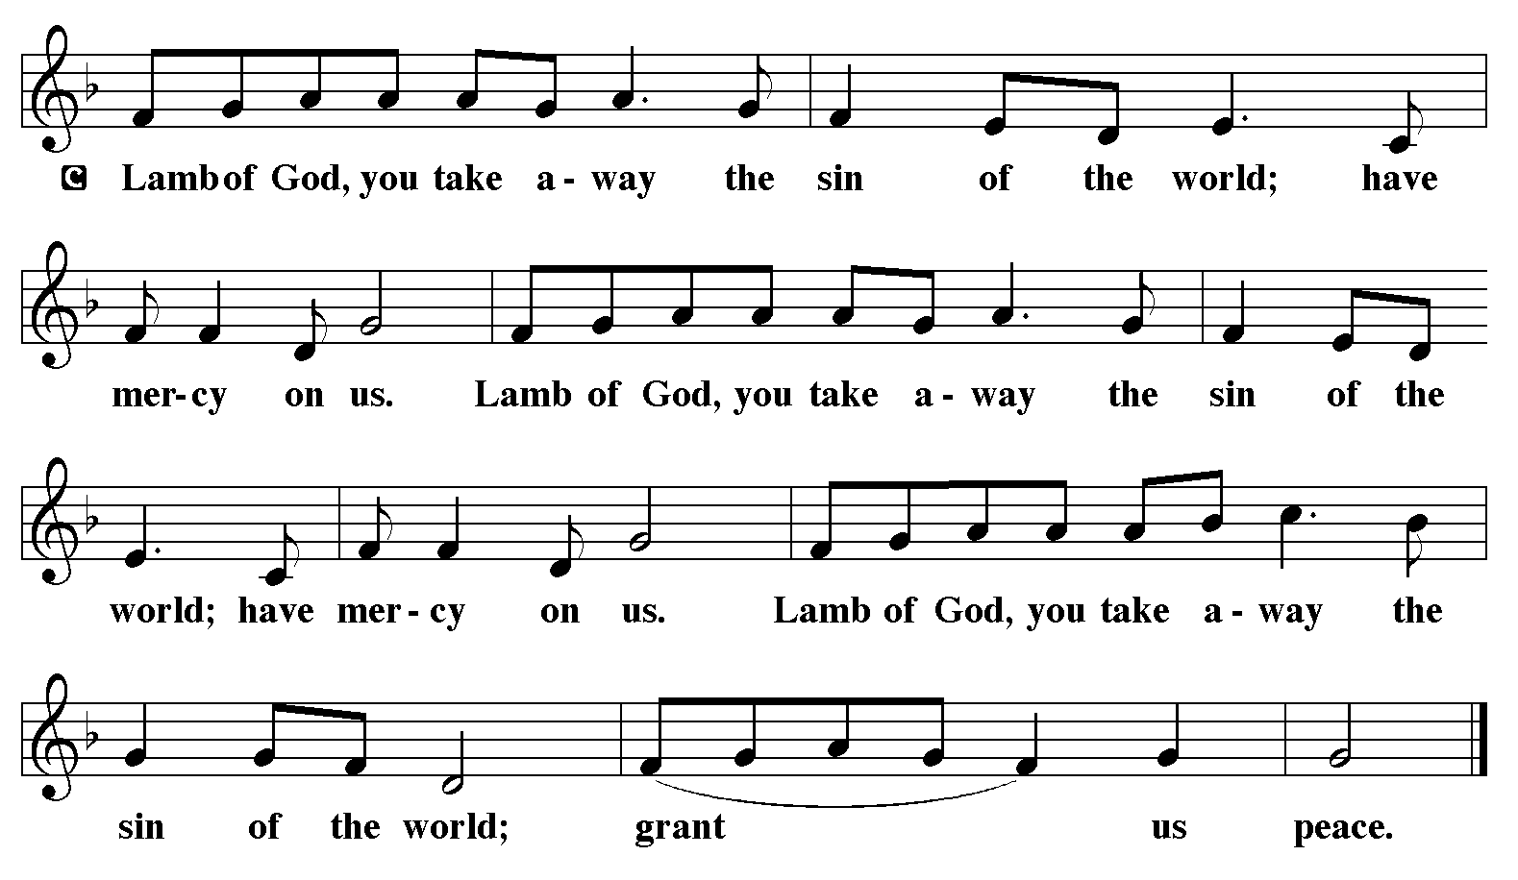
COMMUNION HYMN WOV 701
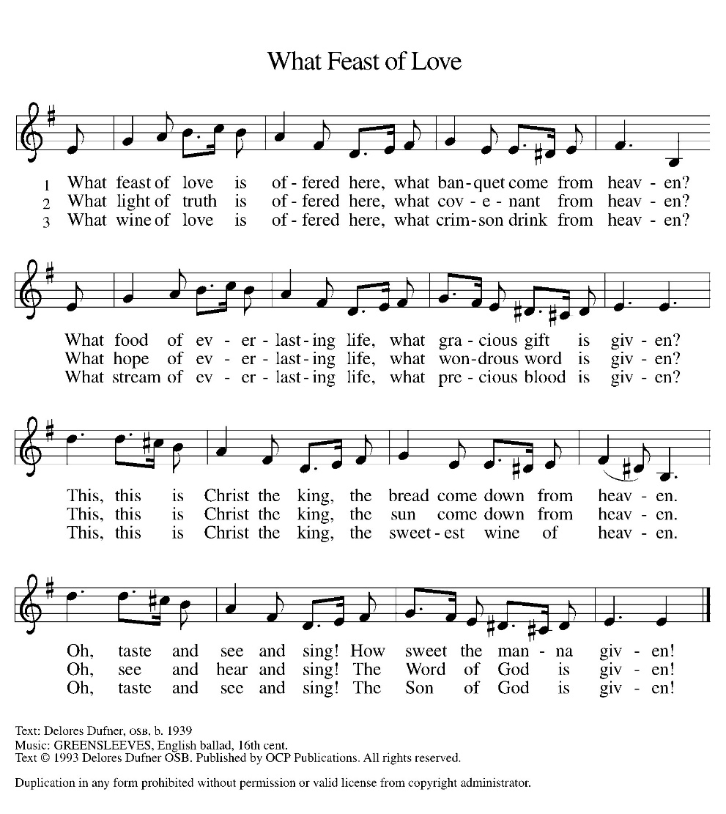
*BLESSING
May the body and blood of our Lord Jesus Christ strengthen you and keep you in his grace.
Amen

*Canticle
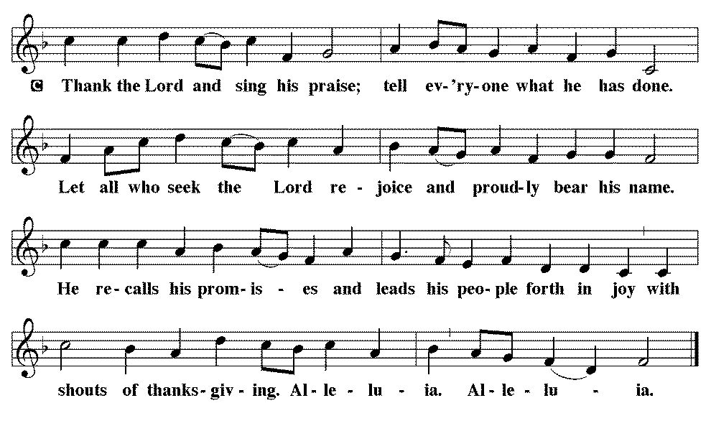

*Prayer after communion

Sustaining God,
with this bread and cup,
you nourish us with mercy and abundant life.
By your Spirit, send us from this table to serve a needy world.
Make us living signs of your liberation, healing, and love,
following the way of Jesus, in whose name we pray.
Amen.

*Blessing

The God of love
draw you into full accord and one mind,
in the body of Christ Jesus. Amen.
The God of hope
grant you strength and joy in all circumstances
through the interceding of the Spirit. Amen.
The God of grace
☩ bless you now and forever. Amen.

SENDING HYMN ELW 705
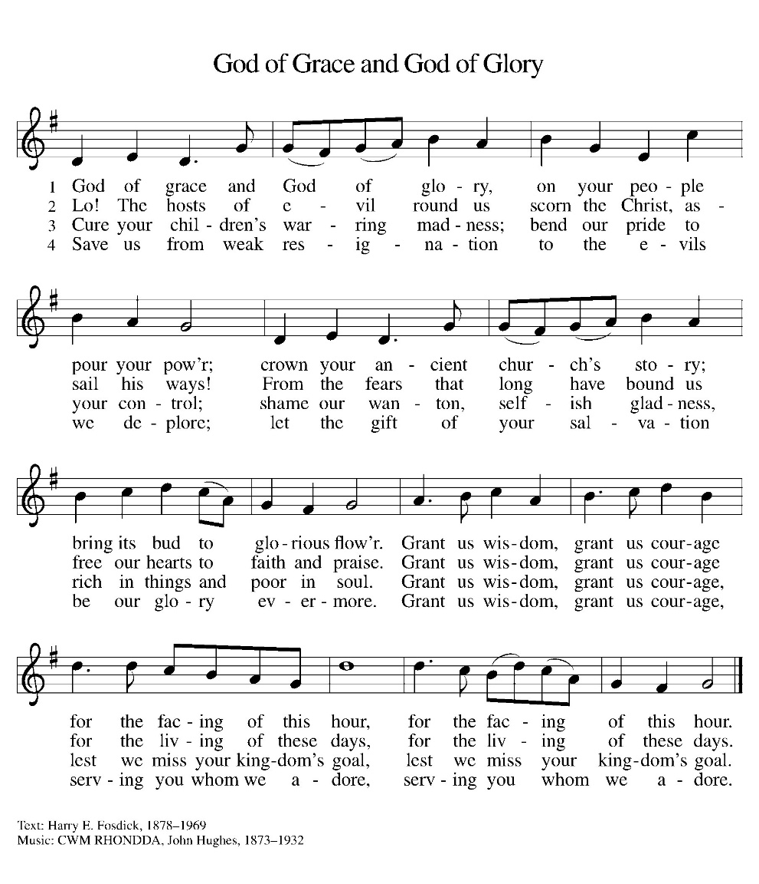
*Dismissal

Go out in joy. Be led forth in peace.
Thanks be to God.

From sundaysandseasons.com. Copyright © 2017 Augsburg Fortress. All rights reserved. Reprinted with permission OneLicenses.net #A-722514.

ANNOUNCEMENTS

Reminder of church coffee at 10:00 a.m. this Tuesday, October 20

October 25th—Spooktacular at McCandles Park from 3:00 to 5:00 p.m. Confirmation Class is hosting a booth

November 1st-- Fall Dinner
11:30 a.m. – 1:00 p.m.
Dine In or Drive Thru
Sign up sheets in the fellowship hall
Church service will be moved to 10:00 a.m.

A suggestion box has been placed on the table in the entry way. Please feel free to put any suggestions or comments for the council in it.

The new sound system has hearing aid assisted listening devices available for use. If you would like to use one, please speak with a council member before the church service.

If you have a favorite hymn you would like to sing during a future church service, please complete one of the cards on the table in the fellowship hall and place it in the basket provided.

There are sign up sheets (with class descriptions underneath) on the table in the entryway for classes that Pastor is offering to the congregation. If you are interested in one or more, please sign up.

Upcoming Community coffees are as follows:
October 23—Wymore City Office
October 30—St. Peter Lutheran Church
November 6—Wymore Library

Remembered in Our Prayers:
Jennifer Cohorst Kent Hohensee Dave Mick
Kathleen Remmers Eric Riley Kai Spann

Pastor Gary: Phone: (402) 658-2253
Email: garygrinvalds@gmail.com
If you wish to have Pastor visit you, please contact him to set up a time. Sunday afternoon & Thursday are his open days.

Your Council leaders are:
President: Josh Schmidt (402) 520-0950
Vice President: Chavonn Mailahn (308) 214-0039
Secretary: Rachel Frerichs (402) 239-0466
At Large: Roger Henrichs (402) 239-7740
Erin Saathoff (402) 239-9117
Jodi Wegner (402) 223-8263
Council meeting: October 22 at 6:30 p.m.

Church Account Balance: 09/30/2026: $40,993.12
Church Offerings: 10/04/2026: $ 1,096.00
10/11/2026: $ 1,356.00

Attendance: 10/11/2026: 45

October Birthdays Anniversaries
16 Landen McKeever 17 Caleb & Jesse Harms
17 Amelia Myer 18 Travis & Jonna Arnold
26 Jason Allington 23 Dave & Linda Creevan
27 Steve Epp
29 Natalie Trauernicht
31 Scott Trauernicht

