Sunday, August 30, 2026
14th Sunday of Pentecost

Our Savior’s Lutheran Church
Website: oursaviorswymore.com
8:00 AM Worship 9:00 AM Fellowship
Faith Formation 5:30 PM Wednesdays

Pastor Gary Grinvalds

Organist: Alice Meints or Sandy Eltiste

Introduction to the day
The prophet Jeremiah speaks of the incurable wound of his suffering yet finds in God’s words the delight of his heart. When Peter doesn’t grasp Jesus’ words about suffering, Jesus tells the disciples they will find their lives in losing them. Such sacrificial love is described by Paul when he urges us to associate with the lowly and not repay evil with evil. In worship we gather as a community that we might offer ourselves for the sake of our suffering world.

*Please Stand
Congregational responses in bold print

WELCOME AND ANNOUNCEMENTS

*Brief order for CONFESSION AND FORGIVENESS

Blessed be the holy Trinity,☩ one God,
whose compassion endures forever.
Amen.
Let us confess our sin to God.
Silence is kept for reflection.
Compassionate God,
we confess to you all our sins.
Our burden is heavy, and we cannot free ourselves.
In your mercy, call us back to you.
Your yoke is easy and your burden is light.
Restore us to dwell in your peace.
In Christ’s name we pray,
Amen.
Jesus says, “Come to me,
all you who are weary
and are carrying heavy burdens,
and I will give you rest.”
In the name of God,
Father, ☩ Son, and Holy Spirit,
your sins are forgiven.
Rest in God’s love.
Amen.

Entrance Hymn ELW 597
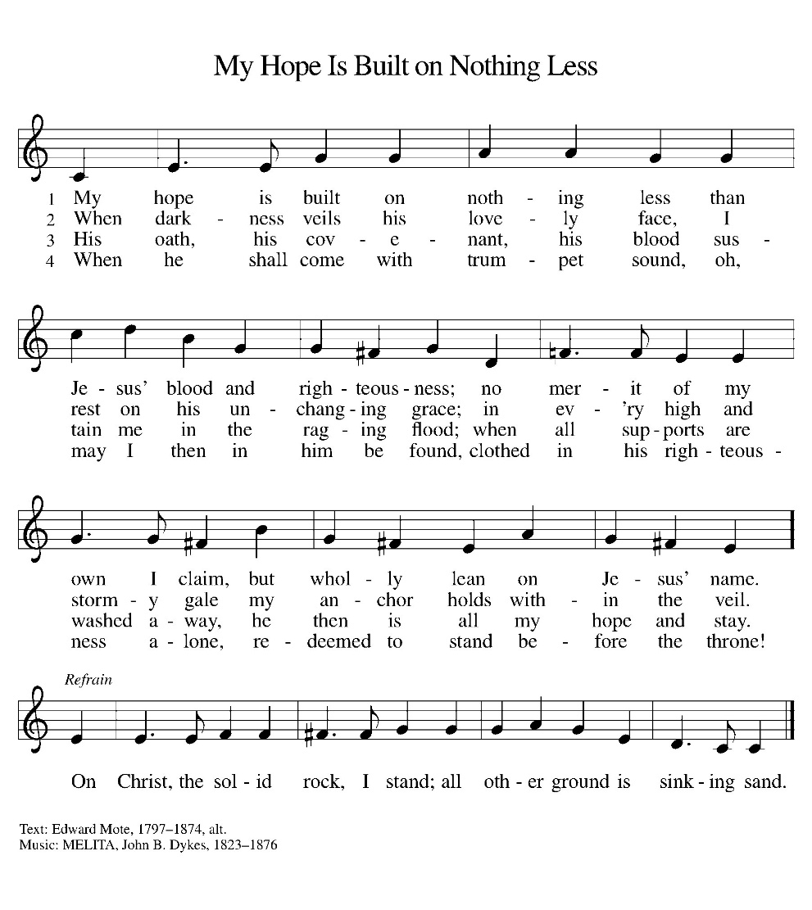

*Blessed are you, O Lord our God, king of the universe,
For in your wisdom you have formed us.
You feed the hungry and clothe the naked,
We bless you and praise your name forever.
You set free those who are bound.
We bless you and praise your name forever.
You raise up those whose courage falters.
We bless you and praise your name forever.
You provide for our every need.
Accept our grateful praises.
You have called us from all peoples.
We rejoice and bless your name forever.
You bless your people with peace.
We bless you and praise your loving grace.
Blessed are you, O Lord our God, king of the universe,
For in your wisdom you have formed us.

*Prayer of the Day

The Lord be with you.
And also with you.

Let us pray.

O God, we thank you for your Son, who chose the path of suffering for the sake of the world. Humble us by his example, point us to the path of obedience, and give us strength to follow your commands, through Jesus Christ, our Savior and Lord.
Amen.

HYMN ELW 785
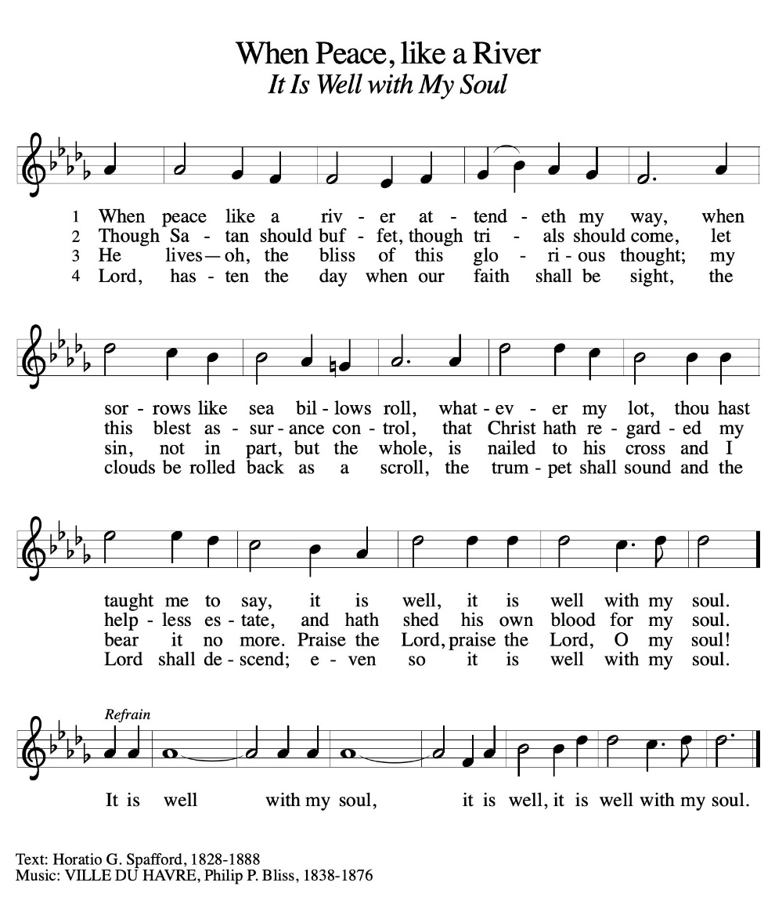

First Lesson: Jeremiah 15:15-21
Jeremiah’s delight in the word of the Lord is contradicted by the heaviness of God’s hand upon him and God’s seeming unfaithfulness. God’s tough love to Jeremiah says that if he repents, he will be allowed to continue in his strenuous ministry. Jeremiah is strengthened by the simple words, “I am with you.”
¹⁵ O Lord, you know; remember me and visit me, and bring down retribution for me on my persecutors. In your forbearance do not take me away; know that on your account I suffer insult. ⁶ Your words were found, and I ate them, and your words became to me a joy and the delight of my heart, for I am called by your name, O Lord, God of hosts. ¹⁷ I did not sit in the company of merrymakers, nor did I rejoice; under the weight of your hand I sat alone, for you had filled me with indignation. ¹⁸ Why is my pain unceasing, my wound incurable, refusing to be healed? Truly, you are to me like a deceitful brook, like waters that fail.
¹⁹ Therefore thus says the Lord: If you turn back, I will take you back, and you shall stand before me. If you utter what is precious and not what is worthless, you shall serve as my mouth. It is they who will turn to you, not you who will turn to them. ²⁰ And I will make you to this people a fortified wall of bronze; they will fight against you, but they shall not prevail over you, for I am with you to save you and deliver you, says the Lord. ²¹ I will deliver you out of the hand of the wicked and redeem you from the grasp of the ruthless.
Word of God, Word of life.
Thanks be to God.

Psalm 26:1-8 Read Responsively

¹ Give judgment for me, O Lord, for I have lived with integrity; I have trusted in the Lord and have not faltered.
² Test me, O Lord, and try me; examine my heart and my mind.
³ For your steadfast love is before my eyes; I have walked faithfully with you.
⁴ I have not sat with the worthless, nor do I consort with the deceitful.
⁵ I have hated the company of evildoers; I will not sit down with the wicked.
⁶ I will wash my hands in innocence, O Lord, that I may go in procession round your altar,
⁷ singing aloud a song of thanksgiving and recounting all your wonderful deeds.
⁸ Lord, I love the house in which you dwell and the place where your glory abides.

Second Lesson: Romans 12:9-21
Paul presents benchmarks for faithful relationships with Christians and non-Christians. Love is the unflagging standard of our behavior. When we encounter evil, we do not resort to its tactics but seek to overcome it with good. While Christians cannot control the actions and attitudes of others, we seek to live at peace with all people.
⁹ Let love be genuine; hate what is evil; hold fast to what is good; ¹⁰ love one another with mutual affection; outdo one another in showing honor. ¹¹ Do not lag in zeal; be ardent in spirit; serve the Lord. ¹² Rejoice in hope; be patient in affliction; persevere in prayer. ¹³ Contribute to the needs of the saints; pursue hospitality to strangers.
¹⁴ Bless those who persecute you; bless and do not curse them. ¹⁵ Rejoice with those who rejoice; weep with those who weep. ¹⁶ Live in harmony with one another; do not be arrogant, but associate with the lowly; do not claim to be wiser than you are. ¹⁷ Do not repay anyone evil for evil, but take thought for what is noble in the sight of all. ¹⁸ If it is possible, so far as it depends on you, live peaceably with all. ¹⁹ Beloved, never avenge yourselves, but leave room for the wrath of God, for it is written, “Vengeance is mine; I will repay, says the Lord.” ²⁰ Instead, “if your enemies are hungry, feed them; if they are thirsty, give them something to drink, for by doing this you will heap burning coals on their heads.” ²¹ Do not be overcome by evil, but overcome evil with good.
Word of God, Word of life.
Thanks be to God.

childrens sermon

*sermon text: Acts 16:20-34

²⁰ When they had brought them before the magistrates, they said, “These men, these Jews, are disturbing our city ²¹ and are advocating customs that are not lawful for us, being Romans, to adopt or observe.” ²² The crowd joined in attacking them, and the magistrates had them stripped of their clothing and ordered them to be beaten with rods. ²³ After they had given them a severe flogging, they threw them into prison and ordered the jailer to keep them securely. ²⁴ Following these instructions, he put them in the innermost cell and fastened their feet in the stocks.
²⁵ About midnight Paul and Silas were praying and singing hymns to God, and the prisoners were listening to them. ²⁶ Suddenly there was an earthquake so violent that the foundations of the prison were shaken, and immediately all the doors were opened and everyone’s chains were unfastened. ²⁷ When the jailer woke up and saw the prison doors wide open, he drew his sword and was about to kill himself, since he supposed that the prisoners had escaped. ²⁸ But Paul shouted in a loud voice, “Do not harm yourself, for we are all here.” ²⁹ The jailer called for lights, and rushing in, he fell down trembling before Paul and Silas. ³⁰ Then he brought them outside and said, “Sirs, what must I do to be saved?” ³¹ They answered, “Believe in the Lord Jesus, and you will be saved, you and your household.” ³² They spoke the word of the Lord to him and to all who were in his house. ³³ At the same hour of the night he took them and washed their wounds; then he and his entire family were baptized without delay. ³⁴ He brought them up into the house and set food before them, and he and his entire household rejoiced that he had become a believer in God.
Word of God, Word of life.
Thanks be to God.

Sermon pastor GARY GRINVALDS

HYMN OF THE DAY ELW 779
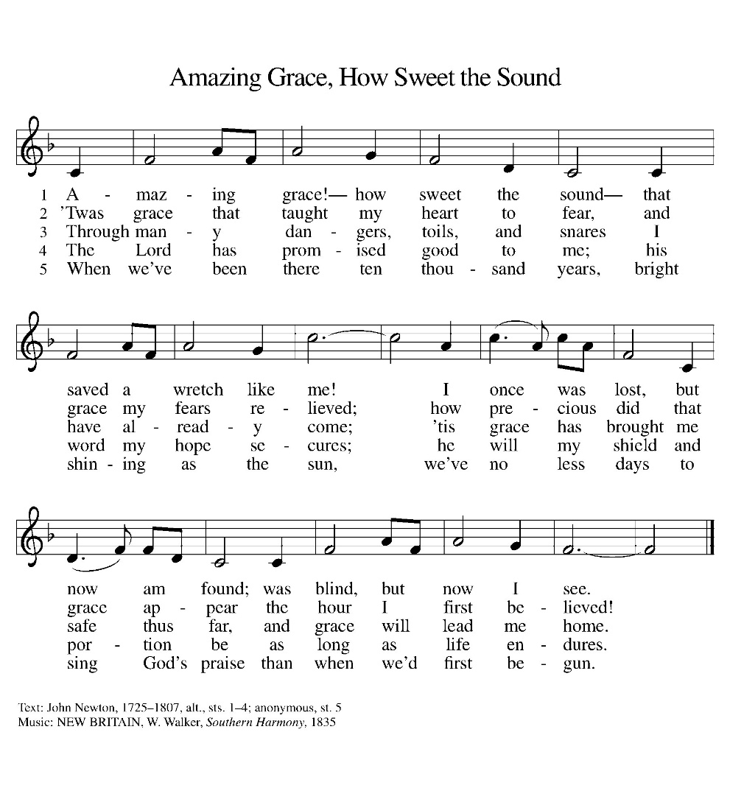

*APOSTLES Creed

I believe in God, the Father almighty,
creator of heaven and earth.
I believe in Jesus Christ, his only Son, our Lord.
He was conceived by the power of the Holy Spirit
and born of the virgin Mary.
He suffered under Pontius Pilate,
was crucified, died, and was buried.
He descended into hell.
On the third day he rose again.
He ascended into heaven,
and is seated at the right hand of the Father.
He will come again to judge the living and the dead.
I believe in the Holy Spirit,
the holy catholic Church,
the communion of saints,
the forgiveness of sins,
the resurrection of the body,
and the life everlasting. Amen

OFFERING

*OFFERTORY Sing verses 1 and 2

*The Prayers
With bold trust in God’s unfailing provision, we pray for the church, those in need, and all of God’s creation.
A brief silence.
For the church in every land, that its mission and ministry is anchored in the love of Christ. When threats or challenges arise, teach us to take up our cross and follow you in faith. Merciful God,
receive our prayer.
For the well-being of your creation, that all that lives and grows on the earth may thrive. Bring relief to areas ravaged by droughts, floods, fires, storms, and other disasters. Merciful God,
receive our prayer.
For the nations and all in authority, that they seek to live in peace with one another. Bless the work of international and diplomatic organizations and all who work to bring peace to a world scarred by violence. Merciful God,
receive our prayer.
For all those in need, that they be satisfied. Ensure all your children have safe access to food, water, shelter, and medical care. Bring healing to all who bear wounds in body, mind, and spirit (especially). Merciful God,
receive our prayer.
For the congregation gathered here to serve you, that they remain strong in faith and united in purpose. Guide our committees, study groups, and other meetings toward honesty and humility, always seeking genuine love. Merciful God,
receive our prayer.
For the faithful departed, that their witness continues to strengthen and guide the church. Renew our hope in your promises in this life and the life to come. Merciful God,
receive our prayer.
Receive our prayers and answer, O God, as you have promised. All this we ask in the name of your Son, Jesus Christ our Lord.
Amen.

*Lord's Prayer

Our Father, who art in heaven, hallowed be thy name,
thy kingdom come,
thy will be done,
on earth as it is in heaven.
Give us this day our daily bread;
and forgive us our trespasses,
as we forgive those
who trespass against us;
and lead us not into temptation,
but deliver us from evil.
For thine is the kingdom,
and the power, and the glory,
forever and ever. Amen.

*Blessing

The Lord bless us and keep us.
The Lord make his face shine on us and be gracious to us.
The Lord look upon us with favor and give us peace.
Amen.

SENDING HYMN ELW 805
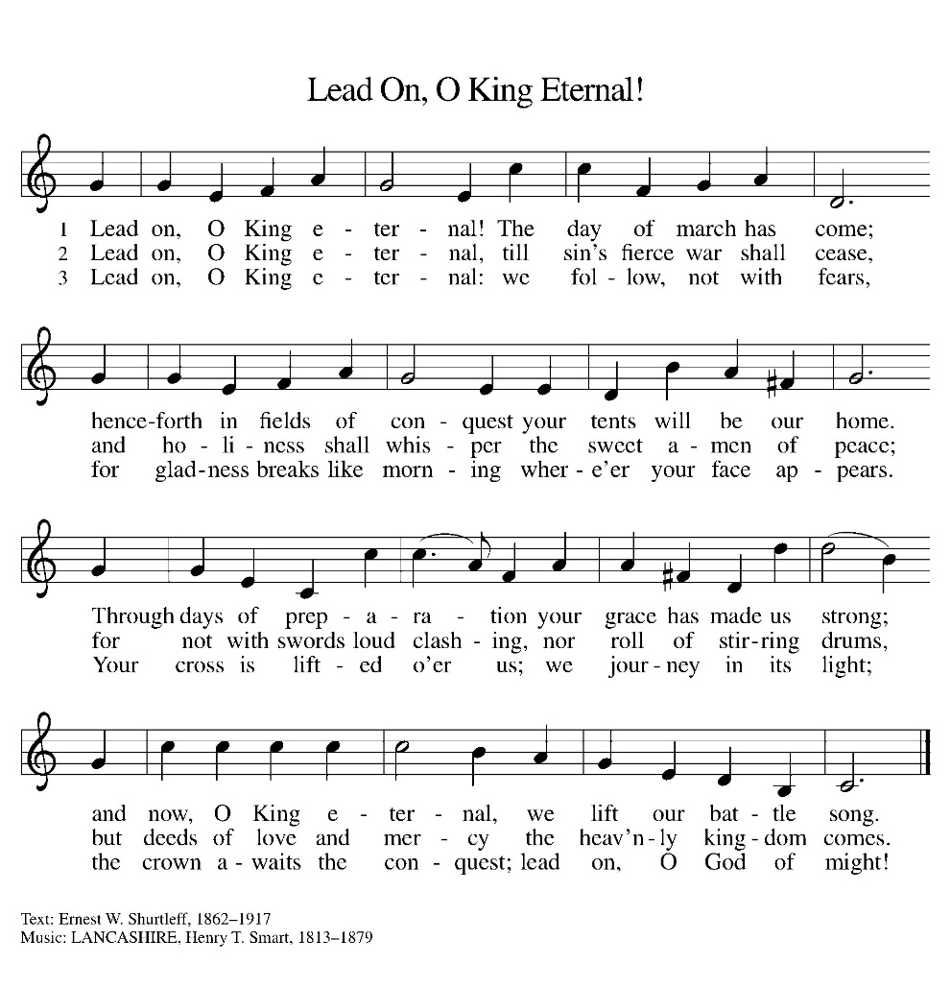
Dismissal
Heaven has come near. Go, share the good news!
Thanks be to God.

From sundaysandseasons.com. Copyright © 2017 Augsburg Fortress. All rights reserved. Reprinted with permission OneLicenses.net #A-722514.

ANNOUNCEMENTS

Reminder of church coffee at 10 a.m. this Tuesday, September 1

Bible Study at 6:00 this Thursday, September 3

Faith Formation & Confirmation classes will begin on September 9, 2026. Faith Formation meets at 5:30 here at church. Confirmation classes start 4:30 at Filley.

If you have a favorite hymn you would like to sing during a future church service, please complete one of the cards on the table in the fellowship hall and place it in the basket provided.

There are sign up sheets on the table in the entryway for the classes that Pastor is offering to the congregation. If you are interested in any of these, please sign up. There are also descriptions of each class beneath the sign up sheet.

Upcoming Community coffees are as follows:
September 4—Wymore Library

Remembered in Our Prayers:
Jennifer Cohorst Kent Hohensee
Kathleen Remmers Eric Riley Kai Spann
Family & friends of Dusty Adams who passed away this week.

Pastor Gary: Phone: (402) 658-2253
Email: garygrinvalds@gmail.com
If you wish to have Pastor visit you, please contact him to set up a time. Sunday afternoon & Thursday are his open days.

Your Council leaders are:
President: Josh Schmidt (402) 520-0950
Vice President: Chavonn Mailahn (308) 214-0039
Secretary: Rachel Frerichs (402) 239-0466
At Large: Roger Henrichs (402) 239-7740
Erin Saathoff (402) 239-9117
Jodi Wegner (402) 223-8263
Council meetings are now held on the 3rd Thursday of each month after Bible Study.

Church Account Balance: 07/31/2026: $53,458.94
Church Offerings: 08/02/2026: $ 915.00
08/09/2026: $ 1,272.00
08/16/2026: $ 817.00
08/23/2026: $ 471.00

Attendance: 08/23/2026: 43

September Birthdays Anniversaries
01 Jaxson Mailahn 05 Jeff & Kelli Murphy
02 Charleigh Acton
07 Emery Saathoff
12 Betsy Frerichs
15 Caleb McKeever
15 Dorothy Skeens
16 Hadlee Maxson
19 Seth Saathoff
20 Jacques Smit 20 Jacques & Jamie Smit
21 Mosely Weyer 24 Jason & Dyan Allington
22 Ron Schroeder 26 Gary & Larissa Grinvalds
27 Jaidyn Allington 28 Steve & Shelley Whitwer
30 Jared Epp
30 Rachel Frerichs

Please have any announcements for the bulletin to Pam by Wednesday noon each week. You may text or call her at
(402) 239-2715 or send an email to the church at oursaviorslutheranwymore@gmail.com. Thank you.

