Sunday, October 4, 2026
19th Sunday of Pentecost

Our Savior’s Lutheran Church
Website: oursaviorswymore.com
8:00 AM Worship 9:00 AM Fellowship
Faith Formation 5:30 PM Wednesdays

Pastor Gary Grinvalds

Organist: Alice Meints or Sandy Eltiste

Introduction to the day
In today’s gospel reading, Jesus tells a vineyard parable, which serves as an image of Israel, the prophets’ mission, and Christ’s death. For Christians, the vineyard also speaks of God’s love poured out in the blood of Christ, given to us for the forgiveness of sin. Grafted onto Christ the vine at baptism, we are nourished with wine and bread so that we may share Christ’s sufferings and know the power of his resurrection.

*Please Stand
Congregational responses in bold print

WELCOME AND ANNOUNCEMENTS

*Brief order for CONFESSION AND FORGIVENESS

Blessed be the holy Trinity, ☩ one God,
who pours love into our hearts
and healing upon the earth.
Amen.
Confident that God justifies us by grace through faith,
let us confess our sin.
Silence is kept for reflection.
Compassionate God,
we confess that we struggle to embody your goodness
in the world and in our own hearts.
Creation groans from overuse.
Jealousy and bitterness strain our relationships.
Indifference keeps us from seeking justice.
Divisions disrupt your call to show genuine love
to others.
Turn our hearts back to you.
Restore our world and reconcile us to one another.
Renew us to live as your holy people,
following the way of Jesus Christ.
Amen.
Hear this good news:
We have peace with God through ☩ Jesus Christ,
in whom there is no condemnation,
but only forgiveness and the promise of eternal life.
Receive freely this healing gift of grace.
Amen.

*Entrance Hymn ELW 832
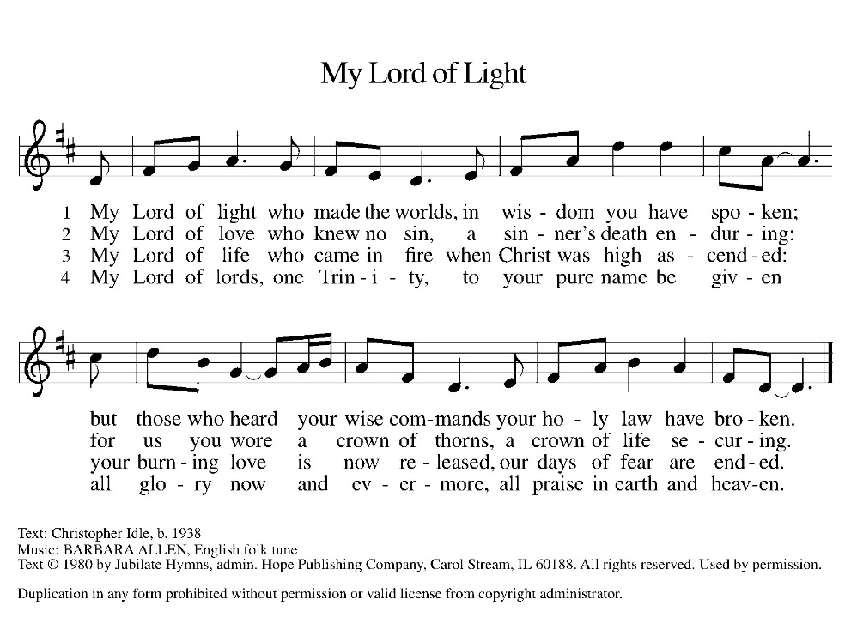

*Greeting

The grace of our Lord Jesus Christ, the love of God, and the communion of the Holy Spirit be with you all.
And also with you.

*Kyrie LBW pg 57
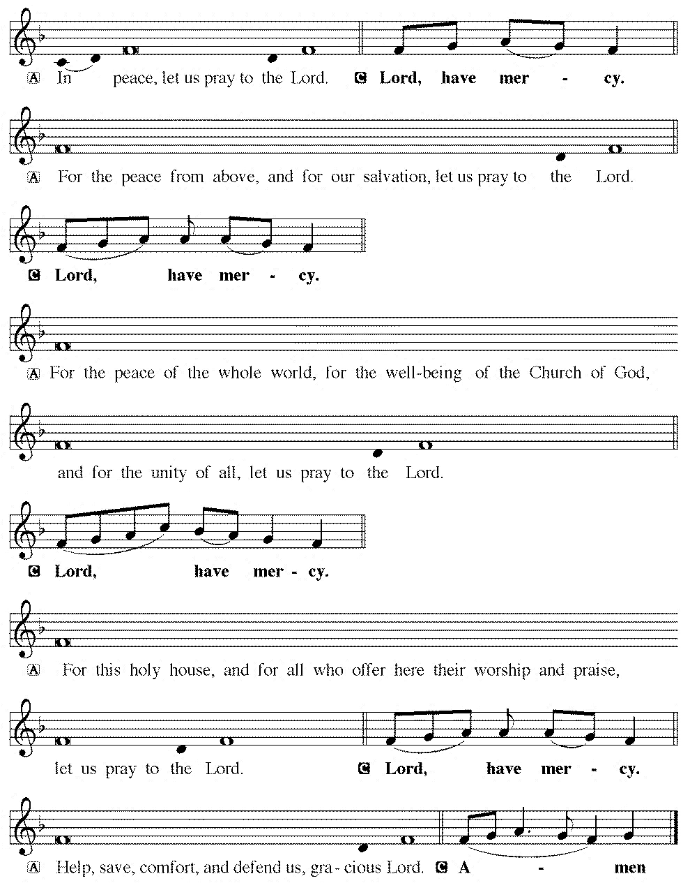

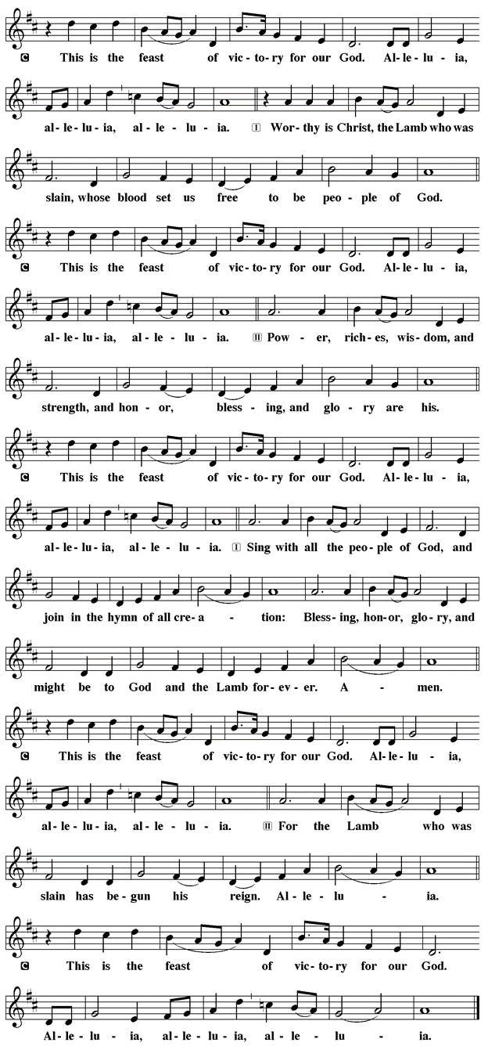
*Prayer of the Day

The Lord be with you.
And also with you.

Let us pray.

Beloved God, from you come all things that are good. Lead us by the inspiration of your Spirit to know those things that are right, and by your merciful guidance, help us to do them, through Jesus Christ, our Savior and Lord.
Amen.

First Lesson: Isaiah 5:1-7
The prophet sings a sad, parable-like love song about the relationship between God and Israel. In this song Israel is compared to a promising vineyard. Despite God’s loving care, the vineyard that is Israel has brought forth “rotten grapes” of injustice and distress, when fine grapes of justice and righteousness were expected.
¹ I will sing for my beloved my love song concerning his vineyard: My beloved had a vineyard on a very fertile hill. ² He dug it and cleared it of stones and planted it with choice vines; he built a watchtower in the midst of it and hewed out a wine vat in it; he expected it to yield grapes, but it yielded rotten grapes. ³ And now, inhabitants of Jerusalem and people of Judah, judge between me and my vineyard. ⁴ What more was there to do for my vineyard that I have not done in it? When I expected it to yield grapes, why did it yield rotten grapes? ⁵ And now I will tell you what I will do to my vineyard. I will remove its hedge, and it shall be devoured; I will break down its wall, and it shall be trampled down. ⁶ I will make it a wasteland; it shall not be pruned or hoed, and it shall be overgrown with briers and thorns; I will also command the clouds that they rain no rain upon it. ⁷ For the vineyard of the Lord of hosts is the house of Israel, and the people of Judah are his cherished garden; he expected justice but saw bloodshed; righteousness but heard a cry!
Word of God, Word of life.
Thanks be to God.
Psalm 80:7-15 Read Responsively

⁷ Restore us, O God of hosts; let your face shine upon us, and we shall be saved.
⁸ You have brought a vine out of Egypt; you cast out the nations and planted it.
⁹ You cleared the ground for it; it took root and filled the land.
¹⁰ The mountains were covered by its shadow and the towering cedar trees by its boughs.
¹¹ You stretched out its tendrils to the sea and its branches to the river.
¹² Why have you broken down its wall, so that all who pass by pluck off its grapes?
¹³ The wild boar of the forest has ravaged it, and the beasts of the field have grazed upon it.
¹⁴ Turn now, O God of hosts, look down from heaven;
¹⁵ behold and tend this vine; preserve what your right hand has planted.

Second Lesson: Philippians 3:4b-14
Paul reviews some of his supposed credentials, which no longer have any bearing in comparison to the right relationship he has been given through the death of Christ. The power of Christ’s resurrection motivates him to press on toward the ultimate goal, eternal life with Christ.
[Paul writes:] ^{4b} If anyone else has reason to be confident in the flesh, I have more: ⁵ circumcised on the eighth day, a member of the people of Israel, of the tribe of Benjamin, a Hebrew born of Hebrews; as to the law, a Pharisee; ⁶ as to zeal, a persecutor of the church; as to righteousness under the law, blameless.
⁷ Yet whatever gains I had, these I have come to regard as loss because of Christ. ⁸ More than that, I regard everything as loss because of the surpassing value of knowing Christ Jesus my Lord. For his sake I have suffered the loss of all things, and I regard them as rubbish, in order that I may gain Christ ⁹ and be found in him, not having a righteousness of my own that comes from the law but one that comes through faith in Christ, the righteousness from God based on faith. ¹⁰ I want to know Christ and the power of his resurrection and the sharing of his sufferings by becoming like him in his death, ¹¹ if somehow I may attain the resurrection from the dead.
¹² Not that I have already obtained this or have already reached the goal, but I press on to lay hold of that for which Christ has laid hold of me. ¹³ Brothers and sisters, I do not consider that I have laid hold of it, but one thing I have laid hold of: forgetting what lies behind and straining forward to what lies ahead, ¹⁴ I press on toward the goal, toward the prize of the heavenly call of God in Christ Jesus.

Word of God, Word of life.
Thanks be to God.

childrens sermon

*Gospel: Matthew 21:33-46

Glory to you, O Lord.

Jesus tells a parable to the religious leaders who are plotting his death, revealing that their plans will, ironically, bring about the fulfillment of scripture.
[Jesus said:] ³³ “Listen to another parable. There was a landowner who planted a vineyard, put a fence around it, dug a winepress in it, and built a watchtower. Then he leased it to tenants and went away. ³⁴ When the harvest time had come, he sent his slaves to the tenants to collect his produce. ³⁵ But the tenants seized his slaves and beat one, killed another, and stoned another. ³⁶ Again he sent other slaves, more than the first, and they treated them in the same way. ³⁷ Then he sent his son to them, saying, ‘They will respect my son.’ ³⁸ But when the tenants saw the son, they said to themselves, ‘This is the heir; come, let us kill him and get his inheritance.’ ³⁹ So they seized him, threw him out of the vineyard, and killed him. ⁴⁰ Now when the owner of the vineyard comes, what will he do to those tenants?” ⁴¹ They said to him, “He will put those wretches to a miserable death and lease the vineyard to other tenants who will give him the produce at the harvest time.”
⁴² Jesus said to them, “Have you never read in the scriptures:
‘The stone that the builders rejected has become the cornerstone;
this was the Lord’s doing, and it is amazing in our eyes’?
⁴³ “Therefore I tell you, the kingdom of God will be taken away from you and given to a people that produces its fruits. ⁴⁴ The one who falls on this stone will be broken to pieces, and it will crush anyone on whom it falls.”
⁴⁵ When the chief priests and the Pharisees heard his parables, they realized that he was speaking about them. ⁴⁶ They wanted to arrest him, but they feared the crowds, because they regarded him as a prophet.
The Gospel of our Lord

Praise to you, O Christ.

Sermon pastor GARY GRINVALDS

HYMN OF THE DAY ELW 342
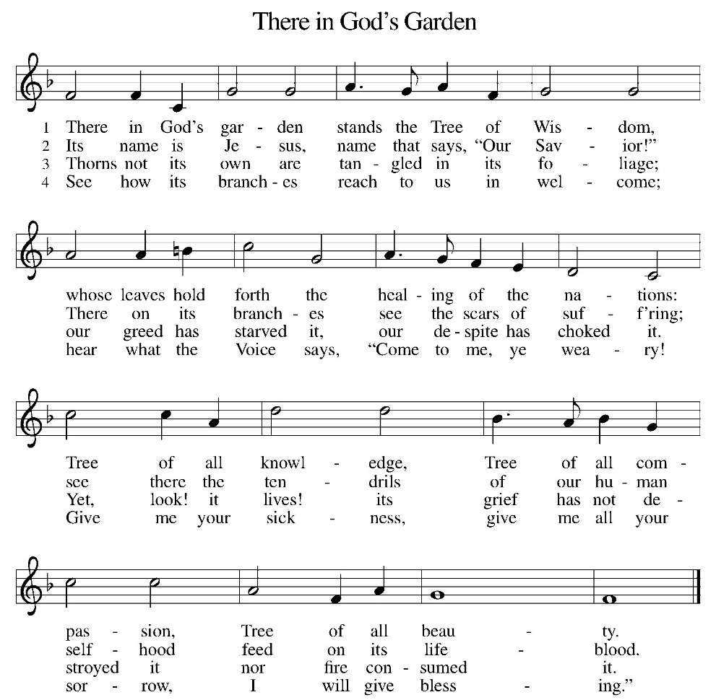
*NICENE CREED
We believe in one God,
the Father, the Almighty,
maker of heaven and earth,
of all that is, seen and unseen.
We believe in one Lord, Jesus Christ,
the only Son of God,
eternally begotten of the Father,
God from God, Light from Light,
true God from true God,
begotten, not made,
of one Being with the Father;
through him all things were made.
For us and for our salvation
he came down from heaven,
was incarnate of the Holy Spirit and the virgin Mary,
and became truly man.
For our sake he was crucified under Pontius Pilate;
he suffered death and was buried.
On the third day he rose again
in accordance with the scriptures;
he ascended into heaven
and is seated at the right hand of the Father.
He will come again in glory to judge the living and the dead, and his kingdom will have no end.
We believe in the Holy Spirit, the Lord, the giver of life,
who proceeds from the Father and the Son,
who with the Father and the Son is worshiped and glorified, who has spoken through the prophets.
We believe in one holy catholic and apostolic church.
We acknowledge one baptism for the forgiveness of sins.
We look for the resurrection of the dead,
and the life of the world to come. Amen.

*The Prayers
Seeking the Spirit of God who makes all things new, we pray for the church and the world.
A brief silence.
God of every generation, we give thanks for all who have sought to renew and transform your holy church). Inspire us to follow their example in our own day. Hear us, O God.
Your mercy is great.
God of every creature, bless and protect the earth and all those who dwell within it. We give thanks for those who have helped us to see your Spirit in creation. Hear us, O God.
Your mercy is great.
God of every tribe and nation, restore peace to the world’s conflict zones, and shelter those who live within them. We pray especially for the safety of displaced people and refugees. Hear us, O God.
Your mercy is great.
God of every comfort, you made us in your own image. Grant healing and relief to all who are sick or suffering. Hear us, O God.
Your mercy is great.
God of every truth, you draw us nearer to you through your holy word. We give thanks for teachers of the faith. Fill their hearts with your Spirit, that they inspire others with your truth. Hear us, O God.
Your mercy is great.
God of every soul, you are the one who calls us home. We give thanks for all the saints who have been restored to perfect unity with you. Hear us, O God.
Your mercy is great.
Trusting in your boundless grace, O God, we lift up these spoken prayers and those in our hearts; through Jesus Christ our Lord.
Amen.

*Peace
The peace of the Lord be with you always.
And also with you.

OFFERING

*Offertory Sing Verses 2&3

*Offertory Prayer

God of creation,
you send rain and the earth springs forth abundantly.
All blessings are from you;
make us generous with what we have.
Use our gifts, our abilities, and our hearts
in service to you and in love to our neighbors,
today and always.
Amen.

*Dialogue

The Lord be with you.
And also with you.

Lift up your hearts.
We lift them to the Lord.

Let us give thanks to the Lord our God.
It is right to give our thanks and praise

*Preface

It is indeed right, our duty and our joy,
that we should at all times and in all places
give thanks and praise to you, almighty and merciful God,
through our Savior Jesus Christ;
who on this day overcame death and the grave,
and by his glorious resurrection opened to us the way of everlasting life.
And so, with all the choirs of angels,
with the church on earth and the hosts of heaven,
we praise your name and join their unending hymn:

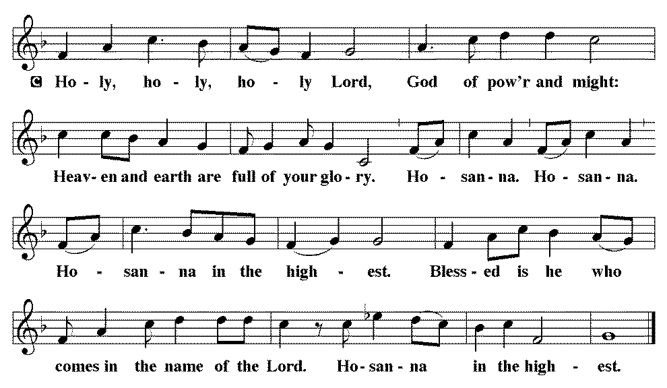

*THE GREAT Thanksgiving
You are indeed holy, almighty and merciful God.
You are most holy, and great is the majesty of your glory.

You so loved the world that you gave your only Son,
so that everyone who believes in him may not perish
but have eternal life.

We give you thanks for his coming into the world to fulfill for us your holy will and to accomplish all things for our salvation.

In the night in which he was betrayed,
our Lord Jesus took bread, and gave thanks;
broke it, and gave it to his disciples, saying:
Take and eat; this is my body, given for you.
Do this for the remembrance of me.

Again, after supper, he took the cup, gave thanks,
and gave it for all to drink, saying:
This cup is the new covenant in my blood,
shed for you and for all people for the forgiveness of sin.
Do this for the remembrance of me.

For as often as we eat of this bread and drink from this cup,
we proclaim the Lord’s death until he comes.
Christ has died. Christ is risen. Christ will come again.

Remembering, therefore, his salutary command, his life-giving passion and death, his glorious resurrection and ascension, and the promise of his coming again, we give thanks to you, O Lord God Almighty, not as we ought but as we are able;
we ask you mercifully to accept our praise and thanksgiving
and with your Word and Holy Spirit to bless us, your servants,
and these your own gifts of bread and wine,
so that we and all who share in the body and blood of Christ
may be filled with heavenly blessing and grace,
and, receiving the forgiveness of sin,
may be formed to live as your holy people
and be given our inheritance with all your saints.
To you, O God, Father, Son, and Holy Spirit,
be all honor and glory in your holy church, now and forever.
Amen.

*Lord's Prayer

Our Father, who art in heaven, hallowed be thy name,
thy kingdom come,
thy will be done,
on earth as it is in heaven.
Give us this day our daily bread;
and forgive us our trespasses,
as we forgive those
who trespass against us;
and lead us not into temptation,
but deliver us from evil.
For thine is the kingdom,
and the power, and the glory,
forever and ever. Amen.

*INVITATION TO HOLY COMMUNION

Christ invites you to this table.
All who are thirsty, all who are hungry, come!

AGNUS DEI (Lamb of God) ~ HOLY Communion 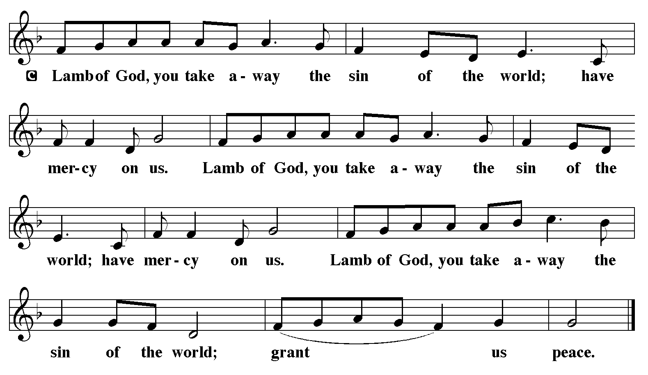
COMMUNION HYMN ELW 595
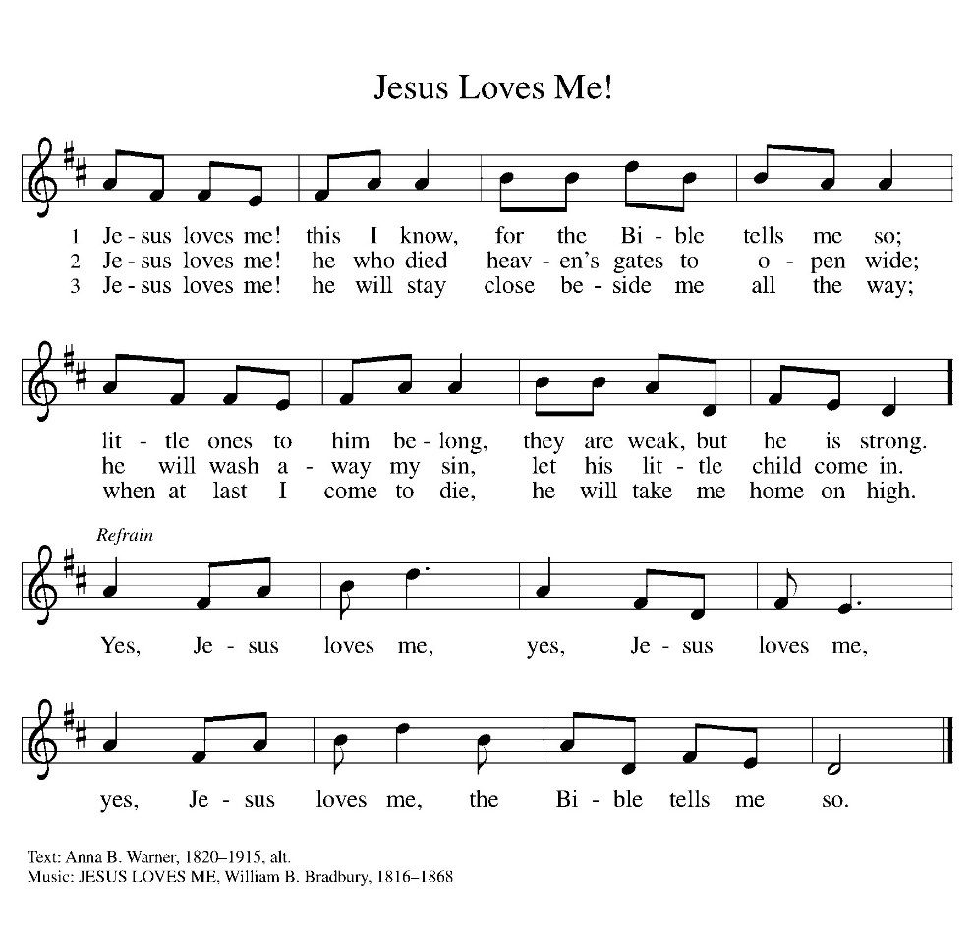

*BLESSING
May the body and blood of our Lord Jesus Christ strengthen you and keep you in his grace.
Amen

*Canticle
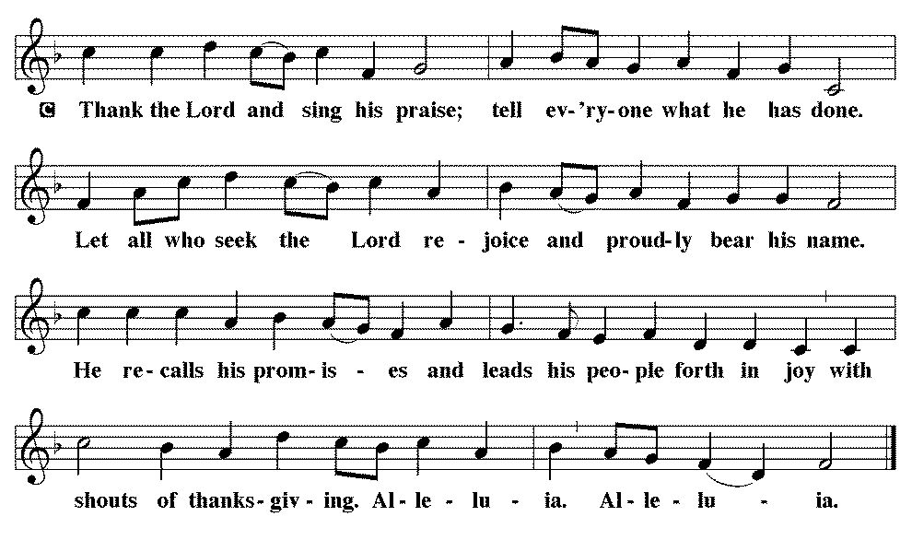

*Prayer after communion

Sustaining God,
with this bread and cup,
you nourish us with mercy and abundant life.
By your Spirit, send us from this table to serve a needy world.
Make us living signs of your liberation, healing, and love,
following the way of Jesus, in whose name we pray.
Amen.

*Blessing

The God of love
draw you into full accord and one mind,
in the body of Christ Jesus. Amen.
The God of hope
grant you strength and joy in all circumstances
through the interceding of the Spirit. Amen.
The God of grace
☩ bless you now and forever. Amen.

SENDING HYMN LBW 506

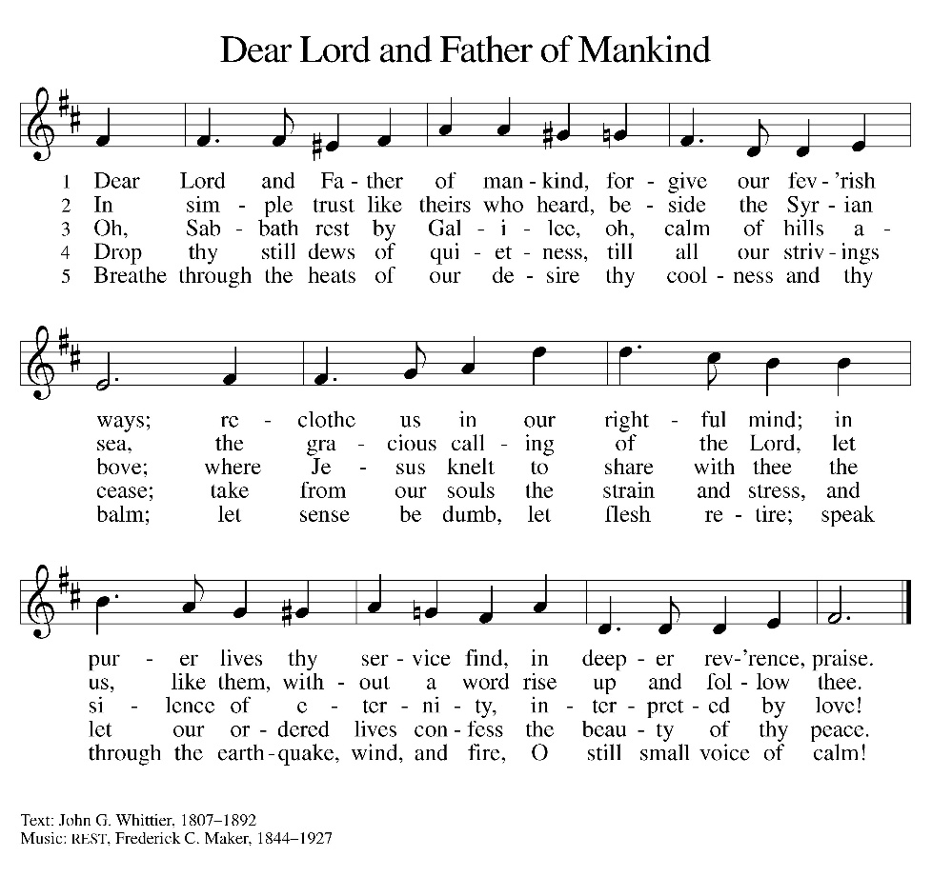
*Dismissal

Go out in joy. Be led forth in peace.
Thanks be to God.

From sundaysandseasons.com. Copyright © 2017 Augsburg Fortress. All rights reserved. Reprinted with permission OneLicenses.net #A-722514.

ANNOUNCEMENTS
Tonight—Fields of Faith will hold their annual event from 6-8 p.m. at the House of Orange Complex, 600 Orange Blvd, Beatrice. It includes a free dinner for all students, live worship band, Student-led prayer & testimonies. The LYF group plans to attend the event.

November 1st-- Fall Dinner
11:30 a.m. – 1:00 p.m.
Dine In or Drive Thru
Sign up sheets in the fellowship hall

A suggestion box has been placed on the table in the entry way. Please feel free to put any suggestions or comments for the council in it.

The new sound system has hearing aid assisted listening devices available for use. If you would like to use one, please speak with a council member before the church service.

If you have a favorite hymn you would like to sing during a future church service, please complete one of the cards on the table in the fellowship hall and place it in the basket provided.

There are sign up sheets (with class descriptions underneath) on the table in the entryway for classes that Pastor is offering to the congregation. If you are interested in one or more, please sign up.

Upcoming Community coffees are as follows:
October 9—Wymore Fire Department
October 16—Coffee Shop at Heritage Inn
October 23—Wymore City Office
October 30—St. Peter Lutheran Church
November 6—Wymore Library

Remembered in Our Prayers:
Jennifer Cohorst Kent Hohensee Dave Mick
Kathleen Remmers Eric Riley Kai Spann

Pastor Gary: Phone: (402) 658-2253
Email: garygrinvalds@gmail.com
If you wish to have Pastor visit you, please contact him to set up a time. Sunday afternoon & Thursday are his open days.

Your Council leaders are:
President: Josh Schmidt (402) 520-0950
Vice President: Chavonn Mailahn (308) 214-0039
Secretary: Rachel Frerichs (402) 239-0466
At Large: Roger Henrichs (402) 239-7740
Erin Saathoff (402) 239-9117
Jodi Wegner (402) 223-8263
Council meeting: October 22 at 6:30 p.m.

Church Account Balance: 08/31/2026: $51,818.49
Church Offerings: 09/06/2026: $ 456.00
09/13/2026: $ 1,222.00
09/20/2026: $ 691.00
09/27/2026: $ 1,279.00

Attendance: 09/21/2026: 61

October Birthdays Anniversaries
04 Rhonda Epp
04 Riley Wegner
07 Kevin Morse
09 Dorothy Erdmann 09 Jon & Nealeigh Acton
10 Carmen McKeever
13 Roger Theye
14 Joel Fossler
16 Landen McKeever 17 Caleb & Jesse Harms
17 Amelia Myer 18 Travis & Jonna Arnold
26 Jason Allington 23 Dave & Linda Creevan
27 Steve Epp
29 Natalie Trauernicht
31 Scott Trauernicht

