Easter Sunday
Sunday, April 5, 2026

Our Savior’s Lutheran Church
8:00 AM Worship 9:00 AM Fellowship
Faith Formation 5:30 PM Wednesdays

Pastor Gary Grinvalds

Organist: Alice Meints or Sandy Eltiste

Introduction to the day
“The last enemy to be destroyed is death,” Paul writes. Today Christ is risen, and we gather together with astonishment and joy. Christ is risen, and we have been set free from the bonds of death. Christ is risen, and we are forgiven. Christ is risen, and with the women at the tomb and Peter, we are amazed. Let us rejoice: Christ is risen indeed! Alleluia!

*Please Stand
Congregational responses in bold print

WELCOME AND ANNOUNCEMENTS

*Brief order for CONFESSION AND FORGIVENESS
Alleluia! Christ is risen.
Christ is risen, indeed. Alleluia!
Salvation belongs to our God who is seated on the throne
and to the Lamb!
Amen.
Let us give thanks for the gifts of baptism.
Water may be poured into the font as the presiding minister continues.
Merciful God,
you are the one who was, who is, and who is to come.
You lead us beside still waters.
We thank you for the waters of creation:
morning dew, gentle rain, roaring waves.
We thank you for the waters that nourish us.
Blessed are you.
You guide us to springs of the water of life.
Jesus Christ, you are the faithful witness
who accompanies us on our journeys.
We give you thanks for your life-giving death and resurrection.
We praise you for joining us in joy and sorrow.
Blessed are you.
You guide us to springs of the water of life.
Holy Spirit, you anoint our head with oil and our cup overflows.
Break down barriers that divide us.
Fill us with the breath of peace.
Blessed are you.
You guide us to springs of the water of life.
Holy One, we thank you for the gifts and grace of baptism,
and for making us a new creation.
We join with saints and angels, giving you honor and praise,
now and forever.
Amen.
*Entrance Hymn ELW 365

*Greeting

The grace of our Lord Jesus Christ, the love of God, and the communion of the Holy Spirit be with you all.
And also with you.

*Kyrie LBW pg 57
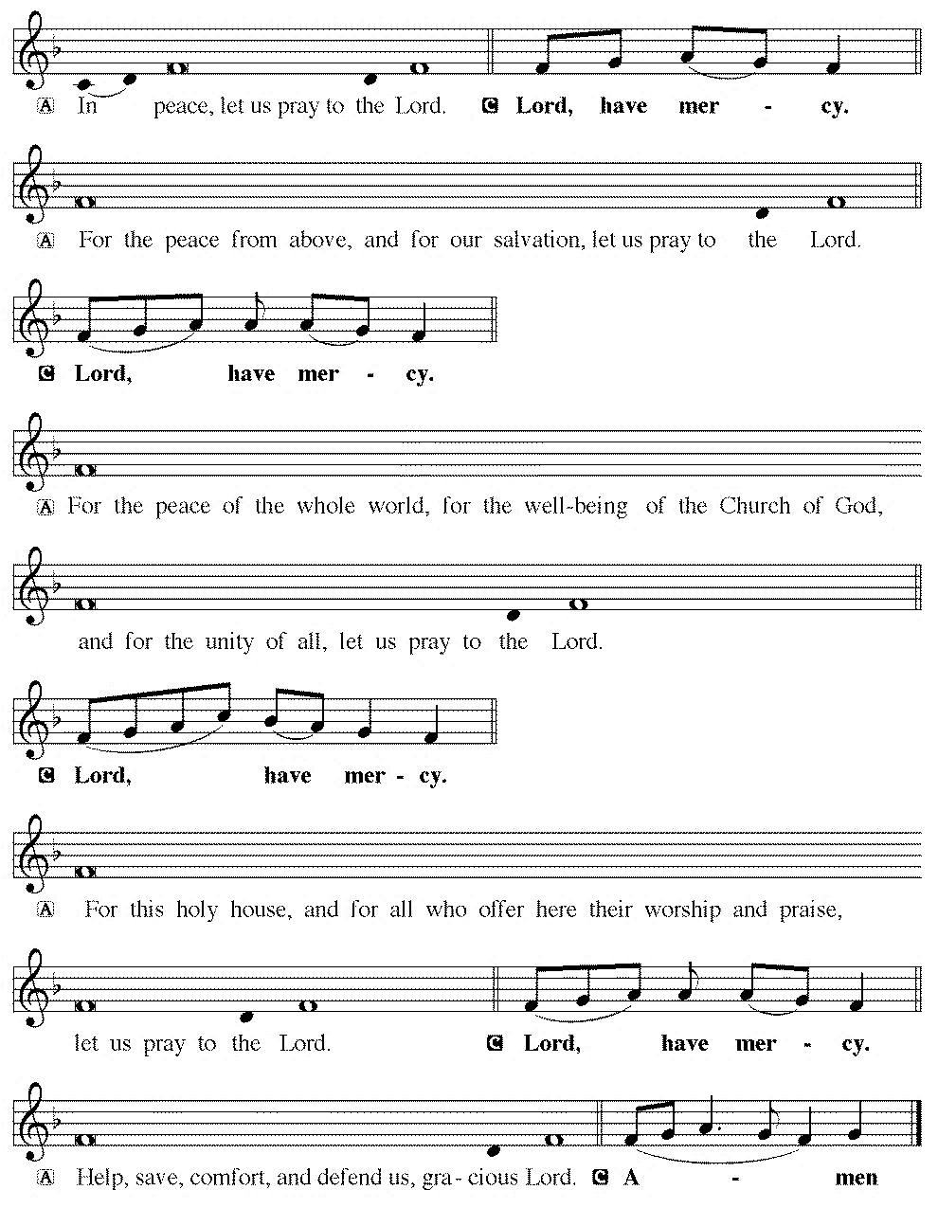

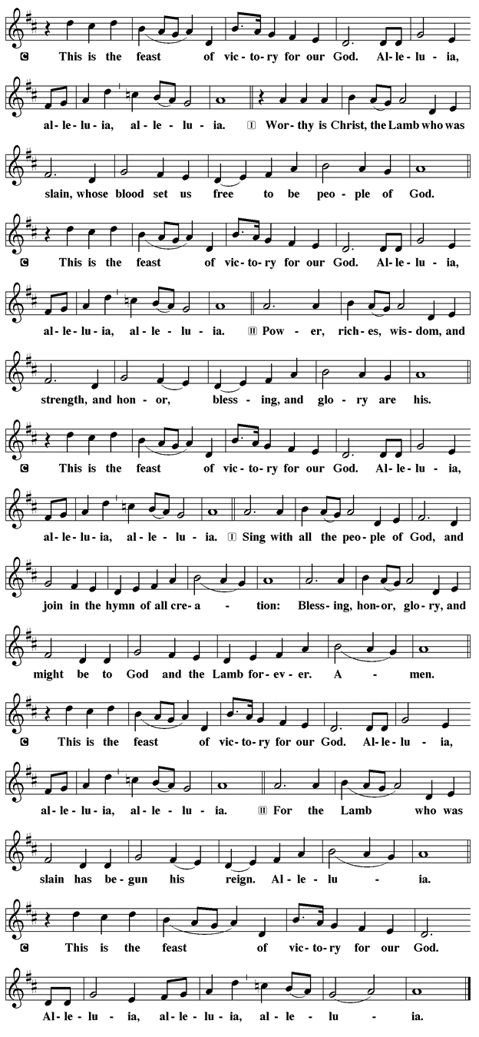
*Prayer of the Day

The Lord be with you.
And also with you.

Let us pray.

O God, you gave your only Son to suffer death on the cross for our redemption, and by his glorious resurrection you delivered us from the power of death. Make us die every day to sin, that we may live with him forever in the joy of the resurrection, through your Son, Jesus Christ our Lord, who lives and reigns with you and the Holy Spirit, one God, now and forever.
Amen.

First Lesson: Acts 10:34-43
Peter’s sermon, delivered at the home of Cornelius, a Roman army officer, is a summary of the essential message of Christianity: Everyone who believes in Jesus, whose life, death, and resurrection fulfilled the words of the prophets, “receives forgiveness of sins through his name.”
³⁴Peter began to speak to [the people]: “I truly understand that God shows no partiality, ³⁵but in every nation anyone who fears him and does what is right is acceptable to him. ³⁶You know the message he sent to the people of Israel, preaching peace by Jesus Christ—he is Lord of all. ³⁷That message spread throughout Judea, beginning in Galilee after the baptism that John announced: ³⁸how God anointed Jesus of Nazareth with the Holy Spirit and with power; how he went about doing good and healing all who were oppressed by the devil, for God was with him. ³⁹We are witnesses to all that he did both in Judea and in Jerusalem. They put him to death by hanging him on a tree; ⁴⁰but God raised him on the third day and allowed him to appear, ⁴¹not to all the people but to us who were chosen by God as witnesses, and who ate and drank with him after he rose from the dead. ⁴²He commanded us to preach to the people and to testify that he is the one ordained by God as judge of the living and the dead. ⁴³All the prophets testify about him that everyone who believes in him receives forgiveness of sins through his name.”
Word of God, Word of life.
Thanks be to God.

Psalm 118:1-2, 14-24 Read Responsively

¹Give thanks to the Lord, for the Lord is good; God’s mercy endures forever.
²Let Israel now declare, “God’s mercy endures forever.”
¹⁴The Lord is my strength and my song, and has become my salvation.
¹⁵Shouts of rejoicing and salvation echo in the tents of the righteous: “The right hand of the Lord acts valiantly!
¹⁶The right hand of the Lord is exalted! The right hand of the Lord acts valiantly!”
¹⁷I shall not die, but live, and declare the works of the Lord.
¹⁸The Lord indeed punished me sorely, but did not hand me over to death.
¹⁹Open for me the gates of righteousness; I will enter them and give thanks to the Lord.
²⁰“This is the gate of the Lord; here the righteous may enter.”
²¹I give thanks to you, for you have answered me and you have become my salvation.
²²The stone that the builders rejected has become the chief cornerstone.
²³By the Lord has this been done; it is marvelous in our eyes.
²⁴This is the day that the Lord has made; let us rejoice and be glad in it.

Second Lesson: Colossians 3:1-4
Easter means new life for us as it first meant new life for Christ. His resurrection reshapes the entire focus and motivation for our lives since we are now hidden with the risen Christ in God.
¹ If you have been raised with Christ, seek the things that are above, where Christ is, seated at the right hand of God. ² Set your minds on the things that are above, not on the things that are on earth, ³ for you have died, and your life is hidden with Christ in God. ⁴ When Christ who is your life is revealed, then you also will be revealed with him in glory.

Word of God, Word of life.
Thanks be to God.

childrens sermon

*Gospel: Matthew 28:1-10

Glory to you, O Lord.

Sorrow gives way to “fear and great joy” when two women are sent by an angel to proclaim the good news: Jesus is risen!
¹ After the Sabbath, as the first day of the week was dawning, Mary Magdalene and the other Mary went to see the tomb. ² And suddenly there was a great earthquake, for an angel of the Lord, descending from heaven, came and rolled back the stone and sat on it. ³ His appearance was like lightning and his clothing white as snow. ⁴ For fear of him the guards shook and became like dead men. ⁵ But the angel said to the women, “Do not be afraid, for I know that you are looking for Jesus who was crucified. ⁶ He is not here, for he has been raised, as he said. Come, see the place where he lay. ⁷ Then go quickly and tell his disciples, ‘He has been raised from the dead, and indeed he is going ahead of you to Galilee; there you will see him.’ This is my message for you.” ⁸ So they left the tomb quickly with fear and great joy and ran to tell his disciples. ⁹ Suddenly Jesus met them and said, “Greetings!” And they came to him, took hold of his feet, and worshiped him. ¹⁰ Then Jesus said to them, “Do not be afraid; go and tell my brothers and sisters to go to Galilee; there they will see me.”
The Gospel of our Lord

Praise to you, O Christ.

Sermon pastor GARY GRINVALDS

HYMN OF THE DAY ELW 385

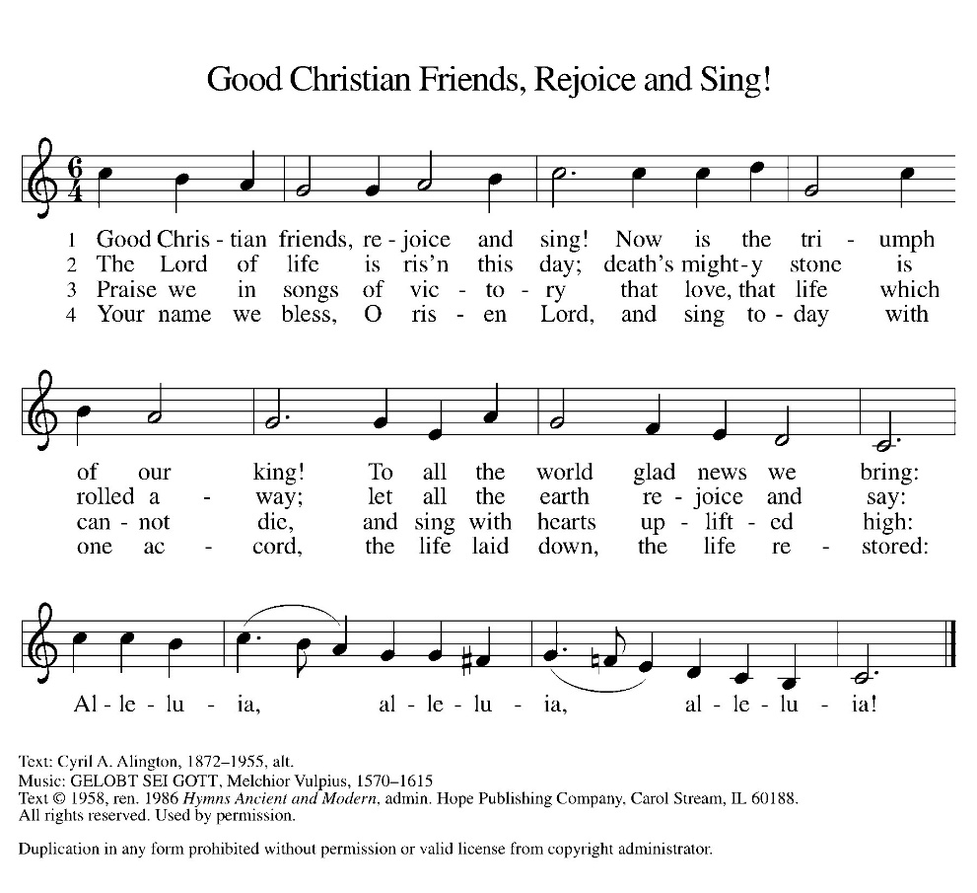

*NICENE CREED
We believe in one God,
the Father, the Almighty,
maker of heaven and earth,
of all that is, seen and unseen.
We believe in one Lord, Jesus Christ,
the only Son of God,
eternally begotten of the Father,
God from God, Light from Light,
true God from true God,
begotten, not made,
of one Being with the Father;
through him all things were made.
For us and for our salvation
he came down from heaven,
was incarnate of the Holy Spirit and the virgin Mary,
and became truly man.
For our sake he was crucified under Pontius Pilate;
he suffered death and was buried.
On the third day he rose again
in accordance with the scriptures;
he ascended into heaven
and is seated at the right hand of the Father.
He will come again in glory to judge the living and the dead, and his kingdom will have no end.
We believe in the Holy Spirit, the Lord, the giver of life,
who proceeds from the Father and the Son,
who with the Father and the Son is worshiped and glorified, who has spoken through the prophets.
We believe in one holy catholic and apostolic church.
We acknowledge one baptism for the forgiveness of sins.
We look for the resurrection of the dead,
and the life of the world to come. Amen.

*The Prayers
Trusting in the power of Christ’s resurrection to heal and redeem our broken world, let us pray for the needs of all creation.
A brief silence.
Risen Savior, you have conquered death and opened the gates of everlasting life. Dispel our doubts and fears and renew our faith and hope in you. Merciful God,
receive our prayer.
Life-giving God, the created world rejoices in Christ’s victory over death. May all the earth be renewed by the light of Jesus’ resurrection, and may we be faithful stewards of all you have made. Merciful God,
receive our prayer.
Sovereign God, let the nations acknowledge your reign of justice and truth. Where violence, oppression, and corruption hold sway, pour out your holy and life-giving Spirit to transform and redeem. Merciful God,
receive our prayer.
Gentle Shepherd, like the women at the empty tomb, many grieve or feel lost and afraid. Draw near to those who are ill or in pain (especially). Reveal yourself to them as the Risen One. Merciful God,
receive our prayer.
Faithful God, we thank you for the living hope you give us through Christ’s resurrection. Bless this community, that we may boldly proclaim Christ’s victory over death in word and deed. Merciful God,
receive our prayer.
Eternal One, we give thanks for all who have died and now share in the joy of your resurrection. Bring us, with them, to the unending feast of your victory. Merciful God,
receive our prayer.
God of resurrection power, use us and these prayers to proclaim the good news of new life to all the world, through Jesus Christ, our risen Savior.
Amen.

*Peace
The peace of the Lord be with you always.
And also with you.

OFFERING

*Offertory

*Offertory Prayer

Merciful God,
accept the fruits of our labor, gathered to give you glory.
You have set a table before us, a glimpse of that great day
when we will hunger and thirst no more.
Nourish us with the body and blood of Jesus,
that goodness and mercy may follow us
and bless the world you love.
In the name of Jesus,
Amen.

*Dialogue

The Lord be with you.
And also with you.

Lift up your hearts.
We lift them to the Lord.

Let us give thanks to the Lord our God.
It is right to give our thanks and praise

*Preface
It is indeed right, our duty, and our joy that we should at all times and in all places give thanks and praise to you, almighty and merciful God, through our Savior Jesus Christ. You call your people to cleanse their hearts and prepare with joy for the paschal feast, that renewed in the gift of baptism, we may come to the fullness of your grace. And so, with all the choirs of angels, with the Church on earth and the hosts of heaven, we praise your name and join their unending hymn:

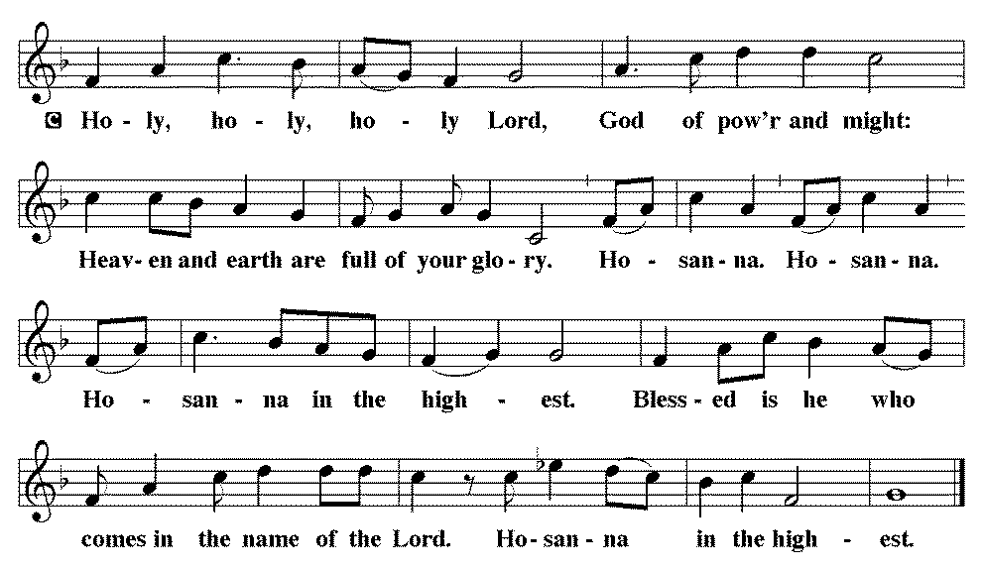

*THE GREAT Thanksgiving
Blessed are you, O God of the universe. Your mercy is everlasting and your faithfulness endures from age to age.

Praise to you for creating the heavens and the earth.
Praise to you for saving the earth from the waters of the flood.
Praise to you for bringing the Israelites safely through the sea.
Praise to you for leading your people through the wilderness to the land of milk and honey.
Praise to you for the words and deeds of Jesus, your anointed one.
Praise to you for the death and resurrection of Christ.
Praise to you for your Spirit poured out on all nations.

In the night in which he was betrayed,
our Lord Jesus took bread, and gave thanks;
broke it, and gave it to his disciples, saying:
Take and eat; this is my body, given for you.
Do this for the remembrance of me.

Again, after supper, he took the cup, gave thanks,
and gave it for all to drink, saying:
This cup is the new covenant in my blood,
shed for you and for all people for the forgiveness of sin.
Do this for the remembrance of me.
With this bread and cup, we remember our Lord’s Passover from death to life as we proclaim the mystery of faith:
Christ has died. Christ has risen. Christ will come again.

O God of resurrection and new life:
Pour out your Holy Spirit on us and on these gifts of bread and wine.
Bless this feast. Grace our table with your presence.
Come, Holy Spirit.

Reveal yourself to us in the breaking of the bread. Raise us up as the body of Christ for the world. Breathe new life into us. Send us forth, burning with justice, peace and love.
Come, Holy Spirit.

With your holy ones of all times and places, with the earth and all its creatures, with sun and moon and stars, we praise you, O God, blessed and holy Trinity, now and forever.
Amen.

*Lord's Prayer

Our Father, who art in heaven, hallowed be thy name,
thy kingdom come,
thy will be done,
on earth as it is in heaven.
Give us this day our daily bread;
and forgive us our trespasses,
as we forgive those
who trespass against us;
and lead us not into temptation,
but deliver us from evil.
For thine is the kingdom,
and the power, and the glory,
forever and ever. Amen.

*INVITATION TO HOLY COMMUNION
Come to the table of new life.
Receive the risen Lord.

AGNUS DEI (Lamb of God) ~ HOLY Communion
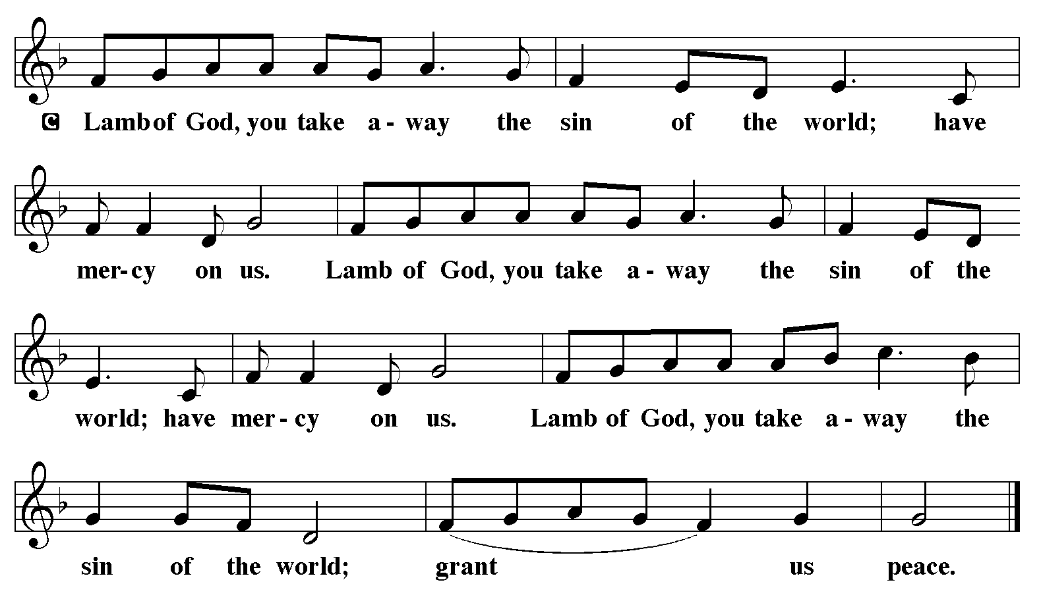

COMMUNION HYMN ELW 376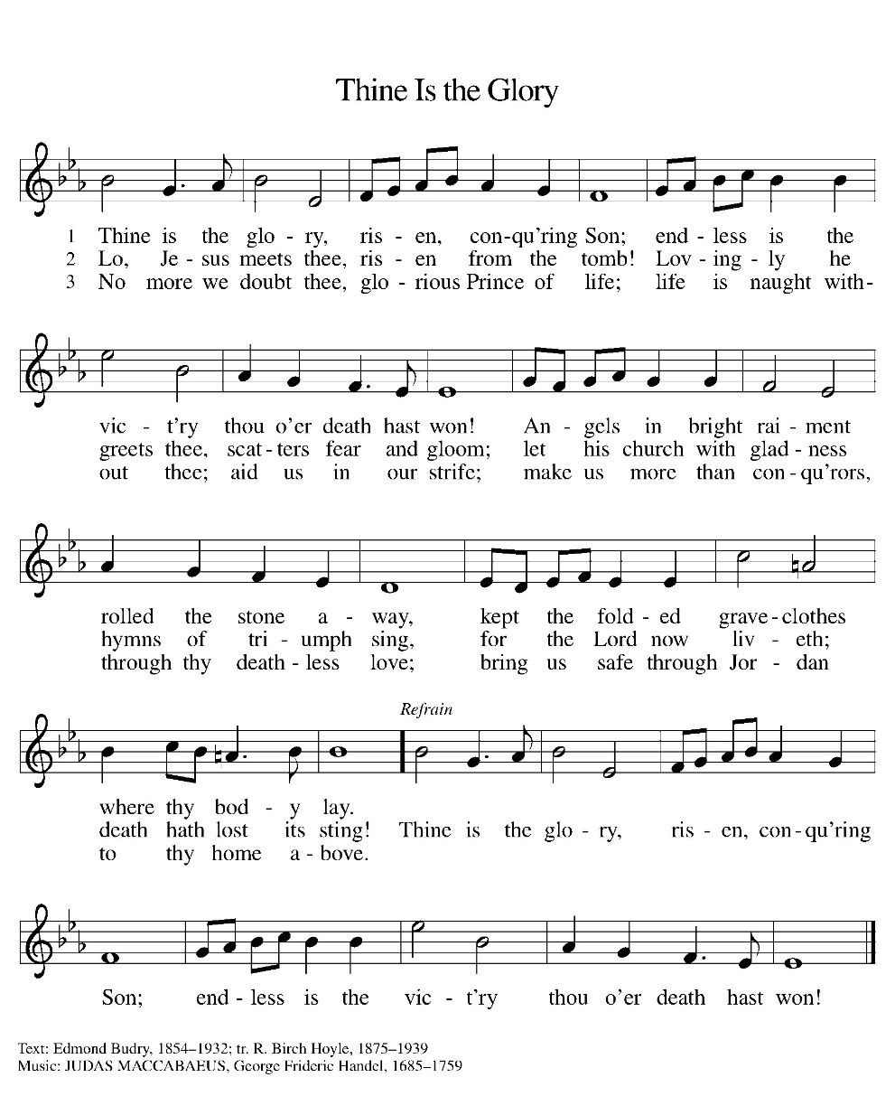

*BLESSING
May the body and blood of our Lord Jesus Christ strengthen you and keep you in his grace.
Amen

*Canticle
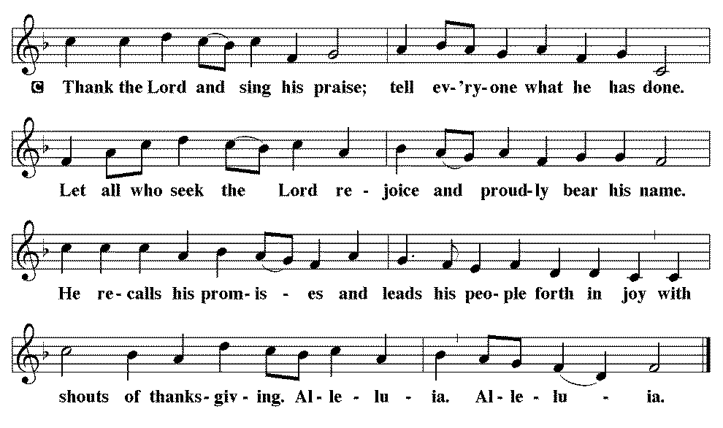

*Prayer after communion
Holy One,
through this meal you have made your home among us
and are making all things new.
Send us now to speak peace to anxious hearts,
to love our enemies,
and to bring your healing to the nations.
In the name of Jesus,
Amen.

*Blessing
God Almighty, who is the beginning and the end,
Jesus Christ, the firstborn of the dead,
and the Spirit, our advocate and peace,
☩ bless you now and forever.
Amen.

SENDING HYMN
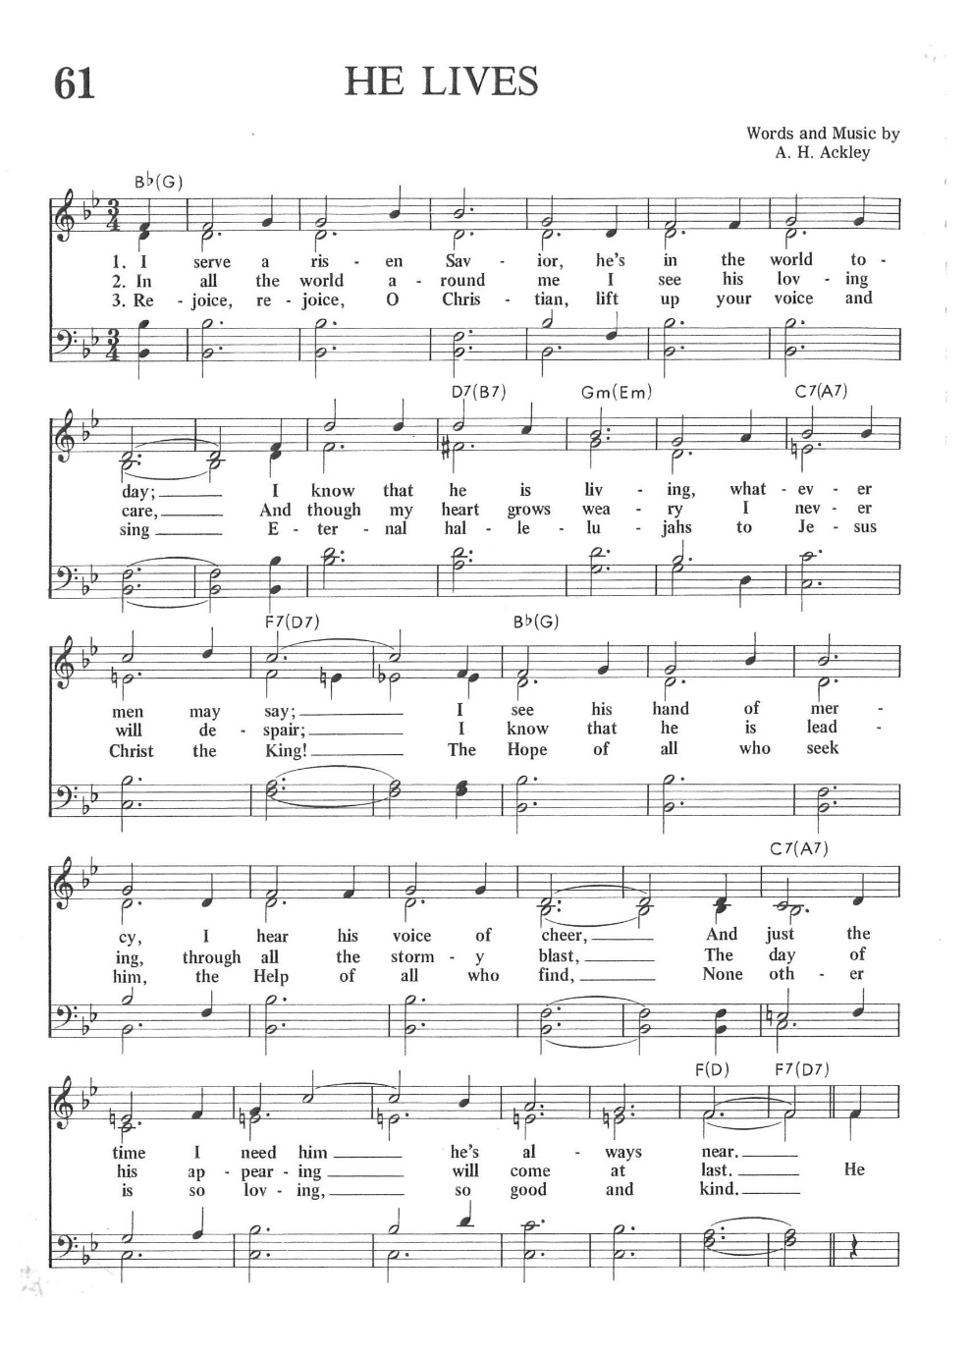
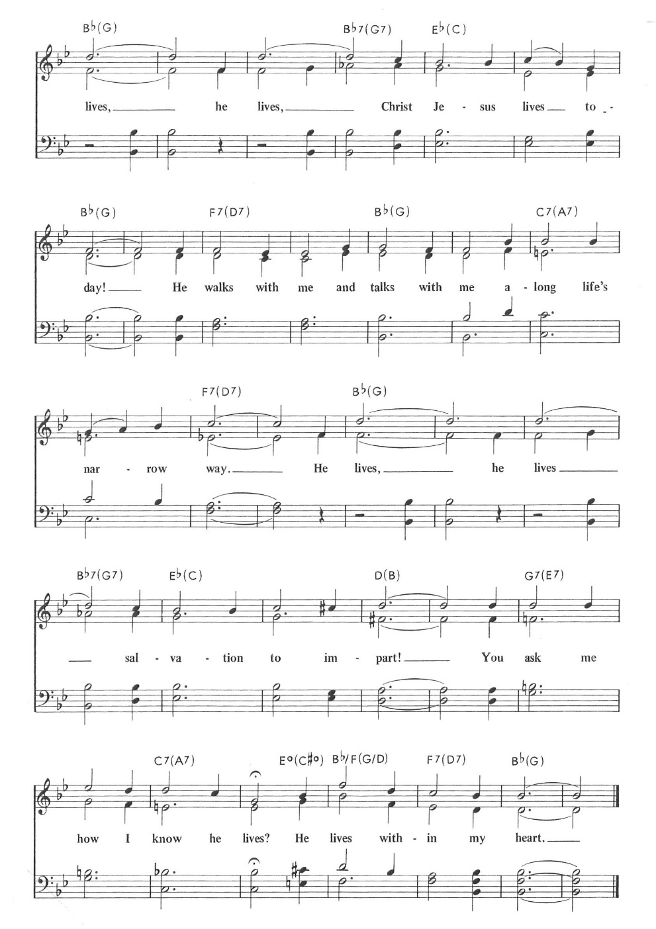
*Dismissal
Go in peace. Praise the Lord. Alleluia!
Thanks be to God. Alleluia!

From sundaysandseasons.com. Copyright © 2017 Augsburg Fortress. All rights reserved. Reprinted with permission OneLicenses.net #A-722514.
ANNOUNCEMENTS

An Easter egg hunt will be held after church service today. All children are welcome.

Thank you to all who led the Lenten services. It was greatly appreciated.

$20 Gift Cards were sent to the following college students:
Madison Wegner Brock Adams
Natalie Trauernicht Alaina Klover
Jaiden Allington Ella Martin
If we missed anyone, please let Elaine or Shirley know. Thank you. Elaine

If you have a key to the church, please let Pam know what number it is. We are trying to track down the keys. Thanks.

Upcoming Community coffees are as follows:
April 10—Arbor State Pharmacy at Park Lodge
April 17—Wymore Church of Christ
April 24—Tim Hanson at Park Lodge
May 1—Wymore Library

Remembered in Our Prayers:
Kent Hohensee Kathleen Remmers Kai Spann

Condolences to Andrea (Whitwer) Madsen and family on the death of her husband.

Pastor Gary: Phone: (402) 658-2253
Email: garygrinvalds@gmail.com
If you wish to have Pastor visit you, please contact him to set up a time. Sunday afternoon & Thursday are his open days.

Your Council leaders are:
President: Josh Schmidt (402) 520-0950
Vice President: Chavonn Mailahn (308) 214-0039
Secretary: Rachel Frerichs (402) 239-0466
At Large: Roger Henrichs (402) 239-7740
Erin Saathoff (402) 239-9117
Jodi Wegner (402) 223-8263
Council meetings are now held on the 3rd Thursday of each month after Bible Study.

Church Account Balance: 02/28/2026: $42,983.57
Church Offerings: 03/01/2026: $ 1,757.00
03/04/2026: $ 57.00
03/08/2026: $ 956.00
03/11/2026: $ 135.00
03/15/2026: $ 526.00
03/18/2026: $ 202.00
03/22/2026: $ 81.00
03/25/2026: $ 106.00
03/29/2026: $ 1,746.00

Attendance 03/29/2026: 66

April Birthdays Anniversaries
01 Dave Creevan 02 Scott & Dee Bednar
05 Maryn Martin 09 Josh & Amy Schmidt
06 Pam Gerdes 10 Larry & Darcie Schmidt
07 Kelly Dieter 12 Joel & Stacy Fossler
08 Sean Rickers
09 Dana Dorn
13 Ava Jerrad
13 Justin Weyer
15 Larissa Grinvalds
19 Mariah Murphy
19 Darcie Schmidt
20 Brigslee Dieter
20 Dustin Wegner
20 Ryker Whitwer

Please have any announcements for the bulletin to Pam by Wednesday noon each week. You may text or call her at
(402) 239-2715 or send an email to the church at oursaviorslutheranwymore@gmail.com. Thank you.

