Sunday, September 27, 2026
18th Sunday of Pentecost

Our Savior’s Lutheran Church
Website: oursaviorswymore.com
8:00 AM Worship 9:00 AM Fellowship
Faith Formation 5:30 PM Wednesdays

Pastor Gary Grinvalds

Organist: Alice Meints or Sandy Eltiste

Introduction to the day
Jesus’ parable about two sons who don’t do what they say reveals surprises in the reign of God. In the reading from Ezekiel the people claim the ways of the Lord are unfair, while God offers repentance and new life. Paul urges us to look to Christ as a model of humility, putting the interests of others above our own. Nourished by the broken bread and shared cup, we offer our lives for the sake of our needy world.

*Please Stand
Congregational responses in bold print

WELCOME AND ANNOUNCEMENTS

*Brief order for CONFESSION AND FORGIVENESS

Blessed be the holy Trinity, ☩ one God,
who pours love into our hearts
and healing upon the earth.
Amen.
Confident that God justifies us by grace through faith,
let us confess our sin.
Silence is kept for reflection.
Compassionate God,
we confess that we struggle to embody your goodness
in the world and in our own hearts.
Creation groans from overuse.
Jealousy and bitterness strain our relationships.
Indifference keeps us from seeking justice.
Divisions disrupt your call to show genuine love
to others.
Turn our hearts back to you.
Restore our world and reconcile us to one another.
Renew us to live as your holy people,
following the way of Jesus Christ.
Amen.
Hear this good news:
We have peace with God through ☩ Jesus Christ,
in whom there is no condemnation,
but only forgiveness and the promise of eternal life.
Receive freely this healing gift of grace.
Amen.

Entrance Hymn ELW 789
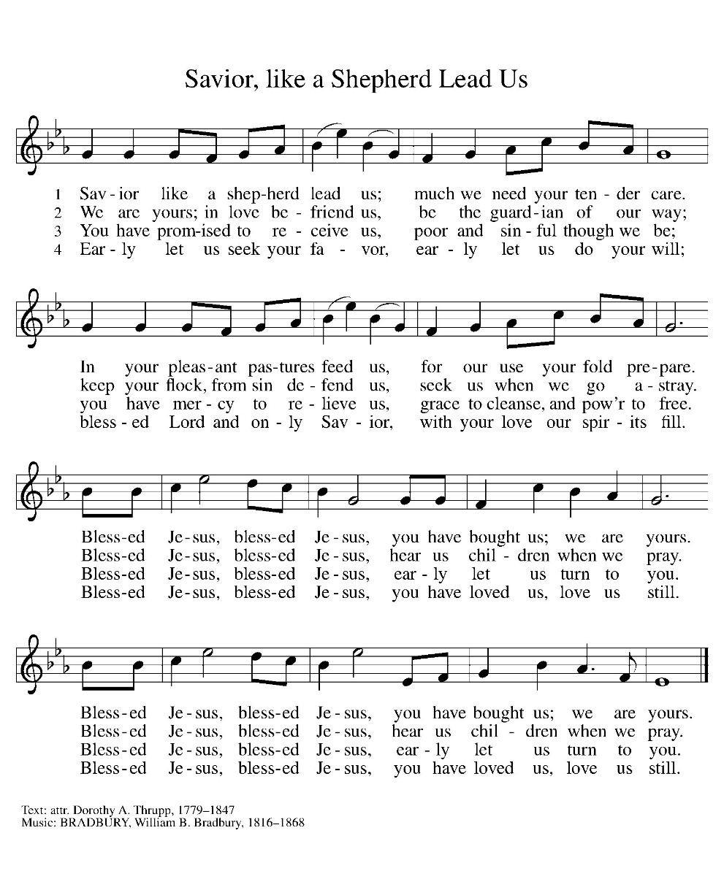

*Blessed are you, O Lord our God, king of the universe,
For in your wisdom you have formed us.
You feed the hungry and clothe the naked,
We bless you and praise your name forever.
You set free those who are bound.
We bless you and praise your name forever.
You raise up those whose courage falters.
We bless you and praise your name forever.
You provide for our every need.
Accept our grateful praises.
You have called us from all peoples.
We rejoice and bless your name forever.
You bless your people with peace.
We bless you and praise your loving grace.
Blessed are you, O Lord our God, king of the universe,
For in your wisdom you have formed us.

*Prayer of the Day

The Lord be with you.
And also with you.

Let us pray.

God of love, giver of life, you know our frailties and failings. Give us your grace to overcome them, keep us from those things that harm us, and guide us in the way of salvation, through Jesus Christ, our Savior and Lord.
Amen.

HYMN ELW 717
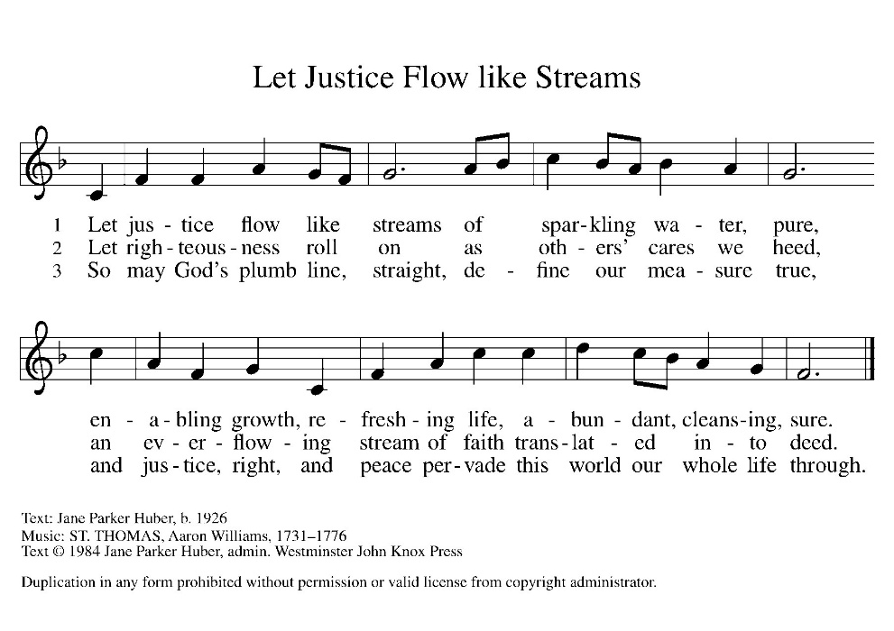

First Lesson: Ezekiel 18:1-4, 25-32
Ezekiel challenges those who think they cannot change because of what their parents were and did, or who think they cannot reverse their own previous behavior. God insistently invites people to turn and live.
¹ The word of the Lord came to me: ² What do you mean by repeating this proverb concerning the land of Israel, “The parents have eaten sour grapes, and the children’s teeth are set on edge”? ³ As I live, says the Lord God, this proverb shall no more be used by you in Israel. ⁴ Know that all lives are mine; the life of the parent as well as the life of the child is mine: it is only the person who sins who shall die.
²⁵ Yet you say, “The way of the Lord is unfair.” Hear now, O house of Israel: Is my way unfair? Is it not your ways that are unfair? ²⁶ When the righteous turn away from their righteousness and commit iniquity, they shall die for it; for the iniquity that they have committed, they shall die. ²⁷ Again, when the wicked turn away from the wickedness they have committed and do what is lawful and right, they shall save their life. ²⁸ Because they considered and turned away from all the transgressions that they had committed, they shall surely live; they shall not die. ²⁹ Yet the house of Israel says, “The way of the Lord is unfair.” O house of Israel, are my ways unfair? Is it not your ways that are unfair?
³⁰ Therefore I will judge you, O house of Israel, all of you according to your ways, says the Lord God. Repent and turn from all your transgressions; otherwise iniquity will be your ruin. ³¹ Cast away from you all the transgressions that you have committed against me, and get yourselves a new heart and a new spirit! Why will you die, O house of Israel? ³² For I have no pleasure in the death of anyone, says the Lord God. Turn, then, and live.
Word of God, Word of life.
Thanks be to God.

Psalm 25:1-9 Read Responsively

¹ To you, O Lord, I lift up my soul.
² My God, I put my trust in you; let me not be put to shame, nor let my enemies triumph over me.
³ Let none who look to you be put to shame; rather let those be put to shame who are treacherous.
⁴ Show me your ways, O Lord, and teach me your paths.
⁵ Lead me in your truth and teach me, for you are the God of my salvation; in you have I trusted all the day long.
⁶ Remember, O Lord, your compassion and love, for they are from everlasting.
⁷ Remember not the sins of my youth and my transgressions; remember me according to your steadfast love and for the sake of your goodness, O Lord.
⁸ You are gracious and upright, O Lord; therefore you teach sinners in your way.
⁹ You lead the lowly in justice and teach the lowly your way.

Second Lesson: Philippians 2:1-13
As part of a call for harmony rather than self-seeking, Paul uses a very early Christian hymn that extols the selflessness of Christ in his obedient death on the cross. Christ’s selfless perspective is to be the essential perspective we share as the foundation for Christian accord.
¹ If, then, there is any comfort in Christ, any consolation from love, any partnership in the Spirit, any tender affection and sympathy, ² make my joy complete: be of the same mind, having the same love, being in full accord and of one mind. ³ Do nothing from selfish ambition or empty conceit, but in humility regard others as better than yourselves. ⁴ Let each of you look not to your own interests but to the interests of others. ⁵ Let the same mind be in you that was in Christ Jesus, ⁶ who, though he existed in the form of God, did not regard equality with God as something to be grasped, ⁷ but emptied himself, taking the form of a slave, assuming human likeness. And being found in appearance as a human, ⁸ he humbled himself and became obedient to the point of death— even death on a cross. ⁹ Therefore God exalted him even more highly and gave him the name that is above every other name, ¹⁰ so that at the name given to Jesus every knee should bend, in heaven and on earth and under the earth, ¹¹ and every tongue should confess that Jesus Christ is Lord, to the glory of God the Father. ¹² Therefore, my beloved, just as you have always obeyed me, not only in my presence but much more now in my absence, work on your own salvation with fear and trembling, ¹³ for it is God who is at work in you, enabling you both to will and to work for his good pleasure.
Word of God, Word of life.
Thanks be to God.

childrens sermon

*Gospel: Matthew 21:23-32

Glory to you, O Lord.

After driving the moneychangers out of the temple (21:12), Jesus begins teaching there. His authority is questioned by the religious leaders, who are supposed to be in charge of the temple.
²³ When [Jesus] entered the temple, the chief priests and the elders of the people came to him as he was teaching and said, “By what authority are you doing these things, and who gave you this authority?” ²⁴ Jesus said to them, “I will also ask you one question; if you tell me the answer, then I will also tell you by what authority I do these things. ²⁵ Did the baptism of John come from heaven, or was it of human origin?” And they argued with one another, “If we say, ‘From heaven,’ he will say to us, ‘Why, then, did you not believe him?’ ²⁶ But if we say, ‘Of human origin,’ we are afraid of the crowd, for all regard John as a prophet.” ²⁷ So they answered Jesus, “We do not know.” And he said to them, “Neither will I tell you by what authority I am doing these things.
²⁸ “What do you think? A man had two sons; he went to the first and said, ‘Son, go and work in the vineyard today.’ ²⁹ He answered, ‘I will not,’ but later he changed his mind and went. ³⁰ The father went to the second and said the same, and he answered, ‘I go, sir,’ but he did not go. ³¹ Which of the two did the will of his father?” They said, “The first.” Jesus said to them, “Truly I tell you, the tax collectors and the prostitutes are going into the kingdom of God ahead of you. ³² For John came to you in the way of righteousness, and you did not believe him, but the tax collectors and the prostitutes believed him, and even after you saw it you did not change your minds and believe him.”
The Gospel of our Lord
Praise to you, O Christ.

Sermon pastor GARY GRINVALDS

HYMN OF THE DAY ELW 514
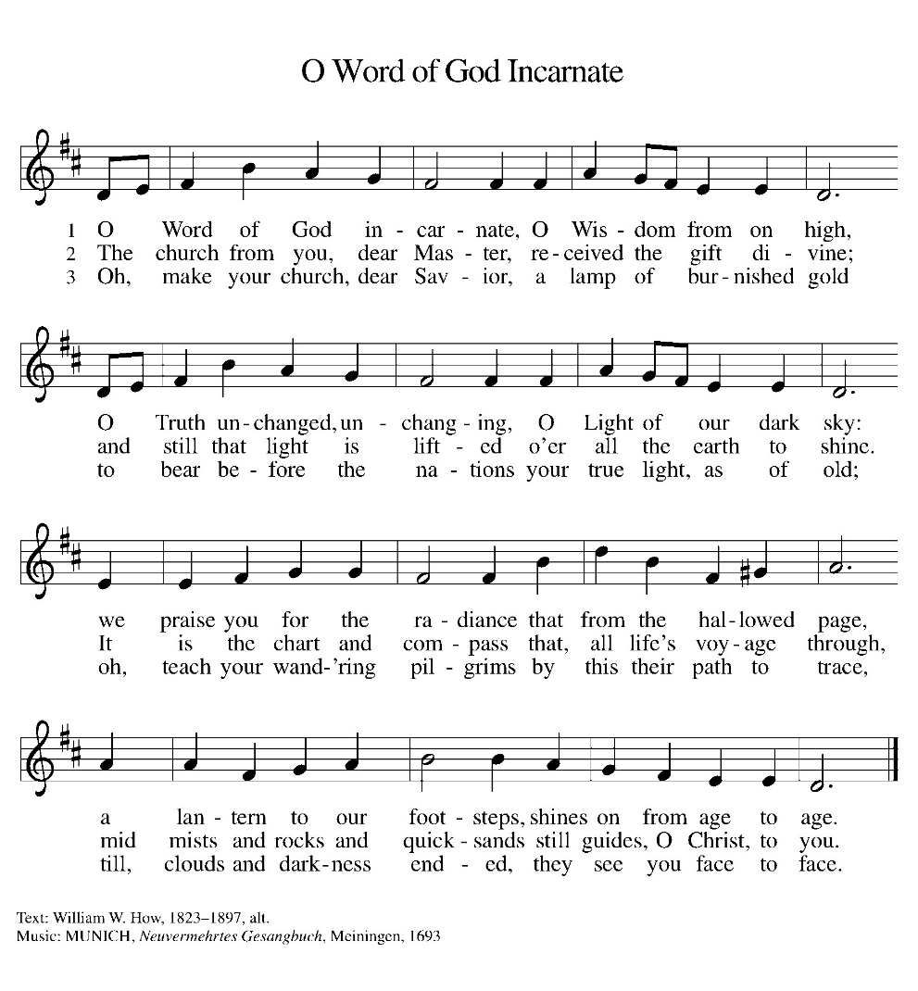

*APOSTLES Creed

I believe in God, the Father almighty,
creator of heaven and earth.
I believe in Jesus Christ, his only Son, our Lord.
He was conceived by the power of the Holy Spirit
and born of the virgin Mary.
He suffered under Pontius Pilate,
was crucified, died, and was buried.
He descended into hell.
On the third day he rose again.
He ascended into heaven,
and is seated at the right hand of the Father.
He will come again to judge the living and the dead.
I believe in the Holy Spirit,
the holy catholic Church,
the communion of saints,
the forgiveness of sins,
the resurrection of the body,
and the life everlasting. Amen

OFFERING

*OFFERTORY Sing verses 1 and 2

*The Prayers
Reminded of God’s gracious and abundant love, we offer our prayers, confident that God hears us.
A brief silence.
Center your church in humility as we strive to follow in your way. Help us listen to the cries of those who have been unfairly hurt by the church and dare to name difficult truths. Show all your love. Hear us, O God.
Your mercy is great.
You call us to care for your creation. Lead us into your promise of a better world through sustainable practices and respect for your handiwork. Hear us, O God.
Your mercy is great.

Inspire all in positions of authority to act honorably. Remind them of their call to use their authority for the sake of the common good. Give them the gift of humility. Hear us, O God.
Your mercy is great.
Comfort those who come before you in fear and trembling. Calm troubled hearts with your forgiveness. Help all those in need. Grant us your salvation. Hear us, O God.
Your mercy is great.
Change this congregation’s heart when we say no to your call. Open us to courageous learning and service in our community, especially in new or challenging places. Hear us, O God.
Your mercy is great.
Your steadfast love holds all the saints who have finished their work and are at rest. As we grieve, remind us of your mercy so we may also give thanks. Hear us, O God.
Your mercy is great.
Grant the prayers we have offered, what we have forgotten to ask, and whatever else you see that we need. We ask this in Jesus’ name.
Amen.

*Lord's Prayer

Our Father, who art in heaven, hallowed be thy name,
thy kingdom come,
thy will be done,
on earth as it is in heaven.
Give us this day our daily bread;
and forgive us our trespasses,
as we forgive those
who trespass against us;
and lead us not into temptation,
but deliver us from evil.
For thine is the kingdom,
and the power, and the glory,
forever and ever. Amen.

*Blessing

The Lord bless us and keep us.
The Lord make his face shine on us and be gracious to us.
The Lord look upon us with favor and give us peace.
Amen.

SENDING HYMN ELW 550
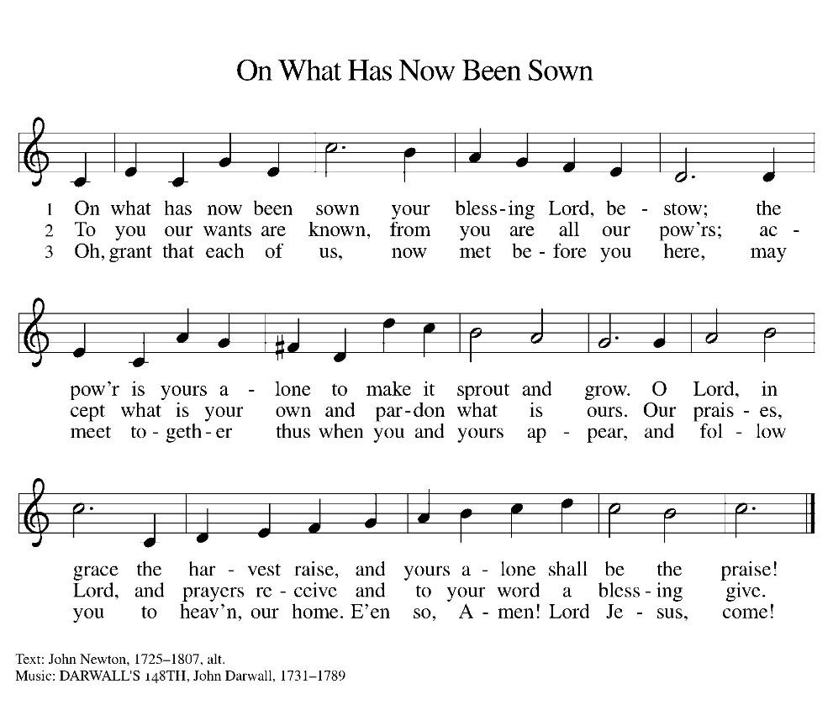

Dismissal
Go out in joy. Be led forth in peace.
Thanks be to God.

From sundaysandseasons.com. Copyright © 2017 Augsburg Fortress. All rights reserved. Reprinted with permission OneLicenses.net #A-722514.

ANNOUNCEMENTS

Bible Study at 6:00 this Thursday, October 1

October 4, 2026—Fields of Faith will hold their annual event from 6-8 p.m. at the House of Orange Complex, 800 Orange Blvd, Beatrice. It includes a free dinner for all students, live worship band, Student-led prayer & testimonies. The LYF group plans to attend the event. More info to follow.

A suggestion box has been placed on the table in the entry way. Please feel free to put any suggestions or comments for the council in it.

The new sound system has hearing aid assisted listening devices available for use. If you would like to use one, please speak with a council member before the church service.
If you have a favorite hymn you would like to sing during a future church service, please complete one of the cards on the table in the fellowship hall and place it in the basket provided.

There are sign up sheets on the table in the entryway for the classes that Pastor is offering to the congregation. If you are interested in any of these, please sign up. There are also descriptions of each class beneath the sign up sheet.

Upcoming Community coffees are as follows:
October 2—Wymore Library
October 9—Wymore Fire Department
October 16—Coffee Shop at Heritage Inn
October 23—Wymore City Office
October 30—St. Peter Lutheran Church

Remembered in Our Prayers:
Jennifer Cohorst Kent Hohensee Dave Mick
Kathleen Remmers Eric Riley Kai Spann

Pastor Gary: Phone: (402) 658-2253
Email: garygrinvalds@gmail.com
If you wish to have Pastor visit you, please contact him to set up a time. Sunday afternoon & Thursday are his open days.

Your Council leaders are:
President: Josh Schmidt (402) 520-0950
Vice President: Chavonn Mailahn (308) 214-0039
Secretary: Rachel Frerichs (402) 239-0466
At Large: Roger Henrichs (402) 239-7740
Erin Saathoff (402) 239-9117
Jodi Wegner (402) 223-8263

Church Account Balance: 08/31/2026: $51,818.49
Church Offerings: 09/06/2026: $ 456.00
09/13/2026: $ 1,222.00
09/20/2026: $ 691.00

Attendance: 09/20/2026: 70

September Birthdays Anniversaries
27 Jaidyn Allington 28 Steve & Shelley Whitwer
30 Jared Epp
30 Rachel Frerichs

October Birthdays Anniversaries
04 Rhonda Epp
04 Riley Wegner
07 Kevin Morse
09 Dorothy Erdmann 09 Jon & Nealeigh Acton
10 Carmen McKeever
13 Roger Theye
14 Joel Fossler
16 Landen McKeever 17 Caleb & Jesse Harms
17 Amelia Myer 18 Travis & Jonna Arnold
26 Jason Allington 23 Dave & Linda Creevan
27 Steve Epp
29 Natalie Trauernicht
31 Scott Trauernicht

Please have any announcements for the bulletin to Pam by Wednesday noon each week. You may text or call her at
(402) 239-2715 or send an email to the church at oursaviorslutheranwymore@gmail.com. Thank you.

