Sunday, September 6, 2026
15th Sunday of Pentecost


Our Savior’s Lutheran Church
Website: oursaviorswymore.com
8:00 AM Worship 9:00 AM Fellowship
Faith Formation 5:30 PM Wednesdays

Pastor Gary Grinvalds

Organist: Alice Meints or Sandy Eltiste

Introduction to the day
Conflict is a part of relationships and life in community. Jesus’ words in today's gospel are often used in situations having to do with church discipline. The prophet Ezekiel tells of warning the wicked to turn from their ways, and Paul reminds us that love is the fulfilling of the law. We gather in the name of Christ, assured that he is present among us with gifts of peace and reconciliation.
*Please Stand
Congregational responses in bold print

WELCOME AND ANNOUNCEMENTS

*Brief order for CONFESSION AND FORGIVENESS

Blessed be the holy Trinity, ☩ one God,
who pours love into our hearts
and healing upon the earth.
Amen.
Confident that God justifies us by grace through faith,
let us confess our sin.
Silence is kept for reflection.
Compassionate God,
we confess that we struggle to embody your goodness
in the world and in our own hearts.
Creation groans from overuse.
Jealousy and bitterness strain our relationships.
Indifference keeps us from seeking justice.
Divisions disrupt your call to show genuine love
to others.
Turn our hearts back to you.
Restore our world and reconcile us to one another.
Renew us to live as your holy people,
following the way of Jesus Christ.
Amen.
Hear this good news:
We have peace with God through ☩ Jesus Christ,
in whom there is no condemnation,
but only forgiveness and the promise of eternal life.
Receive freely this healing gift of grace.
Amen.

*Entrance Hymn ELW 668
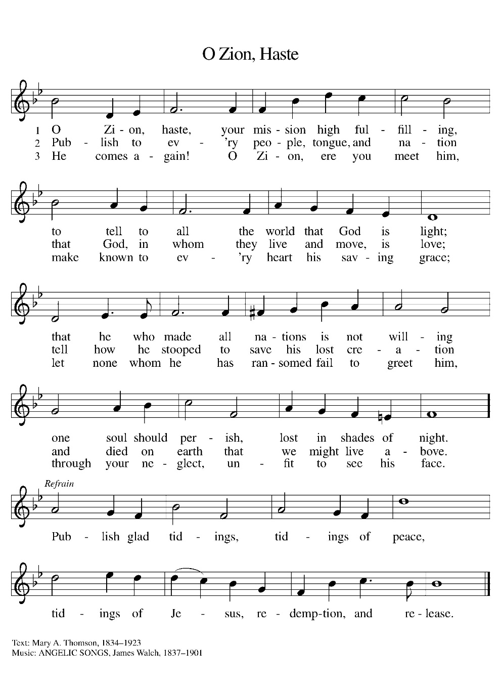

*Greeting

The grace of our Lord Jesus Christ, the love of God, and the communion of the Holy Spirit be with you all.
And also with you.

*Kyrie LBW pg 57
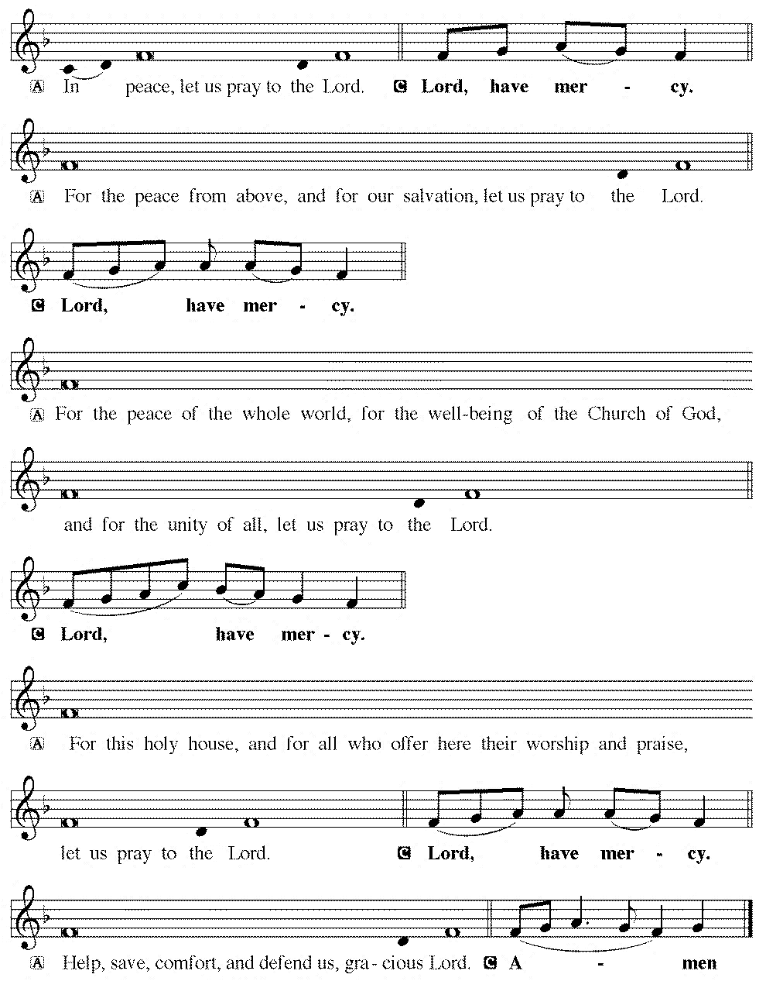

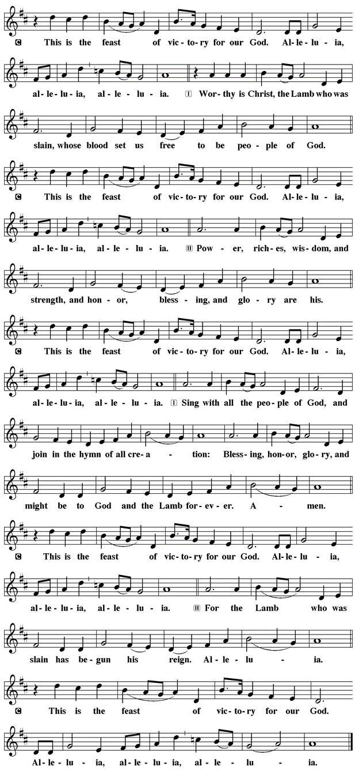
*Prayer of the Day

The Lord be with you.
And also with you.

Let us pray.

O Lord God, enliven and preserve your church with your perpetual mercy. Without your help, we mortals will fail; remove far from us everything that is harmful, and lead us toward all that gives life and salvation, through Jesus Christ, our Savior and Lord.
Amen.

First Lesson: Ezekiel 33:7-11
God appointed Ezekiel as a sentinel for the house of Israel. Ezekiel must faithfully convey God’s warnings to the people. Remarkably, God—who is about to attack Jerusalem—gives a warning with the hope that repentance will make the attack unnecessary.
⁷ So you, mortal, I have made a sentinel for the house of Israel; whenever you hear a word from my mouth, you shall give them warning from me. ⁸ If I say to the wicked, “O wicked ones, you shall surely die,” and you do not speak to warn the wicked to turn from their ways, the wicked shall die in their iniquity, but their blood I will require at your hand. ⁹ But if you warn the wicked to turn from their ways and they do not turn from their ways, the wicked shall die in their iniquity, but you will have saved your life.
¹⁰ Now you, mortal, say to the house of Israel: Thus you have said: “Our transgressions and our sins weigh upon us, and we waste away because of them; how then can we live?” ¹¹ Say to them: As I live, says the Lord God, I have no pleasure in the death of the wicked but that the wicked turn from their ways and live; turn back, turn back from your evil ways, for why will you die, O house of Israel?
Word of God, Word of life.
Thanks be to God.

Psalm 119:33-40 Read Responsively

³³ Teach me, O Lord, the way of your statutes, and I shall keep it to the end.
³⁴ Give me understanding, and I shall keep your teaching; I shall keep it with all my heart.
³⁵ Lead me in the path of your commandments, for that is my desire.
³⁶ Incline my heart to your decrees and not to unjust gain.
³⁷ Turn my eyes from beholding falsehood; give me life in your way.
³⁸ Fulfill your promise to your servant, which is for those who fear you.
³⁹ Turn away the reproach that I dread, because your judgments are good.
⁴⁰ Behold, I long for your commandments; by your righteousness enliven me.

Second Lesson: Romans 13:8-14
The obligation of Christians is to love one another and so fulfill the heart and goal of the law. Clothes make the person as we “put on the Lord Jesus Christ” and live today in light of the future God has in store for us.
⁸ Owe no one anything, except to love one another, for the one who loves another has fulfilled the law. ⁹ The commandments, “You shall not commit adultery; you shall not murder; you shall not steal; you shall not covet,” and any other commandment, are summed up in this word, “You shall love your neighbor as yourself.” ¹⁰ Love does no wrong to a neighbor; therefore, love is the fulfilling of the law.
¹¹ Besides this, you know what time it is, how it is already the moment for you to wake from sleep. For salvation is nearer to us now than when we became believers; ¹² the night is far gone; the day is near. Let us then throw off the works of darkness and put on the armor of light; ¹³ let us walk decently as in the day, not in reveling and drunkenness, not in illicit sex and licentiousness, not in quarreling and jealousy. ¹⁴ Instead, put on the Lord Jesus Christ, and make no provision for the flesh, to gratify its desires.

Word of God, Word of life.
Thanks be to God.

childrens sermon

*Sermon Text: Acts 8:26-40
²⁶ Then an angel of the Lord said to Philip, “Get up and go toward the south to the road that goes down from Jerusalem to Gaza.” (This is a wilderness road.) ²⁷ So he got up and went. Now there was an Ethiopian eunuch, a court official of the Candace, the queen of the Ethiopians, in charge of her entire treasury. He had come to Jerusalem to worship ²⁸ and was returning home; seated in his chariot, he was reading the prophet Isaiah. ²⁹ Then the Spirit said to Philip, “Go over to this chariot and join it.” ³⁰ So Philip ran up to it and heard him reading the prophet Isaiah. He asked, “Do you understand what you are reading?” ³¹ He replied, “How can I, unless someone guides me?” And he invited Philip to get in and sit beside him. ³² Now the passage of the scripture that he was reading was this:
“Like a sheep he was led to the slaughter, and like a lamb silent before its shearer, so he does not open his mouth.
³³ In his humiliation justice was denied him. Who can describe his generation? For his life is taken away from the earth.”
³⁴ The eunuch asked Philip, “About whom, may I ask you, does the prophet say this, about himself or about someone else?” ³⁵ Then Philip began to speak, and starting with this scripture he proclaimed to him the good news about Jesus. ³⁶ As they were going along the road, they came to some water, and the eunuch said, “Look, here is water! What is to prevent me from being baptized?” ³⁸ He commanded the chariot to stop, and both of them, Philip and the eunuch, went down into the water, and Philip baptized him. ³⁹ When they came up out of the water, the Spirit of the Lord snatched Philip away; the eunuch saw him no more and went on his way rejoicing. ⁴⁰ But Philip found himself at Azotus, and as he was passing through the region he proclaimed the good news to all the towns until he came to Caesarea.
Word of God, Word of life.
Thanks be to God.

Sermon pastor GARY GRINVALDS

HYMN OF THE DAY ELW 676
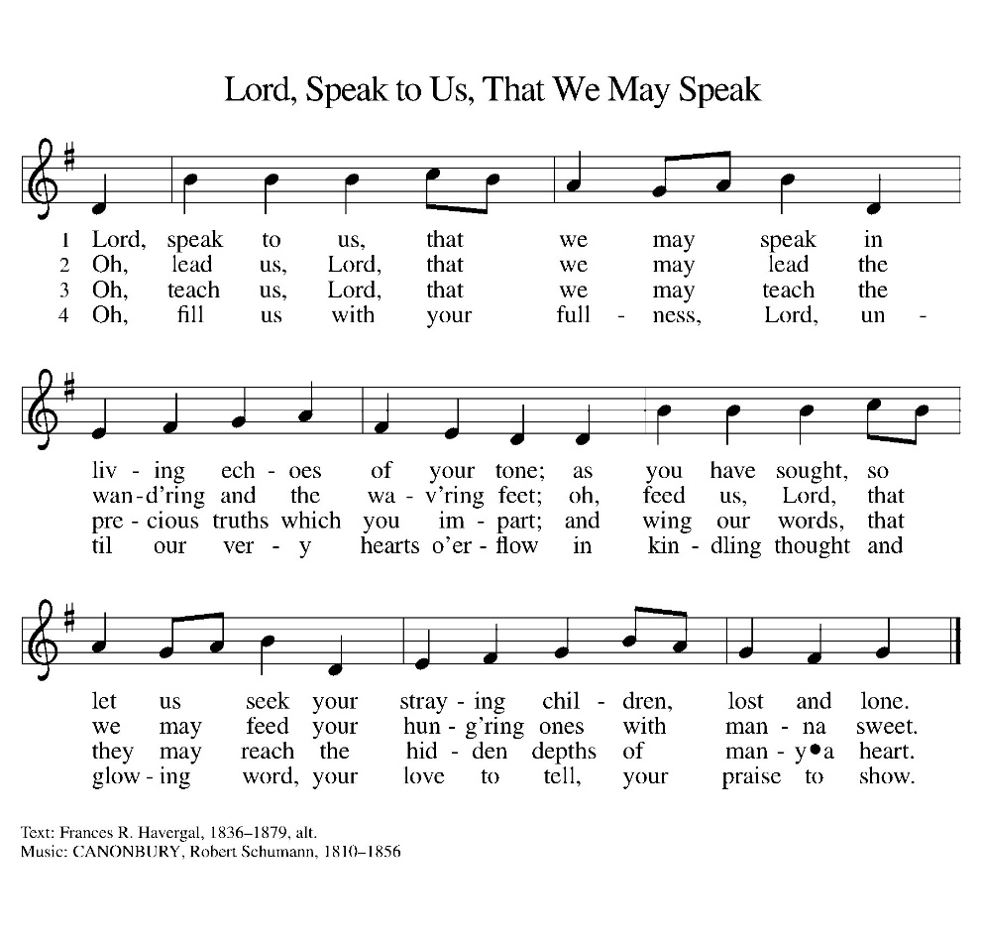

*NICENE CREED
We believe in one God,
the Father, the Almighty,
maker of heaven and earth,
of all that is, seen and unseen.
We believe in one Lord, Jesus Christ,
the only Son of God,
eternally begotten of the Father,
God from God, Light from Light,
true God from true God,
begotten, not made,
of one Being with the Father;
through him all things were made.
For us and for our salvation
he came down from heaven,
was incarnate of the Holy Spirit and the virgin Mary,
and became truly man.
For our sake he was crucified under Pontius Pilate;
he suffered death and was buried.
On the third day he rose again
in accordance with the scriptures;
he ascended into heaven
and is seated at the right hand of the Father.
He will come again in glory to judge the living and the dead, and his kingdom will have no end.
We believe in the Holy Spirit, the Lord, the giver of life,
who proceeds from the Father and the Son,
who with the Father and the Son is worshiped and glorified, who has spoken through the prophets.
We believe in one holy catholic and apostolic church.
We acknowledge one baptism for the forgiveness of sins.
We look for the resurrection of the dead,
and the life of the world to come. Amen.

*The Prayers
Reminded of God’s gracious and abundant love, we offer our prayers, confident that God hears us.
A brief silence.
Proclaiming God, empower your church throughout the world to announce the words you give us. Open us to receive your word in unexpected ways. Hear us, O God.
Your mercy is great.
Forming God, renew the cycles of your creation that provide for the needs of all. Protect grasslands, marshes, swamps, and all places of transition. Heal communities crying out after disaster. Hear us, O God.
Your mercy is great.
Governing God, turn all who create, enforce, or interpret legislation away from selfish gain and toward your promise of good for all, especially the good of all who labor. Hear us, O God.
Your mercy is great.
Attending God, wake us up to any around us who are in need. Restore broken relationships, failing health, frayed emotions, and the hurts we carry with us. Hear us, O God.
Your mercy is great.
Gathering God, resolve conflicts in this community through your righteousness and grace. Reconcile us to each other, making your good news known even through our imperfections. Hear us, O God.
Your mercy is great.
Loving God, all who die in faith have life with you. We give you thanks for the nearness of your salvation for all who have gone before us. Hear us, O God.
Your mercy is great.
Grant the prayers we have offered, what we have forgotten to ask, and whatever else you see that we need. We ask this in Jesus’ name.
Amen.

*Peace
The peace of the Lord be with you always.
And also with you.

OFFERING

*Offertory Sing Verses 2&3

*Offertory Prayer

God of creation,
you send rain and the earth springs forth abundantly.
All blessings are from you;
make us generous with what we have.
Use our gifts, our abilities, and our hearts
in service to you and in love to our neighbors,
today and always.
Amen.
*Dialogue

The Lord be with you.
And also with you.

Lift up your hearts.
We lift them to the Lord.

Let us give thanks to the Lord our God.
It is right to give our thanks and praise

*Preface

It is indeed right, our duty and our joy,
that we should at all times and in all places
give thanks and praise to you, almighty and merciful God,
through our Savior Jesus Christ;
who on this day overcame death and the grave,
and by his glorious resurrection opened to us the way of everlasting life.
And so, with all the choirs of angels,
with the church on earth and the hosts of heaven,
we praise your name and join their unending hymn:

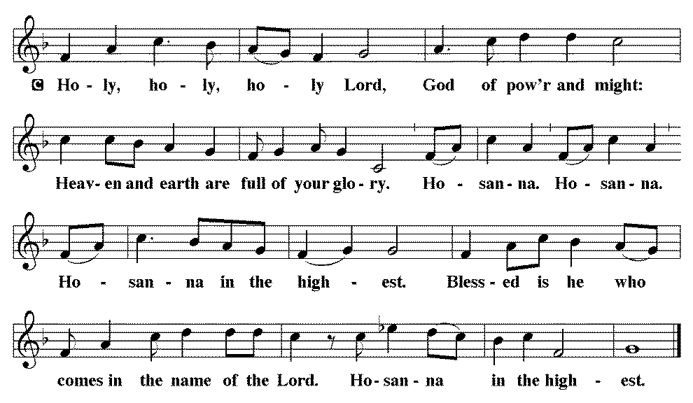

*THE GREAT Thanksgiving
You are indeed holy, almighty and merciful God.
You are most holy, and great is the majesty of your glory.

You so loved the world that you gave your only Son,
so that everyone who believes in him may not perish
but have eternal life.

We give you thanks for his coming into the world to fulfill for us your holy will and to accomplish all things for our salvation.

In the night in which he was betrayed,
our Lord Jesus took bread, and gave thanks;
broke it, and gave it to his disciples, saying:
Take and eat; this is my body, given for you.
Do this for the remembrance of me.

Again, after supper, he took the cup, gave thanks,
and gave it for all to drink, saying:
This cup is the new covenant in my blood,
shed for you and for all people for the forgiveness of sin.
Do this for the remembrance of me.

For as often as we eat of this bread and drink from this cup,
we proclaim the Lord’s death until he comes.
Christ has died. Christ is risen. Christ will come again.

Remembering, therefore, his salutary command, his life-giving passion and death, his glorious resurrection and ascension, and the promise of his coming again, we give thanks to you, O Lord God Almighty, not as we ought but as we are able;
we ask you mercifully to accept our praise and thanksgiving
and with your Word and Holy Spirit to bless us, your servants,
and these your own gifts of bread and wine,
so that we and all who share in the body and blood of Christ
may be filled with heavenly blessing and grace,
and, receiving the forgiveness of sin,
may be formed to live as your holy people
and be given our inheritance with all your saints.
To you, O God, Father, Son, and Holy Spirit,
be all honor and glory in your holy church, now and forever.
Amen.

*Lord's Prayer

Our Father, who art in heaven, hallowed be thy name,
thy kingdom come,
thy will be done,
on earth as it is in heaven.
Give us this day our daily bread;
and forgive us our trespasses,
as we forgive those
who trespass against us;
and lead us not into temptation,
but deliver us from evil.
For thine is the kingdom,
and the power, and the glory,
forever and ever. Amen.

*INVITATION TO HOLY COMMUNION

Christ invites you to this table.
All who are thirsty, all who are hungry, come!

AGNUS DEI (Lamb of God) ~ HOLY Communion 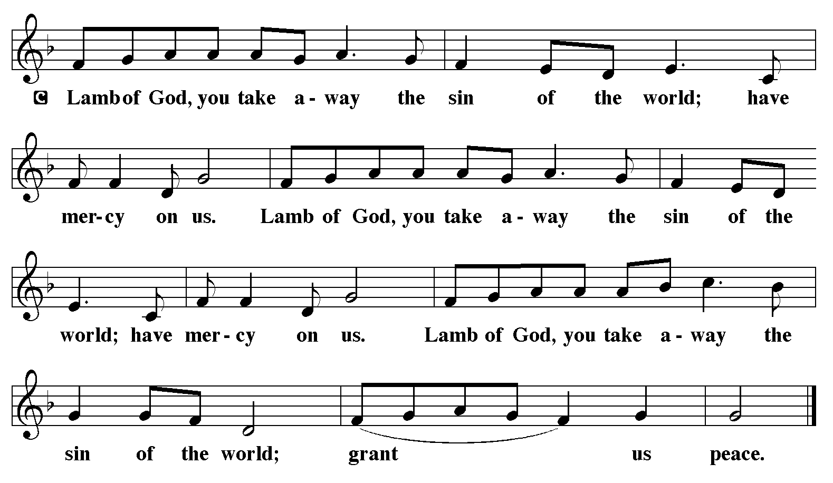
COMMUNION HYMN ELW 467
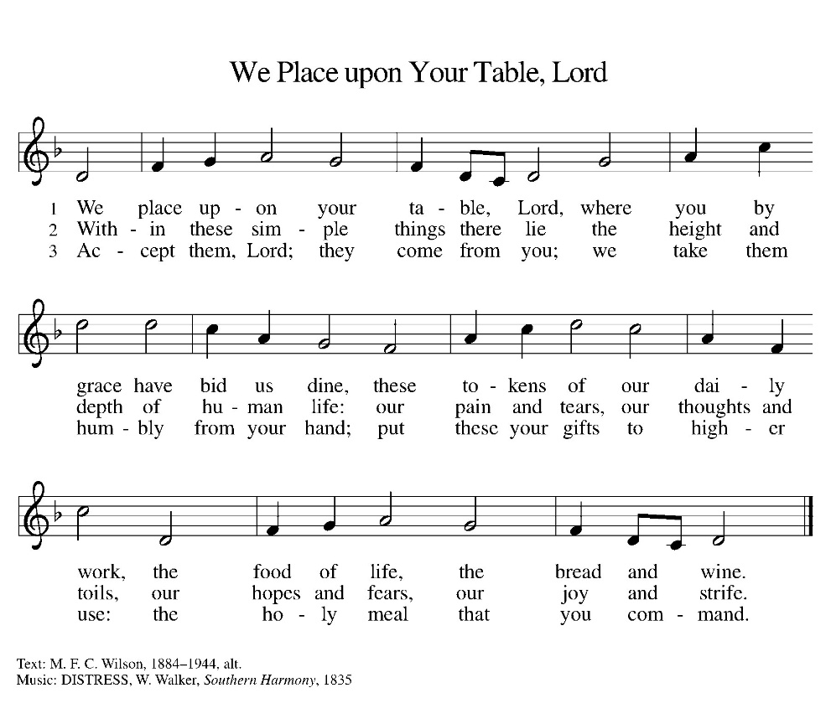

*BLESSING
May the body and blood of our Lord Jesus Christ strengthen you and keep you in his grace.
Amen

*Canticle
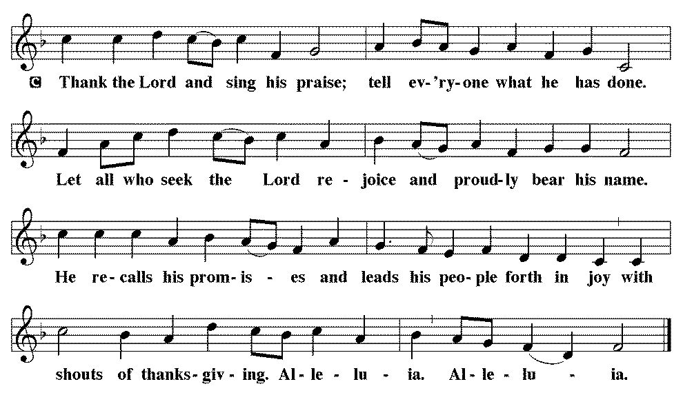

*Prayer after communion

Sustaining God,
with this bread and cup,
you nourish us with mercy and abundant life.
By your Spirit, send us from this table to serve a needy world.
Make us living signs of your liberation, healing, and love,
following the way of Jesus, in whose name we pray.
Amen.

*Blessing

The God of love
draw you into full accord and one mind,
in the body of Christ Jesus. Amen.
The God of hope
grant you strength and joy in all circumstances
through the interceding of the Spirit. Amen.
The God of grace
☩ bless you now and forever. Amen.

SENDING HYMN WOV 651
SHINE, JESUS, SHINE (blue book)

*Dismissal

Go out in joy. Be led forth in peace.
Thanks be to God.

From sundaysandseasons.com. Copyright © 2017 Augsburg Fortress. All rights reserved. Reprinted with permission OneLicenses.net #A-722514.

ANNOUNCEMENTS
Faith Formation & Confirmation classes will begin on September 9, 2026. Faith Formation meets at 5:30 here at church. Confirmation classes start 4:30 at Filley.

If you have a favorite hymn you would like to sing during a future church service, please complete one of the cards on the table in the fellowship hall and place it in the basket provided.

There are sign up sheets on the table in the entryway for the classes that Pastor is offering to the congregation. If you are interested in any of these, please sign up. There are also descriptions of each class beneath the sign up sheet.

Upcoming Community coffees are as follows:
September 11—Blue Springs Methodist Church
September 18—Wymore Medical at Park Lodge
September 25—Senior Benefits (Ray Manske) at Park Lodge
October 2—Wymore Library

Remembered in Our Prayers:
Blake Barg Jennifer Cohorst Kent Hohensee
Kathleen Remmers Eric Riley Kai Spann
The family & friends of Dustin Adams

Condolences to Larry & Darcy, Josh & Amy and family on the passing of Randy Schmidt.
Pastor Gary: Phone: (402) 658-2253
Email: garygrinvalds@gmail.com
If you wish to have Pastor visit you, please contact him to set up a time. Sunday afternoon & Thursday are his open days.

Your Council leaders are:
President: Josh Schmidt (402) 520-0950
Vice President: Chavonn Mailahn (308) 214-0039
Secretary: Rachel Frerichs (402) 239-0466
At Large: Roger Henrichs (402) 239-7740
Erin Saathoff (402) 239-9117
Jodi Wegner (402) 223-8263
Council meetings are now held on the 3rd Thursday of each month after Bible Study.

Church Account Balance: 07/31/2026: $53,458.94
Church Offerings: 08/02/2026: $ 915.00
08/09/2026: $ 1,272.00
08/16/2026: $ 817.00
08/23/2026: $ 471.00
08/30/2026: $

Attendance: 08/30/2026: 55

September Birthdays Anniversaries
07 Emery Saathoff
12 Betsy Frerichs
15 Caleb McKeever
15 Dorothy Skeens
16 Hadlee Maxson
19 Seth Saathoff
20 Jacques Smit 20 Jacques & Jamie Smit
21 Mosely Weyer 24 Jason & Dyan Allington
22 Ron Schroeder 26 Gary & Larissa Grinvalds
27 Jaidyn Allington 28 Steve & Shelley Whitwer
30 Jared Epp
30 Rachel Frerichs

Please have any announcements for the bulletin to Pam by Wednesday noon each week. You may text or call her at
(402) 239-2715 or send an email to the church at oursaviorslutheranwymore@gmail.com. Thank you.

