April 3, 2026
GOOD FRIDAY
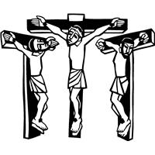

We gather and depart in total silence to remember our Lord’s suffering and death.

Introduction
Life and death stand side by side as we enter into Good Friday. In John’s passion account, Jesus reveals the power and glory of God, even as he is put on trial and sentenced to death. Standing with the disciples at the foot of the cross, we pray for the whole world in the ancient bidding prayer, as Christ’s death offers life to all. We gather in solemn devotion, but always with the promise that the tree around which we assemble is indeed a tree of life. We depart silently, and we anticipate the culmination of the Three Days in the Easter Vigil.

*Greeting
The grace of our Lord Jesus Christ, the love of God, and the communion of the Holy Spirit be with you all.
And also with you.

*Prayer of the Day

Almighty God, look with loving mercy on your family, for whom our Lord Jesus Christ was willing to be betrayed, to be given over to the hands of sinners, and to suffer death on the cross; who now lives and reigns with you and the Holy Spirit, one God, forever and ever.
Amen.

First Reading: Isaiah 52:13—53:12
The fourth servant poem promises ultimate vindication for the servant, who made his life an offering for sin. The servant pours himself out to death and is numbered with the transgressors, images that the early church saw as important keys for understanding the death of Jesus.
¹³ See, my servant shall prosper; he shall be exalted and lifted up, and shall be very high. ¹⁴ Just as there were many who were astonished at him —so marred was his appearance, beyond human semblance, and his form beyond that of mortals—
¹⁵ so he shall startle many nations; kings shall shut their mouths because of him; for that which had not been told them they shall see, and that which they had not heard they shall contemplate.
^{53:1}Who has believed what we have heard? And to whom has the arm of the Lord been revealed? ² For he grew up before him like a young plant, and like a root out of dry ground; he had no form or majesty that we should look at him, nothing in his appearance that we should desire him. ³ He was despised and rejected by others; a man of suffering and acquainted with infirmity; and as one from whom others hide their faces he was despised, and we held him of no account. ⁴ Surely he has borne our infirmities and carried our diseases; yet we accounted him stricken, struck down by God, and afflicted. ⁵ But he was wounded for our transgressions, crushed for our iniquities; upon him was the punishment that made us whole, and by his bruises we are healed. ⁶ All we like sheep have gone astray; we have all turned to our own way, and the Lord has laid on him the iniquity of us all. ⁷ He was oppressed, and he was afflicted, yet he did not open his mouth; like a lamb that is led to the slaughter, and like a sheep that before its shearers is silent, so he did not open his mouth. ⁸ By a perversion of justice he was taken away. Who could have imagined his future? For he was cut off from the land of the living, stricken for the transgression of my people. ⁹ They made his grave with the wicked and his tomb with the rich, although he had done no violence, and there was no deceit in his mouth. ¹⁰ Yet it was the will of the Lord to crush him with pain. When you make his life an offering for sin, he shall see his offspring, and shall prolong his days; through him the will of the Lord shall prosper. ¹¹ Out of his anguish he shall see light; he shall find satisfaction through his knowledge. The righteous one, my servant, shall make many righteous, and he shall bear their iniquities. ¹² Therefore I will allot him a portion with the great, and he shall divide the spoil with the strong; because he poured out himself to death,and was numbered with the transgressors; yet he bore the sin of many, and made intercession for the transgressors.

Psalm: Psalm 22
¹ My God, my God, why have you forsaken me? Why so far from saving me, so far from the words of my groaning?
² My God, I cry out by day, but you do not answer; by night, but I find no rest.
³ Yet you are the Holy One, enthroned on the praises of Israel.
⁴ Our ancestors put their trust in you, they trusted, and you rescued them.
⁵ They cried out to you and were delivered; they trusted in you and were not put to shame.
⁶ But as for me, I am a worm and not human, scorned by all and despised by the people.
⁷ All who see me laugh me to scorn; they curl their lips; they shake their heads.
⁸ “Trust in the Lord; let the Lord deliver; let God rescue him if God so delights in him.”
⁹ Yet you are the one who drew me forth from the womb, and kept me safe on my mother’s breast.
¹⁰ I have been entrusted to you ever since I was born; you were my God when I was still in my mother’s womb.
¹¹ Be not far from me, for trouble is near, and there is no one to help.
¹² Many young bulls encircle me; strong bulls of Bashan surround me.
¹³ They open wide their jaws at me, like a slashing and roaring lion.
¹⁴ I am poured out like water; all my bones are out of joint; my heart within my breast is melting wax.
¹⁵ My strength is dried up like a potsherd; my tongue sticks to the roof of my mouth; and you have laid me in the dust of death.
¹⁶ Packs of dogs close me in, a band of evildoers circles round me; they pierce my hands and my feet.
¹⁷ I can count all my bones while they stare at me and gloat.
¹⁸ They divide my garments among them; for my clothing, they cast lots.
¹⁹ But you, O Lord, be not far away; O my help, hasten to my aid.
²⁰ Deliver me from the sword, my life from the power of the dog.
²¹ Save me from the lion’s mouth! From the horns of wild bulls you have rescued me.
²² I will declare your name to my people; in the midst of the assembly I will praise you.
²³ You who fear the Lord, give praise! All you of Jacob’s line, give glory. Stand in awe of the Lord, all you offspring of Israel.
²⁴ For the Lord does not despise nor abhor the poor in their poverty; neither is the Lord’s face hidden from them; but when they cry out, the Lord hears them.
²⁵ From you comes my praise in the great assembly; I will perform my vows in the sight of those who fear the Lord.
²⁶ The poor shall eat and be satisfied, Let those who seek the Lord give praise! May your hearts live forever!
²⁷ All the ends of the earth shall remember and turn to the Lord; all the families of nations shall bow before God.
²⁸ For dominion belongs to the Lord, who rules over the nations.
²⁹ Indeed, all who sleep in the earth shall bow down in worship; all who go down to the dust, though they be dead, shall kneel be- fore the Lord.
³⁰ Their descendants shall serve the Lord, whom they shall proclaim to generations to come.
³¹ They shall proclaim God’s deliverance to a people yet unborn,
saying to them, “The Lord has acted!”

Second Reading: Hebrews 10:16-25
In the death of Jesus, forgiveness of sins is accomplished and access to God is established. Hence, when we gather together for worship and when we love others, we experience anew the benefits of Jesus’ death.
[After the Holy Spirit says,] ¹⁶ “This is the covenant that I will make with them after those days, says the Lord: I will put my laws in their hearts, and I will write them on their minds,” ¹⁷ he also adds, “I will remember their sins and their lawless deeds no more.”
¹⁸ Where there is forgiveness of these, there is no longer any offering for sin.
¹⁹ Therefore, my friends, since we have confidence to enter the sanctuary by the blood of Jesus, ²⁰ by the new and living way that he opened for us through the curtain (that is, through his flesh), ²¹ and since we have a great priest over the house of God, ²² let us approach with a true heart in full assurance of faith, with our hearts sprinkled clean from an evil conscience and our bodies washed with pure water. ²³ Let us hold fast to the confession of our hope without wavering, for he who has promised is faithful. ²⁴ And let us consider how to provoke one another to love and good deeds, ²⁵ not neglecting to meet together, as is the habit of some, but encouraging one another, and all the more as you see the Day approaching.

Gospel: John 18:1-27
On Good Friday, the story of Jesus’ passion—from his arrest to his burial—is read in its entirety from the Gospel of John.
¹ [Jesus] went out with his disciples across the Kidron valley to a place where there was a garden, which he and his disciples entered.² Now Judas, who betrayed him, also knew the place, because Jesus often met there with his disciples. ³ So Judas brought a detachment of soldiers together with police from the chief priests and the Pharisees, and they came there with lanterns and torches and weapons. ⁴ Then Jesus, knowing all that was to happen to him, came forward and asked them, “Whom are you looking for?” ⁵ They answered, “Jesus of Nazareth.” Jesus replied, “I am he.” Judas, who betrayed him, was standing with them. ⁶ When Jesus said to them, “I am he,” they stepped back and fell to the ground. ⁷ Again he asked them, “Whom are you looking for?” And
they said, “Jesus of Nazareth.” ⁸ Jesus answered, “I told you that I am he. So if you are looking for me, let these men go.” ⁹ This was to fulfill the word that he had spoken, “I did not lose a single one of those whom you gave me.” ¹⁰ Then Simon Peter, who had a sword, drew it, struck the high priest’s slave, and cut off his right ear. The slave’s name was Malchus. ¹¹ Jesus said to Peter, “Put your sword back into its sheath. Am I not to drink the cup that the Father has given me?”
¹² So the soldiers, their officer, and the Jewish police arrested Jesus and bound him. ¹³ First they took him to Annas, who was the father-in-law of Caiaphas, the high priest that year. ¹⁴ Caiaphas was the one who had advised the Jews that it was better to have one person die for the people.
¹⁵ Simon Peter and another disciple followed Jesus. Since that disciple was known to the high priest, he went with Jesus into the courtyard of the high priest, ¹⁶ but Peter was standing outside at the gate. So the other disciple, who was known to the high priest, went out, spoke to the woman who guarded the gate, and brought Peter in. ¹⁷ The woman said to Peter, “You are not also one of this man’s disciples, are you?” He said, “I am not.” ¹⁸ Now the slaves and the police had made a charcoal fire because it was cold, and they were standing around it and warming themselves. Peter also was standing with them and warming himself.
¹⁹ Then the high priest questioned Jesus about his disciples and about his teaching. ²⁰ Jesus answered, “I have spoken openly to the world; I have always taught in synagogues and in the temple, where all the Jews come together. I have said nothing in secret. ²¹ Why do you ask me? Ask those who heard what I said to them; they know what I said.” ²² When he had said this, one of the police standing nearby struck Jesus on the face, saying, “Is that how you answer the high priest?” ²³ Jesus answered, “If I have spoken wrongly, testify to the wrong. But if I have spoken rightly, why do you strike me?” ²⁴ Then Annas sent him bound to Caiaphas the high priest.
²⁵ Now Simon Peter was standing and warming himself. They asked him, “You are not also one of his disciples, are you?” He denied it and said, “I am not.” ²⁶ One of the slaves of the high priest, a relative of the man whose ear Peter had cut off, asked, “Did I not see you in the garden with him?” ²⁷ Again Peter denied it, and at that moment the cock crowed.

Hymn: LBW 117 versus 1-2

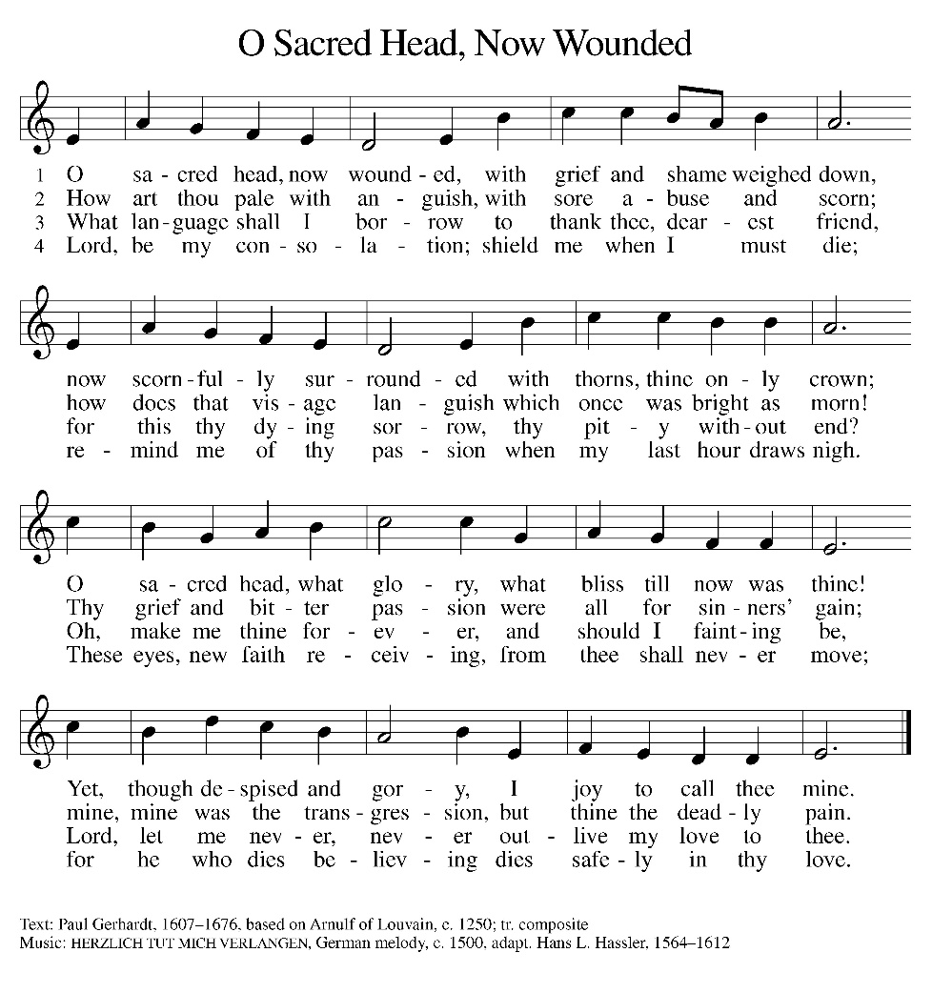
John 18:28—19:16a
²⁸ Then they took Jesus from Caiaphas to Pilate’s headquarters. It was early in the morning. They themselves did not enter the headquarters, so as to avoid ritual defilement and to be able to eat the Passover. ²⁹ So Pilate went out to them and said, “What accusation do you bring against this man?” ³⁰ They answered, “If this man were not a criminal, we would not have handed him over to you.” ³¹ Pilate said to them, “Take him yourselves and judge him according to your law.” The Jews replied, “We are not permitted to put anyone to death.” ³² (This was to fulfill what Jesus had said when he indicated the kind of death he was to die.)
³³ Then Pilate entered the headquarters again, summoned Jesus, and asked him, “Are you the King of the Jews?” ³⁴ Jesus answered, “Do you ask this on your own, or did others tell you about me?” ³⁵ Pilate replied, “I am not a Jew, am I? Your own nation and the chief priests have handed you over to me. What have you done?” ³⁶ Jesus answered, “My kingdom is not from this world. If my kingdom were from this world, my followers would be fighting to keep me from being handed over to the Jews. But as it is, my kingdom is not from here.” ³⁷ Pilate asked him, “So you are a king?” Jesus answered, “You say that I am a king. For this I was born, and for this I came into the world, to testify to the truth. Everyone who belongs to the truth listens to my voice.” ³⁸ Pilate asked him, “What is truth?”
After he had said this, he went out to the Jews again and told them, “I find no case against him. ³⁹ But you have a custom that I release someone for you at the Passover. Do you want me to release for you the King of the Jews?” ⁴⁰ They shouted in reply, “Not this man, but Barabbas!” Now Barabbas was a bandit.
^{19:1} Then Pilate took Jesus and had him flogged. ² And the soldiers wove a crown of thorns and put it on his head, and they dressed him in a purple robe. ³ They kept coming up to him, saying, “Hail, King of the Jews!” and striking him on the face. ⁴ Pilate went out again and said to them, “Look, I am bringing him out to you to let you know that I find no case against him.” ⁵ So Jesus came out, wearing the crown of thorns and the purple robe. Pilate said to them, “Here is the man!” ⁶ When the chief priests and the police saw him, they shouted, “Crucify him! Crucify him!” Pilate said to them, “Take him yourselves and crucify him; I find no case against him.” ⁷ The Jews answered him, “We have a law, and according to that law he ought to die because he has claimed to be the Son of God.”
⁸ Now when Pilate heard this, he was more afraid than ever. ⁹ He entered his headquarters again and asked Jesus, “Where are you from?” But Jesus gave him no answer. ¹⁰ Pilate therefore said to him, “Do you refuse to speak to me? Do you not know that I have power to release you, and power to crucify you?” ¹¹ Jesus answered him, “You would have no power over me unless it had been given you from above; therefore the one who handed me over to you is guilty of a greater sin.” ¹² From then on Pilate tried to release him, but the Jews cried out, “If you release this man, you are no friend of the emperor. Everyone who claims to be a king sets himself against the emperor.”
¹³ When Pilate heard these words, he brought Jesus outside and sat on the judge’s bench at a place called The Stone Pavement, or in Hebrew Gabbatha. ¹⁴ Now it was the day of Preparation for the Passover; and it was about noon. He said to the Jews, “Here is your King!” ¹⁵ They cried out, “Away with him! Away with him! Crucify him!” Pilate asked them, “Shall I crucify your King?” The chief priests answered, “We have no king but the emperor.” ¹⁶ Then he handed him over to them to be crucified.

Hymn: LBW 117 versus 3-4

John 19:16b-42
So they took Jesus; ¹⁷ and carrying the cross by himself, he went out to what is called The Place of the Skull, which in Hebrew is called Golgotha. ¹⁸ There they crucified him, and with him two others, one on either side, with Jesus between them. ¹⁹ Pilate also had an inscription written and put on the cross. It read, “Jesus of Nazareth, the King of the Jews.” ²⁰ Many of the Jews read this inscription, because the place where Jesus was crucified was near the city; and it was written in Hebrew, in Latin, and in Greek. ²¹ Then the chief priests of the Jews said to Pilate, “Do not write, ‘The King of the Jews,’ but, ‘This man said, I am King of the Jews.’ ” ²² Pilate answered, “What I have written I have written.” ²³ When the soldiers had crucified Jesus, they took his clothes and divided them into four parts, one for each soldier. They also took his tunic; now the tunic was seamless, woven in one piece from the top. ²⁴ So they said to one another, “Let us not tear it, but cast lots for it to see who will get it.” This was to fulfill what the scripture says,
“They divided my clothes among themselves,
and for my clothing they cast lots.”
²⁵ And that is what the soldiers did.
Meanwhile, standing near the cross of Jesus were his mother, and his mother’s sister, Mary the wife of Clopas, and Mary Magdalene. ²⁶ When Jesus saw his mother and the disciple whom he loved standing beside her, he said to his mother, “Woman, here is your son.” ²⁷ Then he said to the disciple, “Here is your mother.” And from that hour the disciple took her into his own home.
²⁸ After this, when Jesus knew that all was now finished, he said (in order to fulfill the scripture), “I am thirsty.” ²⁹ A jar full of sour wine was standing there. So they put a sponge full of the wine on a branch of hyssop and held it to his mouth. ³⁰ When Jesus had received the wine, he said, “It is finished.” Then he bowed his head and gave up his spirit.
³¹ Since it was the day of Preparation, the Jews did not want the bodies left on the cross during the sabbath, especially because that sabbath was a day of great solemnity. So they asked Pilate to have the legs of the crucified men broken and the bodies removed. ³² Then the soldiers came and broke the legs of the first and of the other who had been crucified with him. ³³ But when they came to Jesus and saw that he was already dead, they did not break his legs. ³⁴ Instead, one of the soldiers pierced his side with a spear, and at once blood and water came out. ³⁵ (He who saw this has testified so that you also may believe. His testimony is true, and he knows that he tells the truth.) ³⁶ These things occurred so that the scripture might be fulfilled, “None of his bones shall be broken.” ³⁷ And again another passage of scripture says, “They will look on the one whom they have pierced.”
³⁸ After these things, Joseph of Arimathea, who was a disciple of Jesus, though a secret one because of his fear of the Jews, asked Pilate to let him take away the body of Jesus. Pilate gave him permission; so he came and removed his body. ³⁹ Nicodemus, who had at first come to Jesus by night, also came, bringing a mixture of myrrh and aloes, weighing about a hundred pounds. ⁴⁰ They took the body of Jesus and wrapped it with the spices in linen cloths, according to the burial custom of the Jews. ⁴¹ Now there was a garden in the place where he was crucified, and in the garden there was a new tomb in which no one had ever been laid. ⁴² And so, because it was the Jewish day of Preparation, and the tomb was nearby, they laid Jesus there.

SERMON pastor GARY GRINVALDS

HYMN OF THE DAY ELW 349
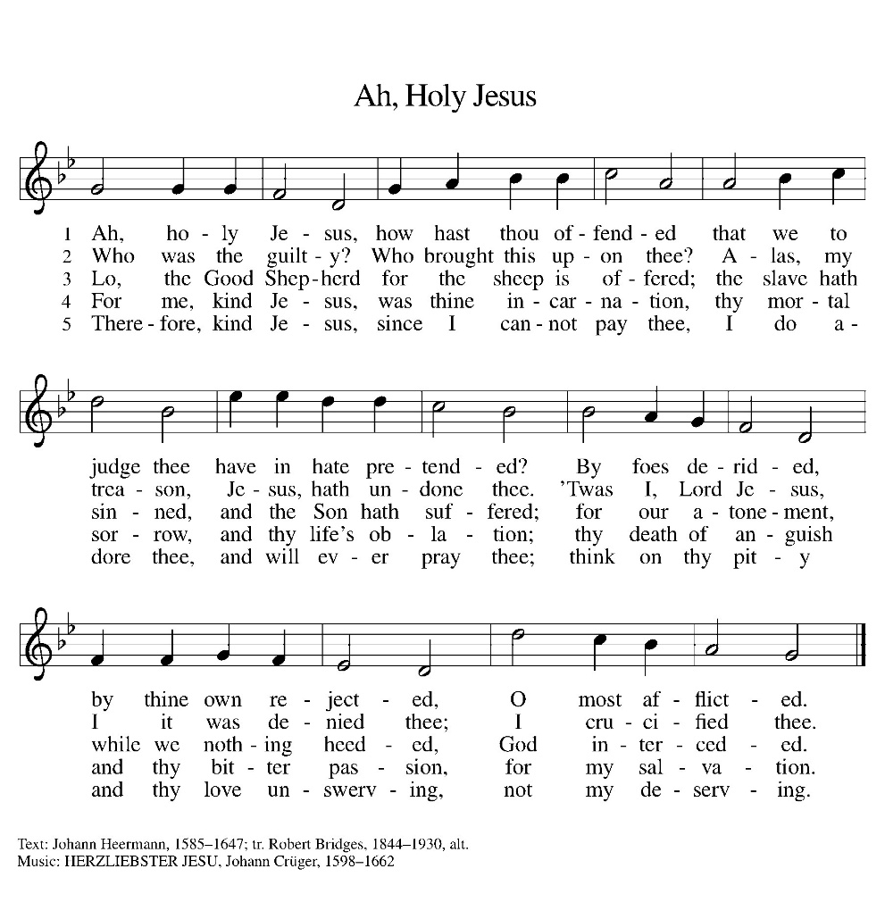
*BIDDING PRAYER

Let us pray, brothers and sisters, for the holy church throughout the world.
Silent prayer.
Almighty and eternal God,
you have shown your glory to all nations in Jesus Christ.
By your Holy Spirit guide the church and gather it throughout the world.
Help it to persevere in faith, proclaim your name, and bring the good news of salvation in Christ to all people.
We ask this through Christ our Lord.
Amen.
Let us pray for our bishops Johnson and Curry, for our pastor(s), for our deacon(s), for and all servants of the church, and for all the people of God.
Silent prayer.
Almighty and eternal God,
your Spirit guides the church and makes it holy.
Strengthen and uphold our bishops, pastors, other ministers, and lay leaders.
Keep them in health and safety for the good of the church,
and help each of us in our various vocations to do faithfully the work to which you have called us.
We ask this through Christ our Lord.
Amen.
Let us pray for those preparing for baptism.
Silent prayer.
Almighty and eternal God, you continue to bless the church.
Increase the faith and understanding of those preparing for baptism.
Give them new birth as your children, and keep them in the faith and communion of your holy church.
We ask this through Christ our Lord.
Amen.
Let us pray for our sisters and brothers who share our faith in Jesus Christ.
Silent prayer.
Almighty and eternal God, you give your church unity.
Look with favor on all who follow Jesus your Son.
Make all the baptized one in the fullness of faith,
and keep us united in the fellowship of love.
We ask this through Christ our Lord.
Amen.
Let us pray for the Jewish people, the first to hear the word of God.
Silent prayer.

Almighty and eternal God,
long ago you gave your promise to Abraham and your teaching to Moses.
Hear our prayers that the people you called and elected as your own may receive the fulfillment of the covenant’s promises.
We ask this through Christ our Lord.
Amen.
Let us pray for those who do not share our faith in Jesus Christ.
Silent prayer.
Almighty and eternal God, gather into your embrace
all those who call out to you under different names.
Bring an end to inter-religious strife, and make us more faithful witnesses of the love made known to us in your Son.
We ask this through Christ our Lord.
Amen.
Let us pray for those who do not believe in God.
Silent prayer.
Almighty and eternal God, you created humanity
so that all may long to know you and find peace in you.
Grant that all may recognize the signs of your love and grace
in the world and in the lives of Christians,
and gladly acknowledge you as the one true God.
We ask this through Christ our Lord.
Amen.
Let us pray for God's creation.
Silent prayer.
Almighty and eternal God,
you are the creator of a magnificent universe.
Hold all the worlds in the arms of your care
and bring all things to fulfillment in you.
We ask this through Christ our Lord.
Amen.
Let us pray for those who serve in public office.
Silent prayer.

Almighty and eternal God,
you are the champion of the poor and oppressed.
In your goodness, give wisdom to those in authority,
so that all people may enjoy justice, peace, freedom,
and a share in the goodness of your creation.
We ask this through Christ our Lord.
Amen.
Let us pray for those in need.
Silent prayer.
Almighty and eternal God,
you give strength to the weary and new courage to those who have lost heart.
Heal the sick, comfort the dying, give safety to travelers, free those unjustly deprived of liberty, and deliver your world from falsehood, hunger, and disease.
Hear the prayers of all who call on you in any trouble,
that they may have the joy of receiving your help in their need.
We ask this through Christ our Lord.
Amen.

Finally, let us pray for all those things for which our Lord would have us ask.

Our Father, who art in heaven,
hallowed be thy name,
thy kingdom come,
thy will be done,
on earth as it is in heaven.
Give us this day our daily bread;
and forgive us our trespasses,
as we forgive those
who trespass against us;
and lead us not into temptation,
but deliver us from evil.
For thine is the kingdom,
and the power, and the glory,
forever and ever. Amen.

*PROCESSION OF THE CROSS
A large cross is carried in procession through the church and placed before the assembly. The assembly stands and faces the cross as it is brought forward.
Behold the life-giving cross, on which was hung the Savior of the whole world.
Oh, come let us worship him.

Behold the life-giving cross, on which was hung the Savior of the whole world.
Oh, come let us worship him.

Behold the life-giving cross, on which was hung the Savior of the whole world.
Oh, come let us worship him.

SOLEMN REPROACHES

(during this time, the worshipers may come to the cross to make a sign of reverence.)

CLOSING

We adore you, O Christ, and we bless you.
By your holy cross you have redeemed the world.

WE DEPART IN SILENCE TO AWAIT THE LORD’S RESURRECTION ON EASTER MORNING

ANNOUNCEMENTS

EASTER SUNDAY SERVICE
April 5 at 8:00 A.M.

Easter egg hunt after church on Easter Sunday. See flyer on bulletin board.

