Sunday, September 13, 2026
16th Sunday of Pentecost

Our Savior’s Lutheran Church
Website: oursaviorswymore.com
8:00 AM Worship 9:00 AM Fellowship
Faith Formation 5:30 PM Wednesdays

Pastor Gary Grinvalds

Organist: Alice Meints or Sandy Eltiste

Introduction to the day
In today’s second reading Paul questions why we judge one another, since we all stand before the judgment of God. Yet we do sin against one another, and Jesus’ challenge that we forgive seventy-seven times reveals God’s boundless mercy. When we hear the words of forgiveness in worship and sign ourselves with the cross, we are renewed in baptism to be signs of reconciliation in the world.
*Please Stand
Congregational responses in bold print

WELCOME AND ANNOUNCEMENTS

*Brief order for CONFESSION AND FORGIVENESS

Blessed be the holy Trinity, ☩ one God,
who pours love into our hearts
and healing upon the earth.
Amen.
Confident that God justifies us by grace through faith,
let us confess our sin.
Silence is kept for reflection.
Compassionate God,
we confess that we struggle to embody your goodness
in the world and in our own hearts.
Creation groans from overuse.
Jealousy and bitterness strain our relationships.
Indifference keeps us from seeking justice.
Divisions disrupt your call to show genuine love
to others.
Turn our hearts back to you.
Restore our world and reconcile us to one another.
Renew us to live as your holy people,
following the way of Jesus Christ.
Amen.
Hear this good news:
We have peace with God through ☩ Jesus Christ,
in whom there is no condemnation,
but only forgiveness and the promise of eternal life.
Receive freely this healing gift of grace.
Amen.

Entrance Hymn ELW 452
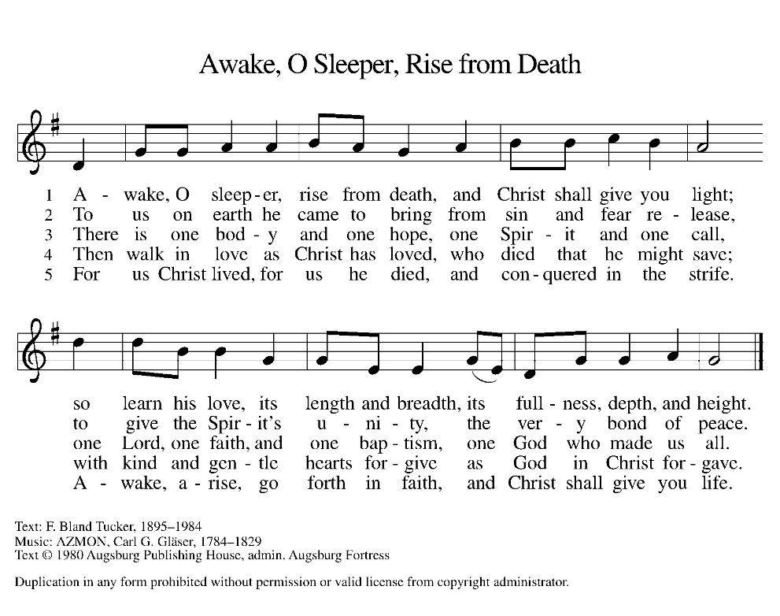
*Blessed are you, O Lord our God, king of the universe,
For in your wisdom you have formed us.
You feed the hungry and clothe the naked,
We bless you and praise your name forever.
You set free those who are bound.
We bless you and praise your name forever.
You raise up those whose courage falters.
We bless you and praise your name forever.
You provide for our every need.
Accept our grateful praises.
You have called us from all peoples.
We rejoice and bless your name forever.
You bless your people with peace.
We bless you and praise your loving grace.
Blessed are you, O Lord our God, king of the universe,
For in your wisdom you have formed us.

*Prayer of the Day

The Lord be with you.
And also with you.

Let us pray.

O Lord God, merciful judge, you are the inexhaustible fountain of forgiveness. Replace our hearts of stone with hearts that love and adore you, that we may delight in doing your will, through Jesus Christ, our Savior and Lord.
Amen.

HYMN ELW 835
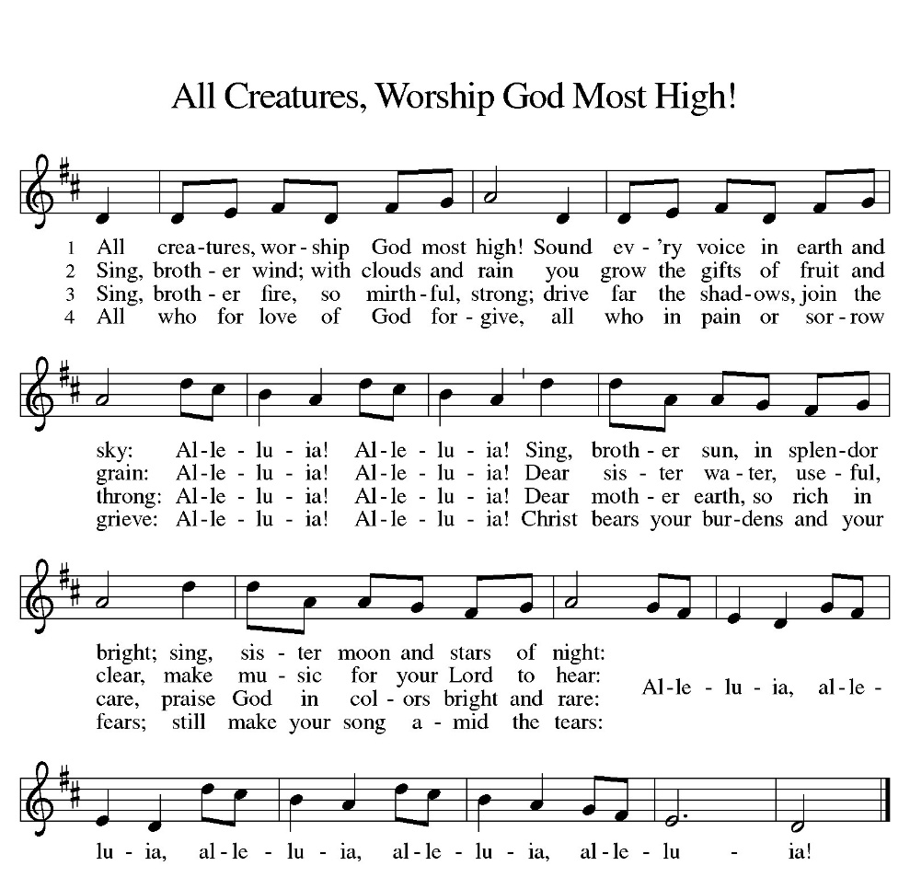

First Lesson: Genesis 50:15-21
After Jacob’s death the brothers of Joseph begged for forgiveness for the crime they had done against him. You intended to do me harm, Joseph said, but God used this as an opportunity to do good and save many lives.
¹⁵ Realizing that their father was dead, Joseph’s brothers said, “What if Joseph still bears a grudge against us and pays us back in full for all the wrong that we did to him?” ¹⁶ So they approached Joseph, saying, “Your father gave this instruction before he died, ¹⁷ ‘Say to Joseph: I beg you, forgive the crime of your brothers and the wrong they did in harming you.’ Now therefore please forgive the crime of the servants of the God of your father.” Joseph wept when they spoke to him. ¹⁸ Then his brothers also wept, fell down before him, and said, “We are here as your slaves.” ¹⁹ But Joseph said to them, “Do not be afraid! Am I in the place of God? ²⁰ Even though you intended to do harm to me, God intended it for good, in order to preserve a numerous people, as he is doing today. ²¹ So have no fear; I myself will provide for you and your little ones.” In this way he reassured them, speaking kindly to them.
Word of God, Word of life.
Thanks be to God.

Psalm 103:1-13 Read Responsively

¹ Bless the Lord, O my soul, and all that is within me, bless God’s| holy name.
² Bless the Lord, O my soul, and forget not all God’s benefits—
³ who forgives all your sins and heals all your diseases;
⁴ who redeems your life from the grave and crowns you with steadfast love and mercy;
⁵ who satisfies your desires with good things so that your youth is renewed like an eagle’s.
⁶ O Lord, you provide vindication and justice for all who are oppressed.
⁷ You made known your ways to Moses and your works to the children of Israel.
⁸ Lord, you are full of compassion and mercy, slow to anger and abounding in steadfast love;
⁹ you will not always accuse us, nor will you keep your anger forever.
¹⁰ You have not dealt with us according to our sins, nor repaid us according to our iniquities.
¹¹ For as the heavens are high above the earth, so great is your steadfast love for those who fear you.
¹² As far as the east is from the west, so far have you removed our transgressions from us.
¹³ As a father has compassion for his children, so you have compassion for those who fear you, O Lord.

Second Lesson: Romans 14:1-12
This Christian community has significant struggles with diversity. Here Paul helps us understand that despite different practices in worship and personal piety, we do not judge one another. All Christians belong to the Lord Jesus Christ who died for all of us and will judge each of us.
¹ Welcome those who are weak in faith but not for the purpose of quarreling over opinions. ² Some believe in eating anything, while the weak eat only vegetables. ³ Those who eat must not despise those who abstain, and those who abstain must not pass judgment on those who eat, for God has welcomed them. ⁴ Who are you to pass judgment on slaves of another? It is before their own lord that they stand or fall. And they will be upheld, for the Lord is able to make them stand.
⁵ Some judge one day to be better than another, while others judge all days to be alike. Let all be fully convinced in their own minds. ⁶ Those who observe the day, observe it for the Lord. Also those who eat, eat for the Lord, since they give thanks to God, while those who abstain, abstain for the Lord and give thanks to God.
⁷ For we do not live to ourselves, and we do not die to ourselves. ⁸ If we live, we live to the Lord, and if we die, we die to the Lord; so then, whether we live or whether we die, we are the Lord’s. ⁹ For to this end Christ died and lived again, so that he might be Lord of both the dead and the living.
¹⁰ Why do you pass judgment on your brother or sister? Or you, why do you despise your brother or sister? For we will all stand before the judgment seat of God. ¹¹ For it is written,
“As I live, says the Lord, every knee shall bow to me,
and every tongue shall give praise to God.”
¹² So then, each one of us will be held accountable.
Word of God, Word of life.
Thanks be to God.

childrens sermon

*sermon text: Habakkuk 1:12—2:4

¹² Are you not from of old, O Lord my God, my Holy One? You shall not die. O Lord, you have marked them for judgment, and you, O Rock, have established them for punishment. ¹³ Your eyes are too pure to behold evil, and you cannot look on wrongdoing; why do you look on the treacherous and are silent when the wicked swallow those more righteous than they? ¹⁴ You have made people like the fish of the sea, like crawling things that have no ruler. ¹⁵ He brings all of them up with a hook; he drags them out with his net; he gathers them in his seine, so he rejoices and exults. ¹⁶ Therefore he sacrifices to his net and makes offerings to his seine, for by them his portion is lavish, and his food is rich. ¹⁷ Is he then to keep on emptying his net and destroying nations without mercy?

¹ I will stand at my watchpost and station myself on the rampart; I will keep watch to see what he will say to me and what he will answer concerning my complaint. ² Then the Lord answered me and said: Write the vision; make it plain on tablets, so that a runner may read it. ³ For there is still a vision for the appointed time; it speaks of the end and does not lie. If it seems to tarry, wait for it; it will surely come; it will not delay. ⁴ Look at the proud! Their spirit is not right in them, but the righteous live by their faithfulness.
Word of God, Word of life.
Thanks be to God.

Sermon ERin saathoff

HYMN OF THE DAY ELW 606
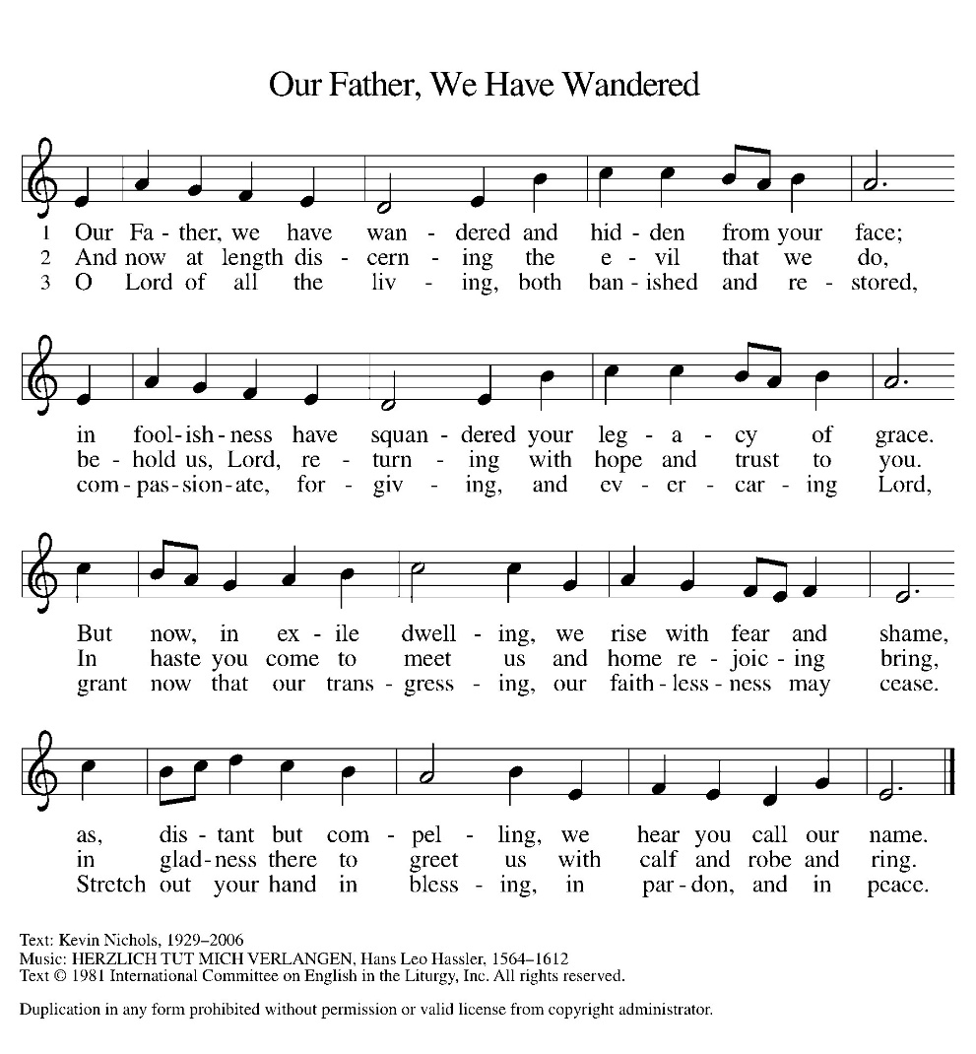

*APOSTLES Creed

I believe in God, the Father almighty,
creator of heaven and earth.
I believe in Jesus Christ, his only Son, our Lord.
He was conceived by the power of the Holy Spirit
and born of the virgin Mary.
He suffered under Pontius Pilate,
was crucified, died, and was buried.
He descended into hell.
On the third day he rose again.
He ascended into heaven,
and is seated at the right hand of the Father.
He will come again to judge the living and the dead.
I believe in the Holy Spirit,
the holy catholic Church,
the communion of saints,
the forgiveness of sins,
the resurrection of the body,
and the life everlasting. Amen

OFFERING

*OFFERTORY Sing verses 1 and 2

*The Prayers
Reminded of God’s gracious and abundant love, we offer our prayers, confident that God hears us.
A brief silence.
Move your church throughout the world away from judging and despising others. Lead us to embody the forgiveness you have given us in Jesus. Hear us, O God.
Your mercy is great.
The endless beauty of your creation reminds us of your mercy. Protect those who care for farms and ranches. Guide those who lead us to wonder at your creation. Hear us, O God.
Your mercy is great.
Raise up leaders to hold all in authority accountable for any misuse of the power entrusted to them. Hear us, O God.
Your mercy is great.
Calm the fears of all in need with your promises. Compassionately free the lives of any who feel bound by their failures. Remember your children in need. Hear us, O God.
Your mercy is great.
Ground this congregation in the welcome you show us in forgiving our sin. Inspire each of us to welcome others for your honor and glory. Hear us, O God.
Your mercy is great.
With you is found the joy and promise of eternal life. Keep us in that joy as we remember all those who have gone before us. Hear us, O God.
Your mercy is great.
Grant the prayers we have offered, what we have forgotten to ask, and whatever else you see that we need. We ask this in Jesus’ name.
Amen.

*Lord's Prayer

Our Father, who art in heaven, hallowed be thy name,
thy kingdom come,
thy will be done,
on earth as it is in heaven.
Give us this day our daily bread;
and forgive us our trespasses,
as we forgive those
who trespass against us;
and lead us not into temptation,
but deliver us from evil.
For thine is the kingdom,
and the power, and the glory,
forever and ever. Amen.

*Blessing

The Lord bless us and keep us.
The Lord make his face shine on us and be gracious to us.
The Lord look upon us with favor and give us peace.
Amen.

SENDING HYMN ELW 544
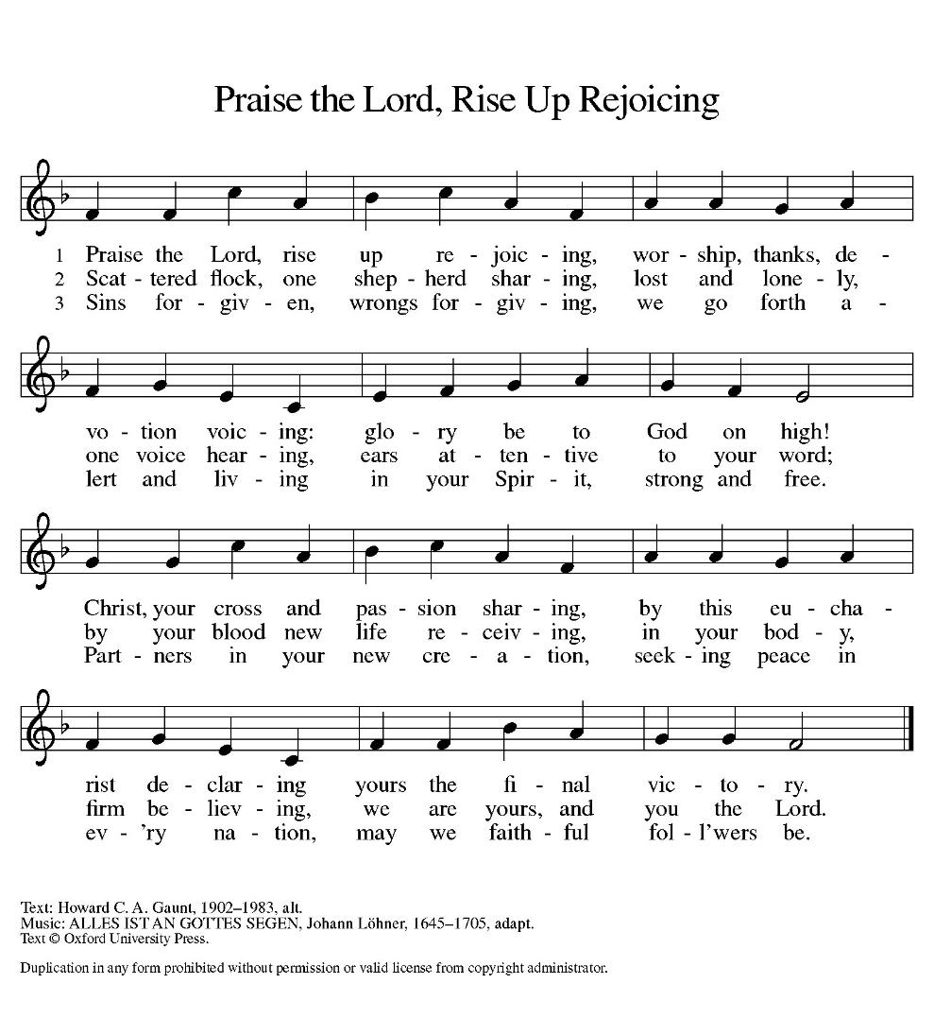

Dismissal
Go out in joy. Be led forth in peace.
Thanks be to God.

From sundaysandseasons.com. Copyright © 2017 Augsburg Fortress. All rights reserved. Reprinted with permission OneLicenses.net #A-722514.

ANNOUNCEMENTS

Reminder of church coffee at 10 a.m. this Tuesday, September 15

Bible Study at 6:00 this Thursday, September 17

September 27, 2026—Trinity Lutheran Church, Hanover 42nd annual “all you can eat” Church Supper from 4-8 p.m. The menu includes grilled ham, BBQ beef, pan fried chicken, scalloped potatoes, corn, green beans, homemade pies, homemade breads and salad bar. Price: Adults -$15, Children 10 and under-$8. Tickets are purchased at the door. Raffle tickets for prizes are being sold in advance by Trinity members and may also be purchased at the door.

If you have a favorite hymn you would like to sing during a future church service, please complete one of the cards on the table in the fellowship hall and place it in the basket provided.

There are sign up sheets on the table in the entryway for the classes that Pastor is offering to the congregation. If you are interested in any of these, please sign up. There are also descriptions of each class beneath the sign up sheet.

Upcoming Community coffees are as follows:
September 18—Wymore Medical at Park Lodge
September 25—Senior Benefits (Ray Manske) at Park Lodge
October 2—Wymore Library

Remembered in Our Prayers:
Jennifer Cohorst Kent Hohensee
Kathleen Remmers Eric Riley Kai Spann
Pastor Gary: Phone: (402) 658-2253
Email: garygrinvalds@gmail.com
If you wish to have Pastor visit you, please contact him to set up a time. Sunday afternoon & Thursday are his open days.

Your Council leaders are:
President: Josh Schmidt (402) 520-0950
Vice President: Chavonn Mailahn (308) 214-0039
Secretary: Rachel Frerichs (402) 239-0466
At Large: Roger Henrichs (402) 239-7740
Erin Saathoff (402) 239-9117
Jodi Wegner (402) 223-8263
Council meetings are now held on the 3rd Thursday of each month after Bible Study.

Church Account Balance: 08/31/2026: $50,174.49*
*does not include offering of 8/30/2026
Church Offerings: 09/06/2026:

Attendance: 09/06/2026: 30

September Birthdays Anniversaries
12 Betsy Frerichs
15 Caleb McKeever
15 Dorothy Skeens
16 Hadlee Maxson
19 Seth Saathoff
20 Jacques Smit 20 Jacques & Jamie Smit
21 Mosely Weyer 24 Jason & Dyan Allington
22 Ron Schroeder 26 Gary & Larissa Grinvalds
27 Jaidyn Allington 28 Steve & Shelley Whitwer
30 Jared Epp
30 Rachel Frerichs

Please have any announcements for the bulletin to Pam by Wednesday noon each week. You may text or call her at
(402) 239-2715 or send an email to the church at oursaviorslutheranwymore@gmail.com. Thank you.

