Sunday, March 29, 2026
Palm Sunday

Our Savior’s Lutheran Church
Website: oursaviorswymore.com
8:00 AM Worship 9:00 AM Fellowship
Faith Formation 5:30 PM Wednesdays

Pastor Gary Grinvalds

Organist: Alice Meints or Sandy Eltiste

Introduction to the day
Today, we encounter the paradox that defines our faith: Jesus Christ is glorified king and humiliated servant. We too are full of paradox: like Peter, we fervently desire to follow Christ, but find ourselves afraid, denying God. We wave palms in celebration today as Christ comes into our midst, and we follow with trepidation as his path leads to death on the cross. Amid it all we are invited into this paradoxical promise of life through Christ’s broken body and outpoured love in a meal of bread and wine. We begin this week that stands at the center of the church year, anticipating the completion of God’s astounding work.

*Please Stand
Congregational responses in bold print

WELCOME AND ANNOUNCEMENTS

*Brief order for CONFESSION AND FORGIVENESS
Blessed be the holy Trinity, ☩ one God,
who forgives all our sin,
whose mercy endures forever.
Amen.
Let us confess our sin before God, who removes our guilt
and blots out all offenses.
Silence is kept for reflection.
Gracious God,
have mercy on us according to your steadfast love.
For seeking worldly delights that deceive us and dishonor you:
Gracious God,
have mercy on us according to your steadfast love.
For desiring self-reliance instead of hungering for your word:
Gracious God,
have mercy on us according to your steadfast love.
For failing to recognize your coming reign,
and for hindering the work of the Spirit: Gracious God,
have mercy on us according to your steadfast love.
For drawing from the well of self-serving ambition,
and for disdaining the living water Christ offers: Gracious God,
have mercy on us according to your steadfast love.
For disregarding voices from the margin,
and for distrusting signs of your healing and hope in the world:
Gracious God,
have mercy on us according to your steadfast love.
For dwelling in tombs of self-pity and discontent,
and for disregarding Christ’s call to come forth to life:
Gracious God,
have mercy on us according to your steadfast love.
God’s steadfast love, grace, and forgiveness abound.
Through faith, the free gift of God,
you have been clothed in the righteousness of Christ.
In the name of ☩ Jesus Christ, your sins are forgiven.
The Spirit of the One who raised Christ from the dead
dwells in you,
pours God’s love into your hearts,
and gives you life and peace.
Amen.

Please stand and wave Palms while singing entrance hymn.

*Entrance Hymn ELW 344

*Greeting

The grace of our Lord Jesus Christ, the love of God, and the communion of the Holy Spirit be with you all.
And also with you.

Kyrie LBW pg 57
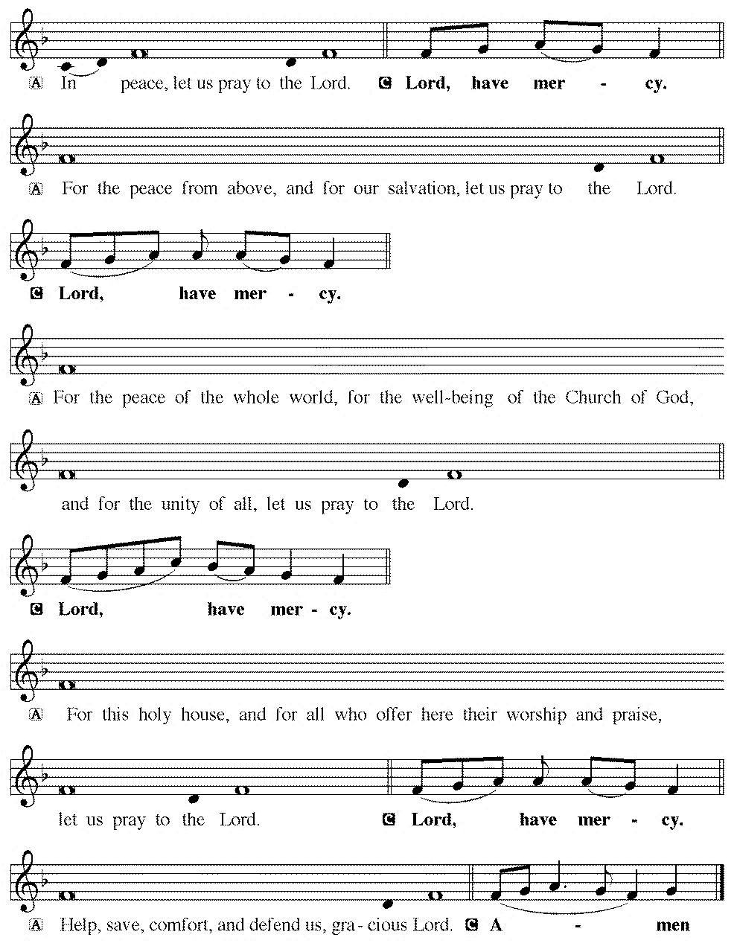
*Hymn OF PRAISE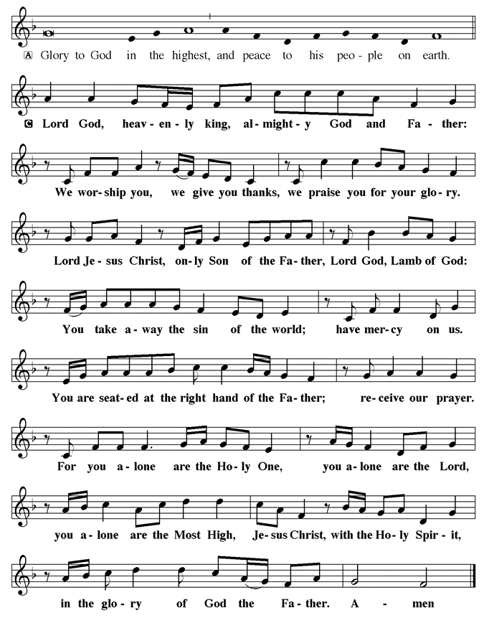

*Prayer of the Day

The Lord be with you.
And also with you.

Let us pray.

Everlasting God, in your endless love for the human race you sent our Lord Jesus Christ to take on our nature and to suffer death on the cross. In your mercy enable us to share in his obedience to your will and in the glorious victory of his resurrection, who lives and reigns with you and the Holy Spirit, one God, now and forever.
Amen.

First Lesson: Isaiah 50:4-9a
The servant of the Lord expresses absolute confidence in his final vindication, despite the fact that he has been struck and spit upon. This characteristic of the servant played an important role in the early church’s understanding of the suffering, death, and resurrection of Jesus.
⁴ The Lord God has given me a trained tongue, that I may know how to sustain the weary with a word. Morning by morning he wakens, wakens my ear to listen as those who are taught. ⁵ The Lord God has opened my ear, and I was not rebellious; I did not turn backward. ⁶ I gave my back to those who struck me and my cheeks to those who pulled out the beard; I did not hide my face from insult and spitting. ⁷ The Lord God helps me; therefore I have not been disgraced; therefore I have set my face like flint, and I know that I shall not be put to shame; ⁸ he who vindicates me is near. Who will contend with me? Let us stand in court together. Who are my adversaries? Let them confront me. ^{9a} It is the Lord God who helps me; who will declare me guilty?
Word of God, Word of life.
Thanks be to God.

Psalm 31:9-16 Read Responsively

⁹Have mercy on me, O Lord, for I am in trouble; my eye is consumed with sorrow, and also my throat and my belly.
¹⁰For my life is wasted with grief, and my years with sighing;
my strength fails me because of affliction, and my bones are consumed.
¹¹I am the scorn of all my enemies, a disgrace to my neighbors, a dismay to my acquaintances; when they see me in the street they avoid me.
¹²Like the dead I am forgotten, out of mind; I am as useless as a broken pot.
¹³For I have heard the whispering of the crowd; fear is all around; they put their heads together against me; they plot to take my life.
¹⁴But as for me, I have trusted in you, O Lord.
I have said, “You are my God.
¹⁵My times are in your hand; rescue me from the hand of my enemies, and from those who persecute me.
¹⁶Let your face shine upon your servant; save me in your steadfast love.”

Second Lesson: Philippians 2: 5-11
Paul uses an early Christian hymn to help us comprehend Jesus’ obedient selflessness on the cross and how God has made Christ lord over all reality. The perspective of the cross becomes the way we rightly understand God, Christ, our own lives, and fellowship within the community of Christ.
⁵Let the same mind be in you that was in Christ Jesus, ⁶who, though he was in the form of God, did not regard equality with God as something to be exploited, ⁷but emptied himself, taking the form of a slave, being born in human likeness. And being found in human form, ⁸he humbled himself and became obedient to the point of death—even death on a cross. ⁹Therefore God also highly exalted him and gave him the name that is above every name, ¹⁰so that at the name of Jesus every knee should bend, in heaven and on earth and under the earth, ¹¹and every tongue should confess that Jesus Christ is Lord, to the glory of God the Father.

Word of God, Word of life.
Thanks be to God.

childrens sermon

*Gospel: Matthew 21:1-11

Glory to you, O Lord.

Jesus enters Jerusalem
¹ When they had come near Jerusalem and had reached Bethphage, at the Mount of Olives, Jesus sent two disciples, ² saying to them, “Go into the village ahead of you, and immediately you will find a donkey tied and a colt with her; untie them and bring them to me. ³ If anyone says anything to you, just say this, ‘The Lord needs them.’ And he will send them immediately.” ⁴ This took place to fulfill what had been spoken through the prophet:
⁵ “Tell the daughter of Zion,
Look, your king is coming to you,
humble and mounted on a donkey,
and on a colt, the foal of a donkey.”
⁶ The disciples went and did as Jesus had directed them; ⁷ they brought the donkey and the colt and put their cloaks on them, and he sat on them. ⁸ A very large crowd spread their cloaks on the road, and others cut branches from the trees and spread them on the road. ⁹ The crowds that went ahead of him and that followed were shouting,
“Hosanna to the Son of David!
Blessed is the one who comes in the name of the Lord!
Hosanna in the highest heaven!”
¹⁰ When he entered Jerusalem, the whole city was in turmoil, asking, “Who is this?” ¹¹ The crowds were saying, “This is the prophet Jesus from Nazareth in Galilee.”
The Gospel of our Lord

Praise to you, O Christ.

Sermon PASTOR GARY GRINVALDS

*HYMN OF THE DAY

*NICENE CREED
We believe in one God,
the Father, the Almighty,
maker of heaven and earth,
of all that is, seen and unseen.
We believe in one Lord, Jesus Christ,
the only Son of God,
eternally begotten of the Father,
God from God, Light from Light,
true God from true God,
begotten, not made,
of one Being with the Father;
through him all things were made.
For us and for our salvation
he came down from heaven,
was incarnate of the Holy Spirit and the virgin Mary,
and became truly man.
For our sake he was crucified under Pontius Pilate;
he suffered death and was buried.
On the third day he rose again
in accordance with the scriptures;
he ascended into heaven
and is seated at the right hand of the Father.
He will come again in glory to judge the living and the dead, and his kingdom will have no end.
We believe in the Holy Spirit, the Lord, the giver of life,
who proceeds from the Father and the Son,
who with the Father and the Son is worshiped and glorified, who has spoken through the prophets.
We believe in one holy catholic and apostolic church.
We acknowledge one baptism for the forgiveness of sins.
We look for the resurrection of the dead,
and the life of the world to come. Amen.

*The Prayers

Reconciled by God’s mercy and sustained by God’s presence, let us pray for the world and its needs.
A brief silence.
O God, you announce words of grace and truth. Give wisdom to all preachers in your church both globally and locally. Open our hearts to encounter the infinite life you offer in Jesus. Hear us, O God.
Your mercy is great.
You hold the whole universe. Gather sun and moon, clouds and stars, land and sea, and plants and animals around the cross, so that all creation bears witness to your saving love. Hear us, O God.
Your mercy is great.
Your power is sure. Destroy inequity and division in every place, and build your beloved community among all people. Guide judges, attorneys, and juries so that they act with justice and fairness. Hear us, O God.
Your mercy is great.
Your heart breaks open at our pain. Send healing and vindication to all who, like Jesus, know the sting of betrayal, denial, abuse, or false accusations. Be with those experiencing pain or loss this day. Hear us, O God.
Your mercy is great.
Your ways show compassion. Let this same mind be in us as we enter Holy Week. Bless those here who will lead worship and tell the story of Jesus’ death and resurrection. Hear us, O God.
Your mercy is great.
Here other intercessions may be offered.
O God, your embrace is eternal. Praise and thanks to you for all the faithful departed who rest in your mercy. Deliver us all from death’s power and raise us to life in you. Hear us, O God.
Your mercy is great.
Receive our prayers, O God, through Jesus Christ, our strength and salvation.
Amen.

*Peace

The peace of the Lord be with you always.
And also with you.

OFFERING

*OFFERTORY

*Offertory Prayer

O God, maker of heaven and earth,
your steadfast love embraces all creation.
You send rain and sunshine to nourish the earth
and bring forth its bounty.
Through these gifts of bread and wine,
draw us into the death and life of your Son,
who calls us to bear witness to his saving work.
We ask this in Jesus’ name.
Amen.

*Dialogue

The Lord be with you.
And also with you.

Lift up your hearts.
We lift them to the Lord.

Let us give thanks to the Lord our God.
It is right to give our thanks and praise

*Preface
It is indeed right, our duty, and our joy that we should at all times and in all places give thanks and praise to you, almighty and merciful God, through our Savior Jesus Christ. You call your people to cleanse their hearts and prepare with joy for the paschal feast, that renewed in the gift of baptism, we may come to the fullness of your grace. And so, with all the choirs of angels, with the Church on earth and the hosts of heaven, we praise your name and join their unending hymn:

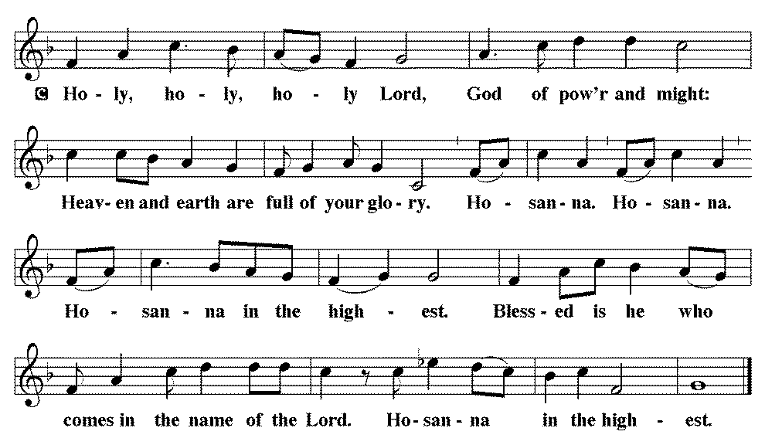

*THE GREAT Thanksgiving
Blessed are you, O God of the universe. Your mercy is everlasting and your faithfulness endures from age to age.

Praise to you for creating the heavens and the earth.
Praise to you for saving the earth from the waters of the flood.
Praise to you for bringing the Israelites safely through the sea.
Praise to you for leading your people through the wilderness to the land of milk and honey.
Praise to you for the words and deeds of Jesus, your anointed one.
Praise to you for the death and resurrection of Christ.
Praise to you for your Spirit poured out on all nations.

In the night in which he was betrayed,
our Lord Jesus took bread, and gave thanks;
broke it, and gave it to his disciples, saying:
Take and eat; this is my body, given for you.
Do this for the remembrance of me.

Again, after supper, he took the cup, gave thanks,
and gave it for all to drink, saying:
This cup is the new covenant in my blood,
shed for you and for all people for the forgiveness of sin.
Do this for the remembrance of me.
With this bread and cup, we remember our Lord’s Passover from death to life as we proclaim the mystery of faith:
Christ has died. Christ has risen. Christ will come again.

O God of resurrection and new life:
Pour out your Holy Spirit on us and on these gifts of bread and wine.
Bless this feast. Grace our table with your presence.
Come, Holy Spirit.

Reveal yourself to us in the breaking of the bread. Raise us up as the body of Christ for the world. Breathe new life into us. Send us forth, burning with justice, peace and love.
Come, Holy Spirit.

With your holy ones of all times and places, with the earth and all its creatures, with sun and moon and stars, we praise you, O God, blessed and holy Trinity, now and forever.
Amen.

*Lord's Prayer

Our Father, who art in heaven, hallowed be thy name,
thy kingdom come,
thy will be done,
on earth as it is in heaven.
Give us this day our daily bread;
and forgive us our trespasses,
as we forgive those
who trespass against us;
and lead us not into temptation,
but deliver us from evil.
For thine is the kingdom,
and the power, and the glory,
forever and ever. Amen.

*INVITATION TO HOLY COMMUNION
Come to the table.
Feast on God’s goodness and mercy.

AGNUS DEI (Lamb of God) ~ HOLY Communion 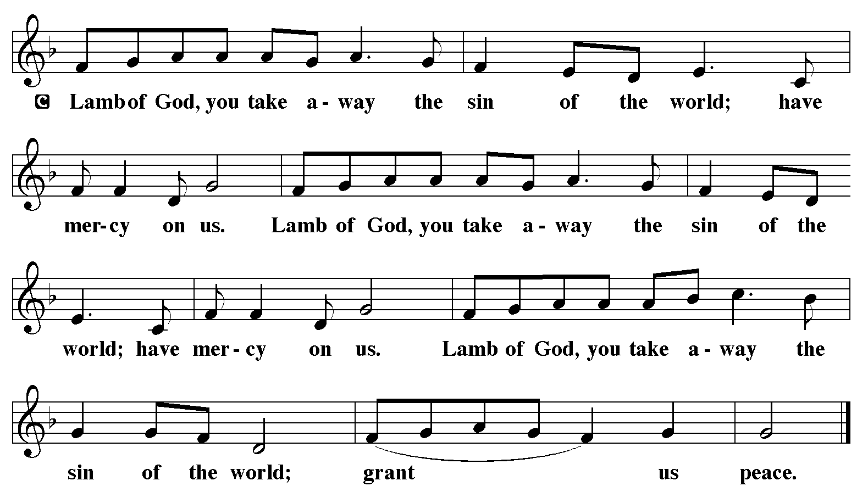
COMMUNION HYMN ELW 353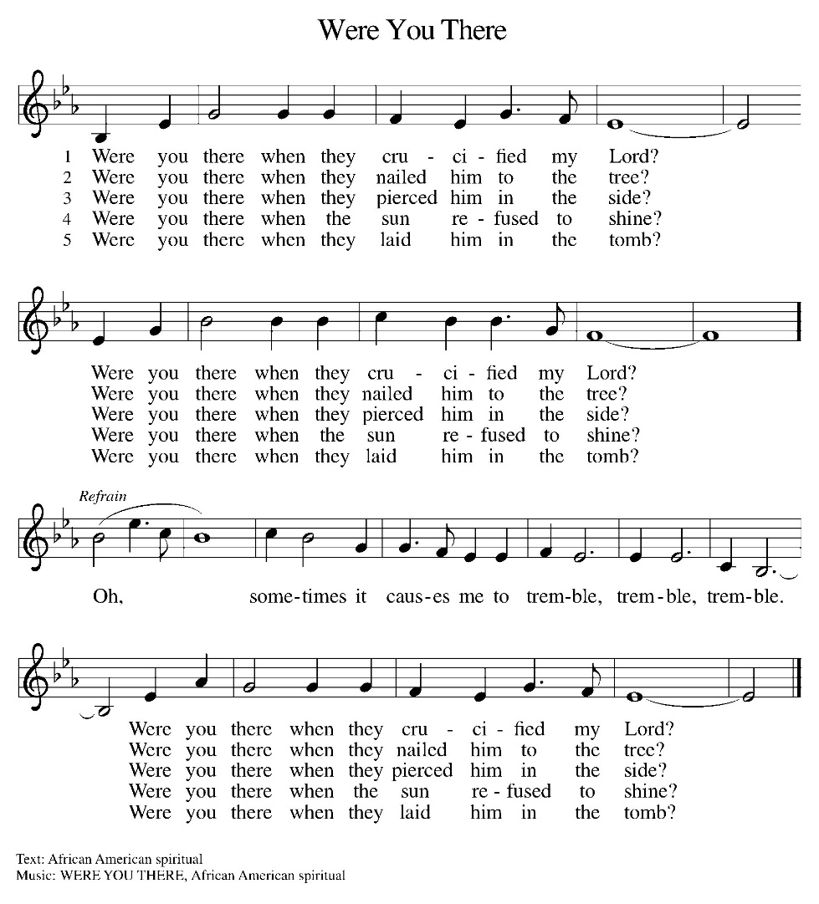

*BLESSING
May the body and blood of our Lord Jesus Christ strengthen you and keep you in his grace.
Amen

*Canticle

*Prayer after communion

God of our salvation,
we give you thanks for this meal that restores our souls,
reconciles us to you, and strengthens us for the journey.
Through the body and blood of your Son,
may we become Christ’s body in the world,
bearing witness to your love for all creation,
through Jesus Christ, our Savior and Lord. Amen.

*Blessing

Receive the blessing of the holy Trinity:
God, who calls all things into existence,
Jesus Christ, who redeems us,
and the Holy Spirit, whose breath sustains creation,
☩ bless you now and always. Amen.

*SENDING HYMN
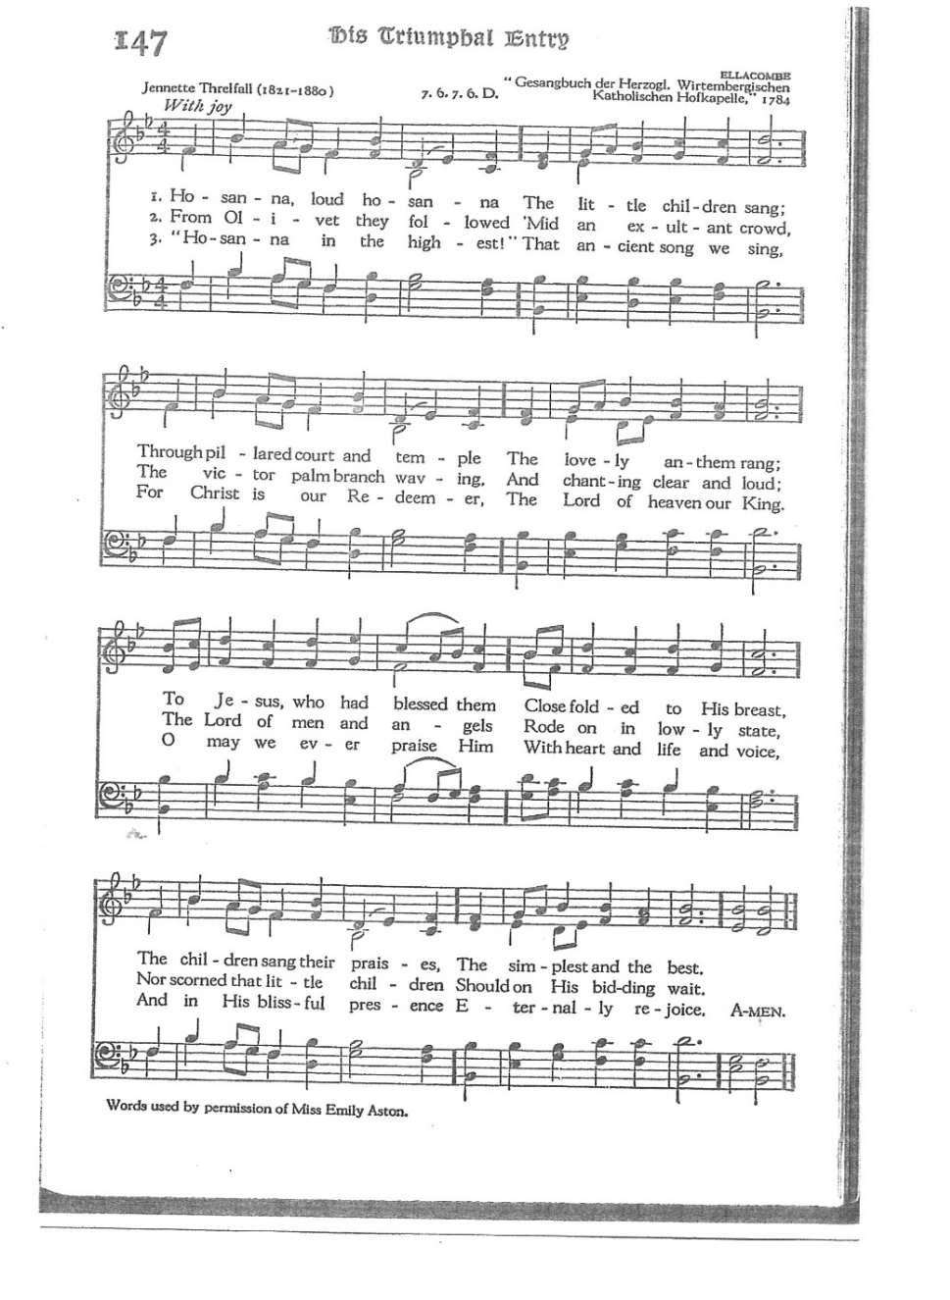

*Dismissal

Go in peace. Believe the good news.
Thanks be to God.

From sundaysandseasons.com. Copyright © 2017 Augsburg Fortress. All rights reserved. Reprinted with permission OneLicenses.net #A-722514.

ANNOUNCEMENTS

HOLY WEEK SERVICE SCHEDULE
Maundy Thursday, April 2, 2026 at 7:30 p.m.
Good Friday, April 3, 2026 at 7:30 p.m.
EASTER SUNDAY, APRIL 5, 2026
8:00 A.M. AT OUR SAVIOR’S

There will be no Bible Study this week due to Maundy Thursday services. It will be on April 23, 2026 at 6:30 (Pastor is unavailable the 16th).

Easter Sunday--an Easter Egg Hunt will be held directly after the church service.

April 11, 2026—Women of the church are invited to a luncheon at American Lutheran in Filley at 11:30 a.m. See flyer in fellowship hall.

There are sign up sheets on the table in the entryway for the classes that Pastor is offering to the congregation. If you are interested in any of these, please sign up. There are also descriptions of each class beneath the sign up sheet.

Upcoming Community coffees are as follows:
April 3—Wymore Library

Remembered in Our Prayers:
Kent Hohensee Kathleen Remmers Kai Spann

Pastor Gary: Phone: (402) 658-2253
Email: garygrinvalds@gmail.com
If you wish to have Pastor visit you, please contact him to set up a time. Sunday afternoon & Thursday are his open days.

Your Council leaders are:
President: Josh Schmidt (402) 520-0950
Vice President: Chavonn Mailahn (308) 214-0039
Secretary: Rachel Frerichs (402) 239-0466
At Large: Roger Henrichs (402) 239-7740
Erin Saathoff (402) 239-9117
Jodi Wegner (402) 223-8263
Council meetings are now held on the 3rd Thursday of each month after Bible Study.

Church Account Balance: 02/28/2026: $42,983.57
Church Offerings: 03/01/2026: $ 1,757.00
03/04/2026: $ 57.00
03/08/2026: $ 956.00
03/11/2026: $ 135.00
03/15/2026: $ 526.00
03/18/2026: $ 202.00
03/22/2026: $ 81.00

Attendance 03/22/2026: 32
03/25/2026: 35

April Birthdays Anniversaries
01 Dave Creevan 02 Scott & Dee Bednar
05 Maryn Martin 09 Josh & Amy Schmidt
06 Pam Gerdes 10 Larry & Darcie Schmidt
07 Kelly Dieter 12 Joel & Stacy Fossler
08 Sean Rickers
09 Dana Dorn
13 Ava Jerrad More birthdays:
13 Justin Weyer 20 Brigslee Dieter
15 Larissa Grinvalds 20 Dustin Wegner
19 Mariah Murphy 20 Ryker Whitwer
19 Darcie Schmidt

