Sunday, October 25, 2026
Reformation Sunday

Our Savior’s Lutheran Church
Website: oursaviorswymore.com
8:00 AM Worship 9:00 AM Fellowship
Faith Formation 5:30 PM Wednesdays

Pastor Gary Grinvalds

Organist: Alice Meints or Sandy Eltiste

Introduction to the day
Rooted in the past and growing into the future, the church must always be reformed in order to live out the love of Christ in an ever-changing world. We celebrate the good news of God’s grace, that Jesus Christ sets us free every day to do this life-transforming work. Trusting in the freedom given to us in baptism, we pray for the church, that Christians will unite more fully in worship and mission.

*Please Stand
Congregational responses in bold print

WELCOME AND ANNOUNCEMENTS

*Brief order for CONFESSION AND FORGIVENESS

Blessed be the holy Trinity, ☩ one God,
who pours love into our hearts
and healing upon the earth.
Amen.
Confident that God justifies us by grace through faith,
let us confess our sin.
Silence is kept for reflection.
Compassionate God,
we confess that we struggle to embody your goodness
in the world and in our own hearts.
Creation groans from overuse.
Jealousy and bitterness strain our relationships.
Indifference keeps us from seeking justice.
Divisions disrupt your call to show genuine love
to others.
Turn our hearts back to you.
Restore our world and reconcile us to one another.
Renew us to live as your holy people,
following the way of Jesus Christ.
Amen.
Hear this good news:
We have peace with God through ☩ Jesus Christ,
in whom there is no condemnation,
but only forgiveness and the promise of eternal life.
Receive freely this healing gift of grace.
Amen.

*Entrance Hymn ELW 504
“A MIGHTY FORTRESS IS OUR GOD”

*Greeting

The grace of our Lord Jesus Christ, the love of God, and the communion of the Holy Spirit be with you all.
And also with you.

*Kyrie LBW pg 57
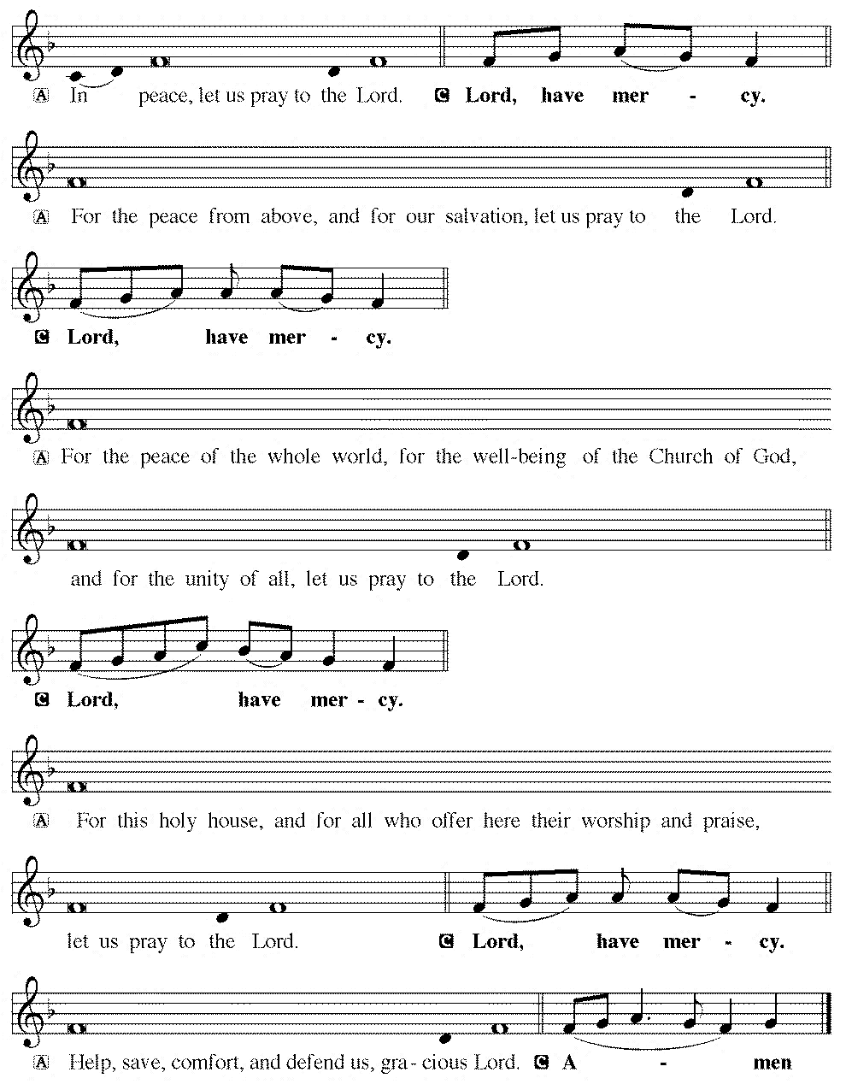

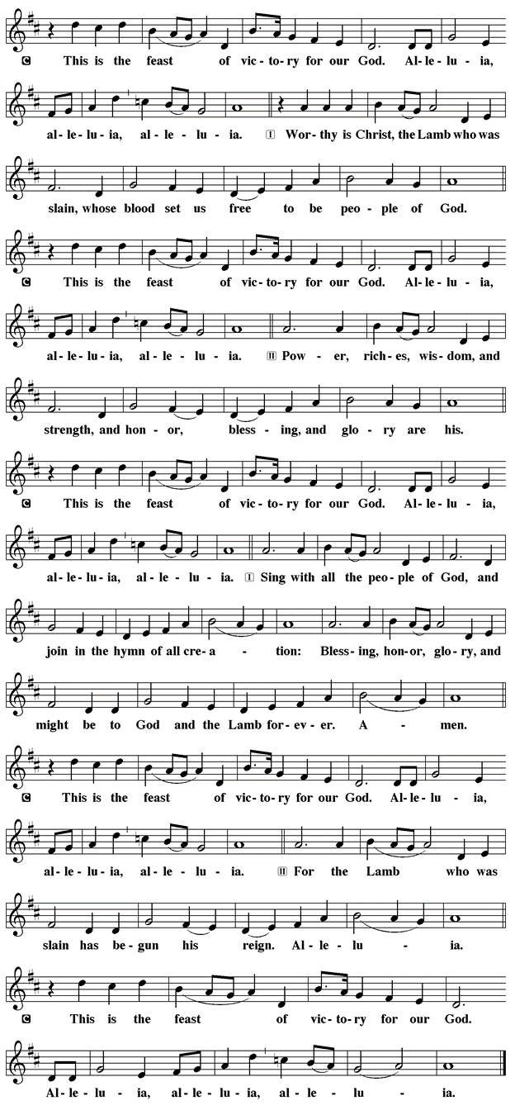
*Prayer of the Day

The Lord be with you.
And also with you.

Let us pray.

Almighty God, gracious Lord, we thank you that your Holy Spirit renews the church in every age. Pour out your Holy Spirit on your faithful people. Keep them steadfast in your word, protect and comfort them in times of trial, defend them against all enemies of the gospel, and bestow on the church your saving peace, through Jesus Christ, our Savior and Lord, who lives and reigns with you and the Holy Spirit, one God, now and forever.
Amen.

First Lesson: Jeremiah 31:31-34
The renewed covenant will not be breakable, but like the old covenant it will expect the people to live upright lives. To know the Lord means that one will defend the cause of the poor and needy (Jer. 22:16). The renewed covenant is possible only because the Lord will forgive iniquity and not remember sin. Our hope lies in a God who forgets.
³¹ The days are surely coming, says the Lord, when I will make a new covenant with the house of Israel and the house of Judah. ³² It will not be like the covenant that I made with their ancestors when I took them by the hand to bring them out of the land of Egypt—a covenant that they broke, though I was their husband, says the Lord. ³³ But this is the covenant that I will make with the house of Israel after those days, says the Lord: I will put my law within them, and I will write it on their hearts, and I will be their God, and they shall be my people. ³⁴ No longer shall they teach one another or say to each other, “Know the Lord,” for they shall all know me, from the least of them to the greatest, says the Lord, for I will forgive their iniquity and remember their sin no more.
Word of God, Word of life.
Thanks be to God.

Psalm 46 Read Responsively

¹ God is our refuge and strength, a very present help in trouble.
² Therefore we will not fear, though the earth be moved, and though the mountains shake in the depths of the sea;
³ though its waters rage and foam, and though the mountains tremble with its tumult.
⁴ There is a river whose streams make glad the city of God, the holy habitation of the Most High.
⁵ God is in the midst of the city; it shall not be shaken; God shall help it at the break of day.
⁶ The nations rage, and the kingdoms shake; God speaks, and the earth melts away.
⁷ The Lord of hosts is with us; the God of Jacob is our stronghold.
⁸ Come now, regard the works of the Lord, what desolations God has brought upon the earth;
⁹ behold the one who makes war to cease in all the world; who breaks the bow, and shatters the spear, and burns the shields with fire.
¹⁰ “Be still, then, and know that I am God; I will be exalted among the nations; I will be exalted in the earth.”
¹¹ The Lord of hosts is with us; the God of Jacob is our stronghold.

Second Lesson: Romans 3:19-28
Paul’s words stand at the heart of the preaching of Martin Luther and other Reformation leaders. No human beings make themselves right with God through works of the law. We are brought into a right relationship with God through the divine activity centered in Christ’s death. This act is a gift of grace that liberates us from sin and empowers our faith in Jesus Christ.
¹⁹ Now we know that, whatever the law says, it speaks to those who are under the law, so that every mouth may be silenced and the whole world may be held accountable to God. ²⁰ For no human will be justified before him by deeds prescribed by the law, for through the law comes the knowledge of sin.
²¹ But now, apart from the law, the righteousness of God has been disclosed and is attested by the Law and the Prophets, ²² the righteousness of God through the faith of Jesus Christ for all who believe. For there is no distinction, ²³ since all have sinned and fall short of the glory of God; ²⁴ they are now justified by his grace as a gift, through the redemption that is in Christ Jesus, ²⁵ whom God put forward as a sacrifice of atonement by his blood, effective through faith. He did this to demonstrate his righteousness, because in his divine forbearance he had passed over the sins previously committed; ²⁶ it was to demonstrate at the present time his own righteousness, so that he is righteous and he justifies the one who has the faith of Jesus.
²⁷ Then what becomes of boasting? It is excluded. Through what kind of law? That of works? No, rather through the law of faith. ²⁸ For we hold that a person is justified by faith apart from works prescribed by the law.

Word of God, Word of life.
Thanks be to God.

childrens sermon

*Gospel: John 8:31-36

Glory to you, O Lord.

Jesus speaks of truth and freedom as spiritual realities known through his word. He reveals the truth that sets people free from sin.
³¹ Jesus said to the Jews who had believed in him, “If you continue in my word, you are truly my disciples, ³² and you will know the truth, and the truth will make you free.” ³³ They answered him, “We are descendants of Abraham and have never been slaves to anyone. What do you mean by saying, ‘You will be made free’?”
³⁴ Jesus answered them, “Very truly, I tell you, everyone who commits sin is a slave to sin. ³⁵ The slave does not have a permanent place in the household; the son has a place there forever. ³⁶ So if the Son makes you free, you will be free indeed.”
The Gospel of our Lord

Praise to you, O Christ.

Sermon pastor GARY GRINVALDS

HYMN OF THE DAY ELW 663
“SPREAD, OH SPREAD, ALIMIGHTY WORD”

*NICENE CREED
We believe in one God,
the Father, the Almighty,
maker of heaven and earth,
of all that is, seen and unseen.
We believe in one Lord, Jesus Christ,
the only Son of God,
eternally begotten of the Father,
God from God, Light from Light,
true God from true God,
begotten, not made,
of one Being with the Father;
through him all things were made.
For us and for our salvation
he came down from heaven,
was incarnate of the Holy Spirit and the virgin Mary,
and became truly man.
For our sake he was crucified under Pontius Pilate;
he suffered death and was buried.
On the third day he rose again
in accordance with the scriptures;
he ascended into heaven
and is seated at the right hand of the Father.
He will come again in glory to judge the living and the dead, and his kingdom will have no end.
We believe in the Holy Spirit, the Lord, the giver of life,
who proceeds from the Father and the Son,
who with the Father and the Son is worshiped and glorified, who has spoken through the prophets.
We believe in one holy catholic and apostolic church.
We acknowledge one baptism for the forgiveness of sins.
We look for the resurrection of the dead,
and the life of the world to come. Amen.

*The Prayers
Seeking the Spirit of God who makes all things new, we pray for the church and the world.
A brief silence.
As we celebrate Reformation Sunday, we remember the witness of Martin Luther and the reformers of the church in every generation. Empower us to continue the work of reform and renewal in our own day. Hear us, O God.
Your mercy is great.
We pray for the healing of natural places despoiled by pollution and human greed. Give all living creatures access to safe land, water, and air. Hear us, O God.
Your mercy is great.
We pray for our criminal justice systems and all those whose lives are affected by them. Give wisdom and discernment to police, probation officers, judges, and attorneys; give courage and peace to prisoners and the formerly incarcerated. Hear us, O God.
Your mercy is great.
We ask your blessing upon all people who have been harmed by the church and its leaders, that the truth may make them free. We pray for the relief of all those who are sick or suffering. Hear us, O God.
Your mercy is great.
We give thanks for those exploring or returning to a life of faith. Encourage and guide them, that they may find their hope in you. Hear us, O God.
Your mercy is great.
With gratitude, we remember those disciples who paved the way for us and all of our beloved dead. Hear us, O God.
Your mercy is great.
Trusting in your boundless grace, O God, we lift up these spoken prayers and those in our hearts; through Jesus Christ our Lord.
Amen.

*Peace
The peace of the Lord be with you always.
And also with you.

OFFERING

*Offertory

*Offertory Prayer

God of creation,
you send rain and the earth springs forth abundantly.
All blessings are from you;
make us generous with what we have.
Use our gifts, our abilities, and our hearts
in service to you and in love to our neighbors,
today and always.
Amen.

*Dialogue

The Lord be with you.
And also with you.

Lift up your hearts.
We lift them to the Lord.

Let us give thanks to the Lord our God.
It is right to give our thanks and praise

*Preface

It is indeed right, our duty and our joy,
that we should at all times and in all places
give thanks and praise to you, almighty and merciful God,
through our Savior Jesus Christ;
who on this day overcame death and the grave,
and by his glorious resurrection opened to us the way of everlasting life.
And so, with all the choirs of angels,
with the church on earth and the hosts of heaven,
we praise your name and join their unending hymn:

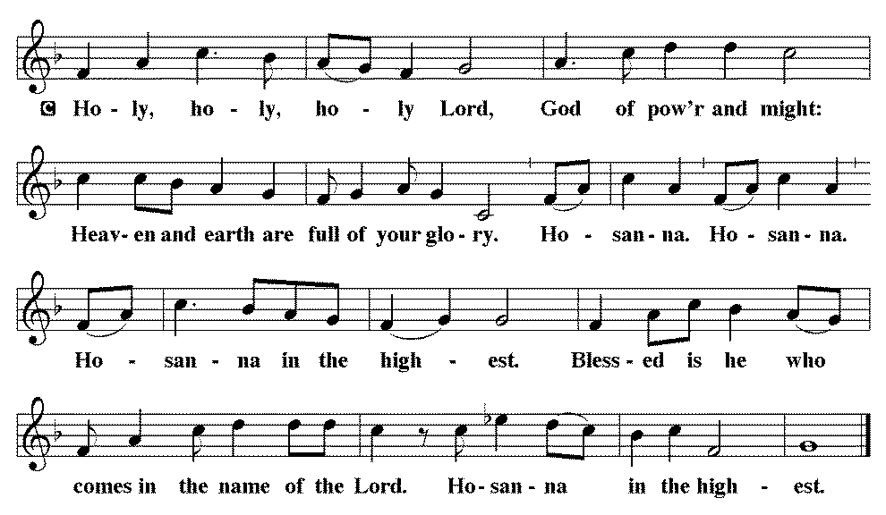

*THE GREAT Thanksgiving
You are indeed holy, almighty and merciful God.
You are most holy, and great is the majesty of your glory.

You so loved the world that you gave your only Son,
so that everyone who believes in him may not perish
but have eternal life.

We give you thanks for his coming into the world to fulfill for us your holy will and to accomplish all things for our salvation.

In the night in which he was betrayed,
our Lord Jesus took bread, and gave thanks;
broke it, and gave it to his disciples, saying:
Take and eat; this is my body, given for you.
Do this for the remembrance of me.

Again, after supper, he took the cup, gave thanks,
and gave it for all to drink, saying:
This cup is the new covenant in my blood,
shed for you and for all people for the forgiveness of sin.
Do this for the remembrance of me.

For as often as we eat of this bread and drink from this cup,
we proclaim the Lord’s death until he comes.
Christ has died. Christ is risen. Christ will come again.

Remembering, therefore, his salutary command, his life-giving passion and death, his glorious resurrection and ascension, and the promise of his coming again, we give thanks to you, O Lord God Almighty, not as we ought but as we are able;
we ask you mercifully to accept our praise and thanksgiving
and with your Word and Holy Spirit to bless us, your servants,
and these your own gifts of bread and wine,
so that we and all who share in the body and blood of Christ
may be filled with heavenly blessing and grace,
and, receiving the forgiveness of sin,
may be formed to live as your holy people
and be given our inheritance with all your saints.
To you, O God, Father, Son, and Holy Spirit,
be all honor and glory in your holy church, now and forever.
Amen.

*Lord's Prayer

Our Father, who art in heaven, hallowed be thy name,
thy kingdom come,
thy will be done,
on earth as it is in heaven.
Give us this day our daily bread;
and forgive us our trespasses,
as we forgive those
who trespass against us;
and lead us not into temptation,
but deliver us from evil.
For thine is the kingdom,
and the power, and the glory,
forever and ever. Amen.

*INVITATION TO HOLY COMMUNION

Christ invites you to this table.
All who are thirsty, all who are hungry, come!

AGNUS DEI (Lamb of God) ~ HOLY Communion 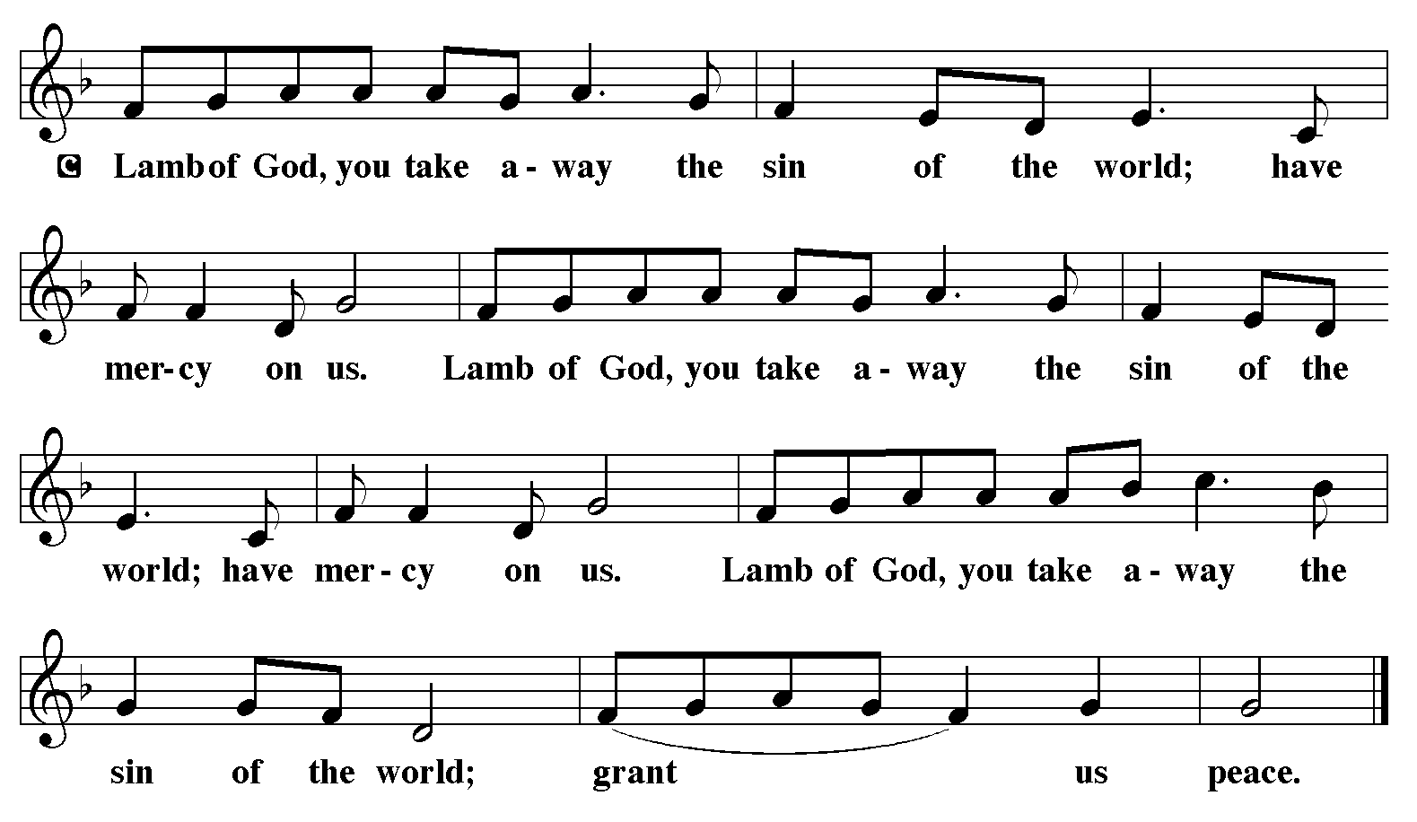
COMMUNION HYMN ELW 665
“RISE, SHINE, YOU PEOPLE!”

*BLESSING
May the body and blood of our Lord Jesus Christ strengthen you and keep you in his grace.
Amen

*Canticle
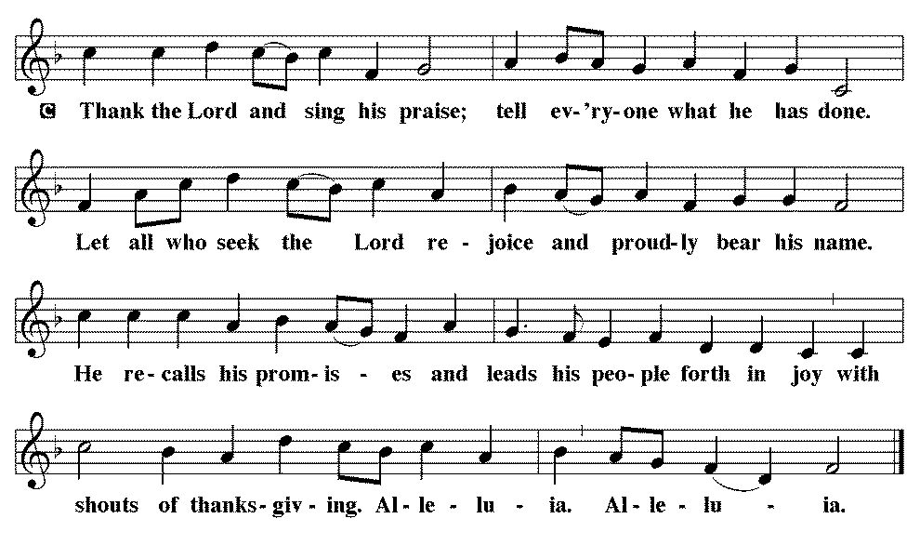

*Prayer after communion

Sustaining God,
with this bread and cup,
you nourish us with mercy and abundant life.
By your Spirit, send us from this table to serve a needy world.
Make us living signs of your liberation, healing, and love,
following the way of Jesus, in whose name we pray.
Amen.

*Blessing

The God of love
draw you into full accord and one mind,
in the body of Christ Jesus. Amen.
The God of hope
grant you strength and joy in all circumstances
through the interceding of the Spirit. Amen.
The God of grace
☩ bless you now and forever. Amen.

SENDING HYMN ELW 534
“SAVIOR, AGAIN TO YOUR DEAR NAME”

*Dismissal

Go out in joy. Be led forth in peace.
Thanks be to God.

From sundaysandseasons.com. Copyright © 2017 Augsburg Fortress. All rights reserved. Reprinted with permission OneLicenses.net #A-722514.

ANNOUNCEMENTS

Today—Spooktacular at McCandles Park from 3:00 to 5:00 p.m. Confirmation Class is hosting a booth

November 1st-- Fall Dinner
11:30 a.m. – 1:00 p.m.
Dine In or Drive Thru
Sign up sheets in the fellowship hall
Church service will be moved to 10:00 a.m.

A suggestion box has been placed on the table in the entry way. Please feel free to put any suggestions or comments for the council in it.

The new sound system has hearing aid assisted listening devices available for use. If you would like to use one, please speak with a council member before the church service.

If you have a favorite hymn you would like to sing during a future church service, please complete one of the cards on the table in the fellowship hall and place it in the basket provided.

There are sign up sheets (with class descriptions underneath) on the table in the entryway for classes that Pastor is offering to the congregation. If you are interested in one or more, please sign up.

Upcoming Community coffees are as follows:
October 30—St. Peter Lutheran Church
November 6—Wymore Library

Remembered in Our Prayers:
Jennifer Cohorst Jenna Forney Kent Hohensee
Dave Mick Kathleen Remmers Eric Riley Kai Spann

Pastor Gary: Phone: (402) 658-2253
Email: garygrinvalds@gmail.com
If you wish to have Pastor visit you, please contact him to set up a time. Sunday afternoon & Thursday are his open days.

Your Council leaders are:
President: Josh Schmidt (402) 520-0950
Vice President: Chavonn Mailahn (308) 214-0039
Secretary: Rachel Frerichs (402) 239-0466
At Large: Roger Henrichs (402) 239-7740
Erin Saathoff (402) 239-9117
Jodi Wegner (402) 223-8263
Council meeting:

Church Account Balance: 09/30/2026: $40,993.12
Church Offerings: 10/04/2026: $ 1,096.00
10/11/2026: $ 1,356.00
10/18/2026: $ 326.00

Attendance: 10/18/2026: 31

October Birthdays Anniversaries
26 Jason Allington 23 Dave & Linda Creevan
27 Steve Epp
29 Natalie Trauernicht
31 Scott Trauernicht

